Below is an example of Old Stain to Paint and Put New Stain color ,2 Coats: Black Cherry

Old stain- Sanding and Clean

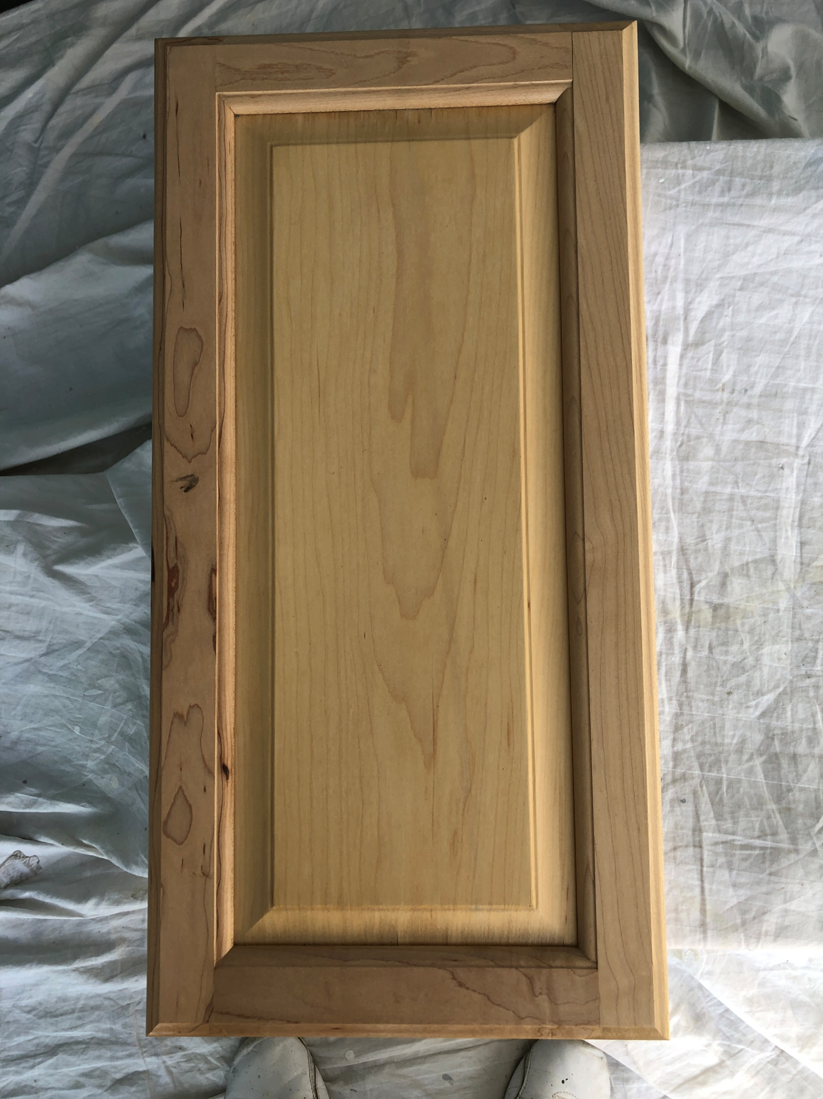

Primer Special
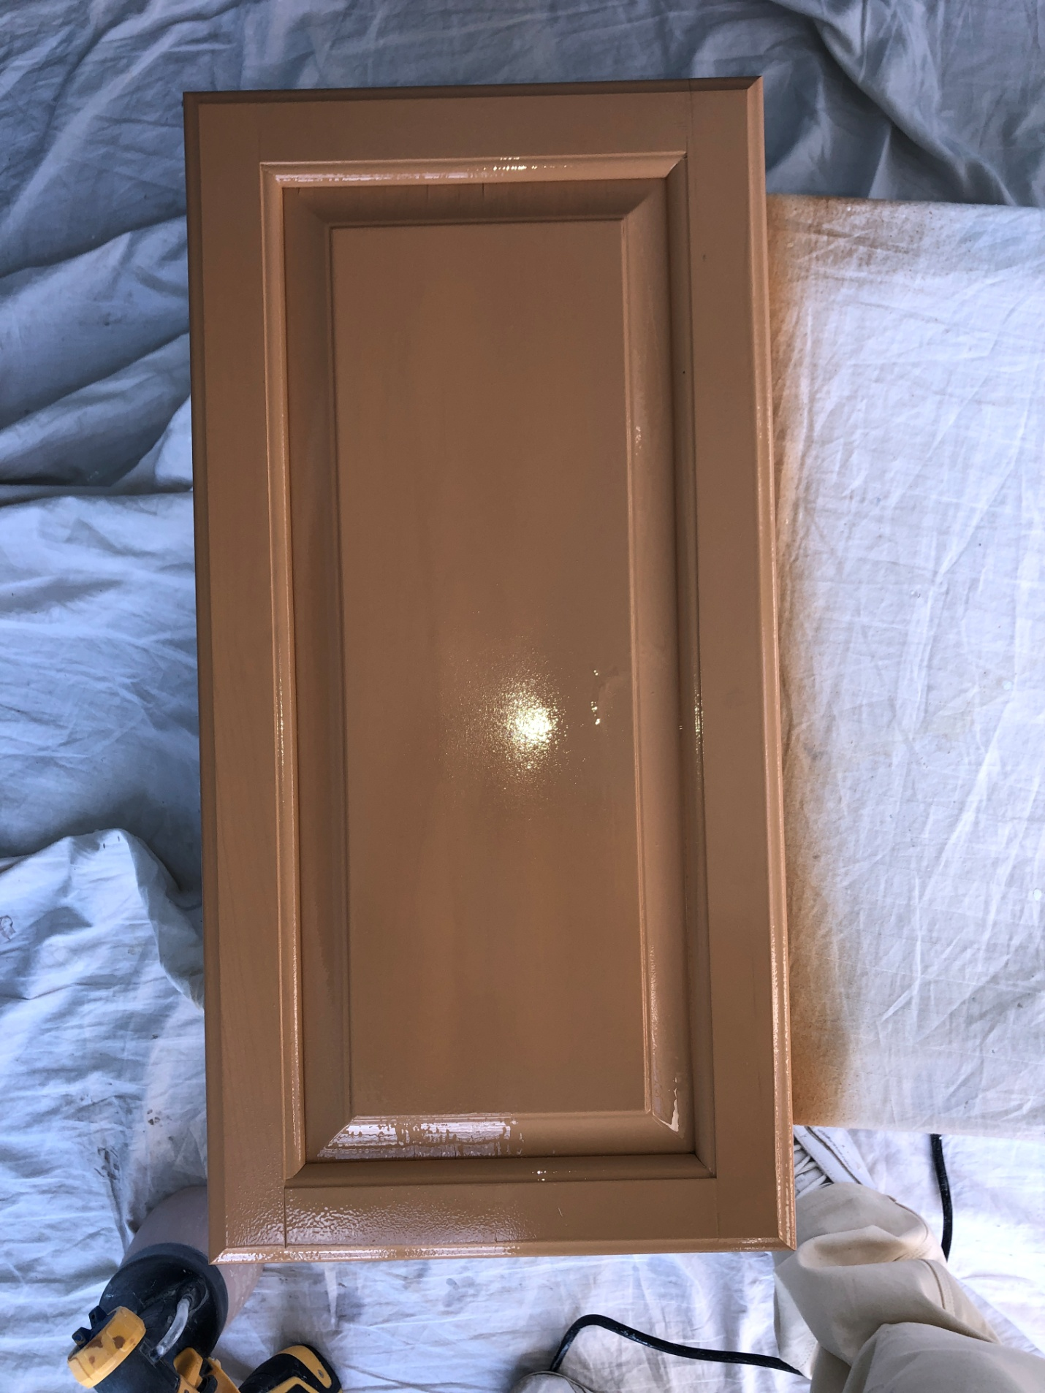

1 Coat Stain Black Cherry
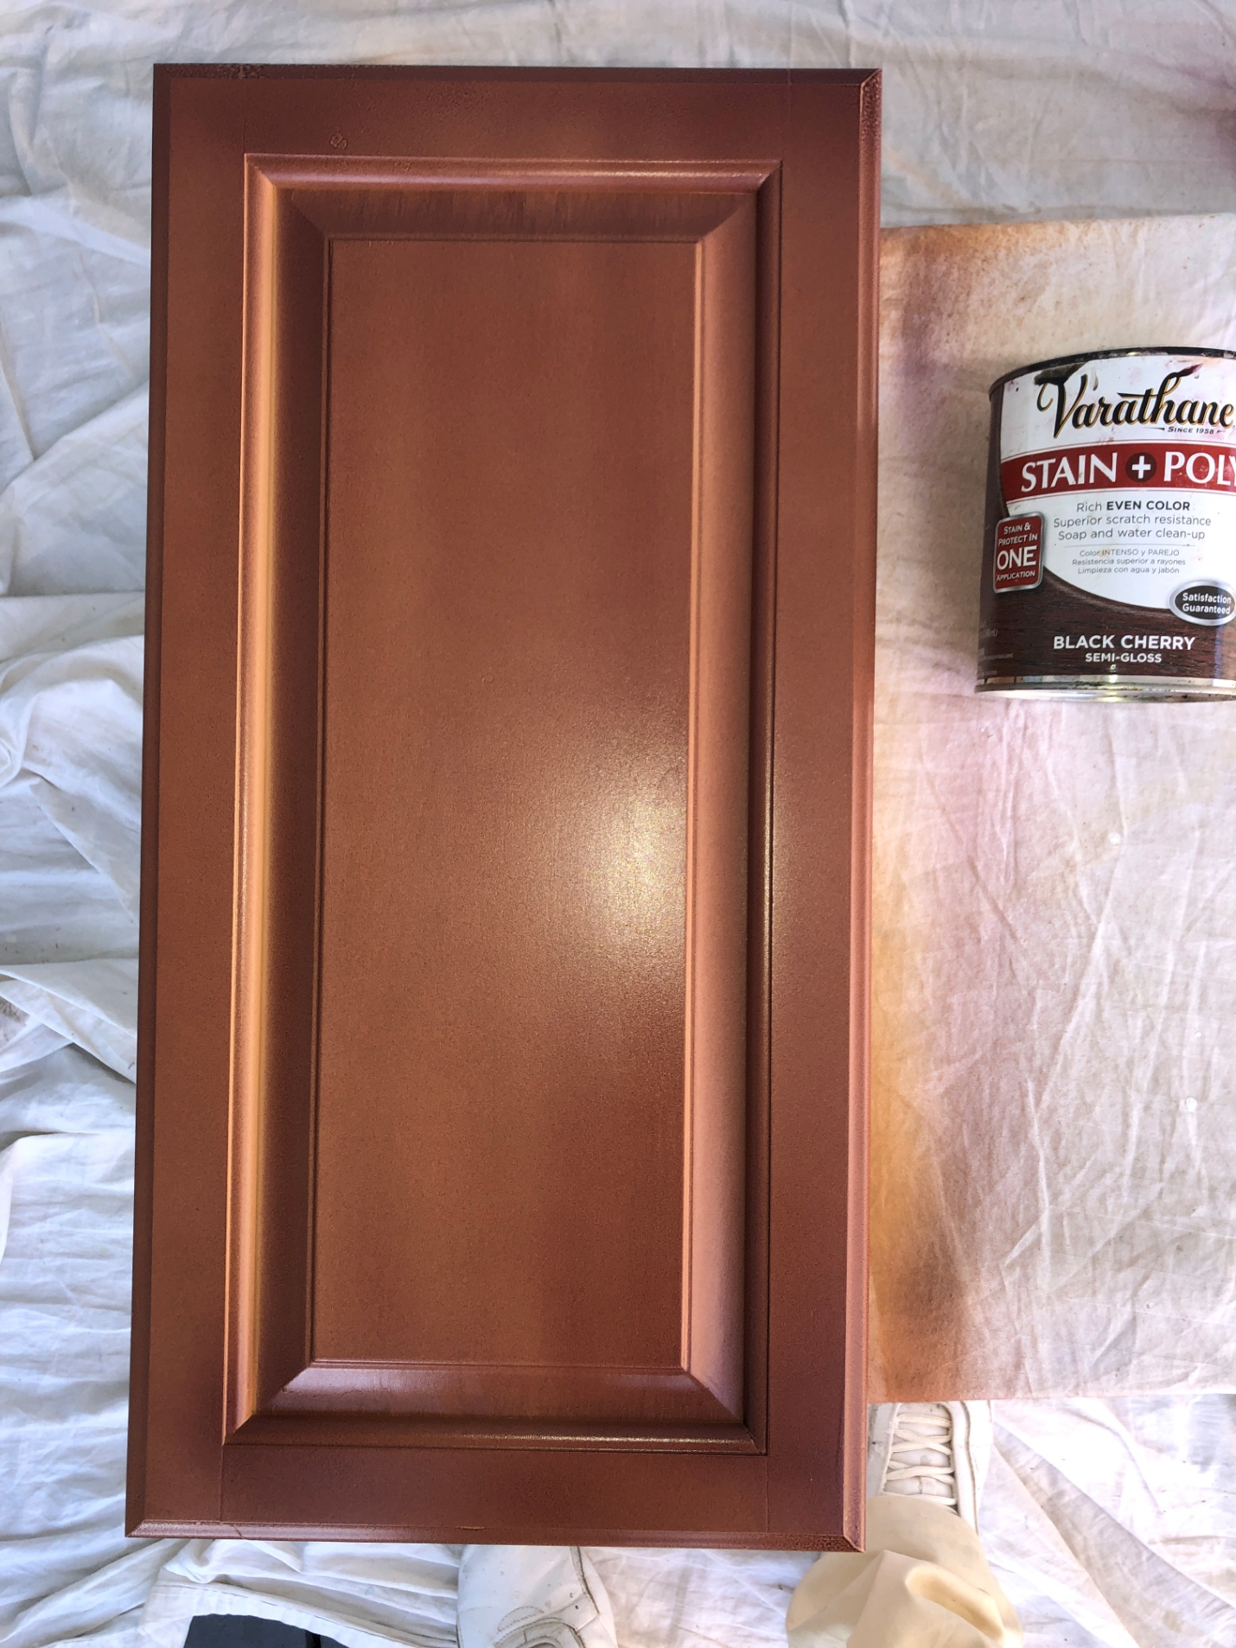

Second Coat Stain Black Cherry
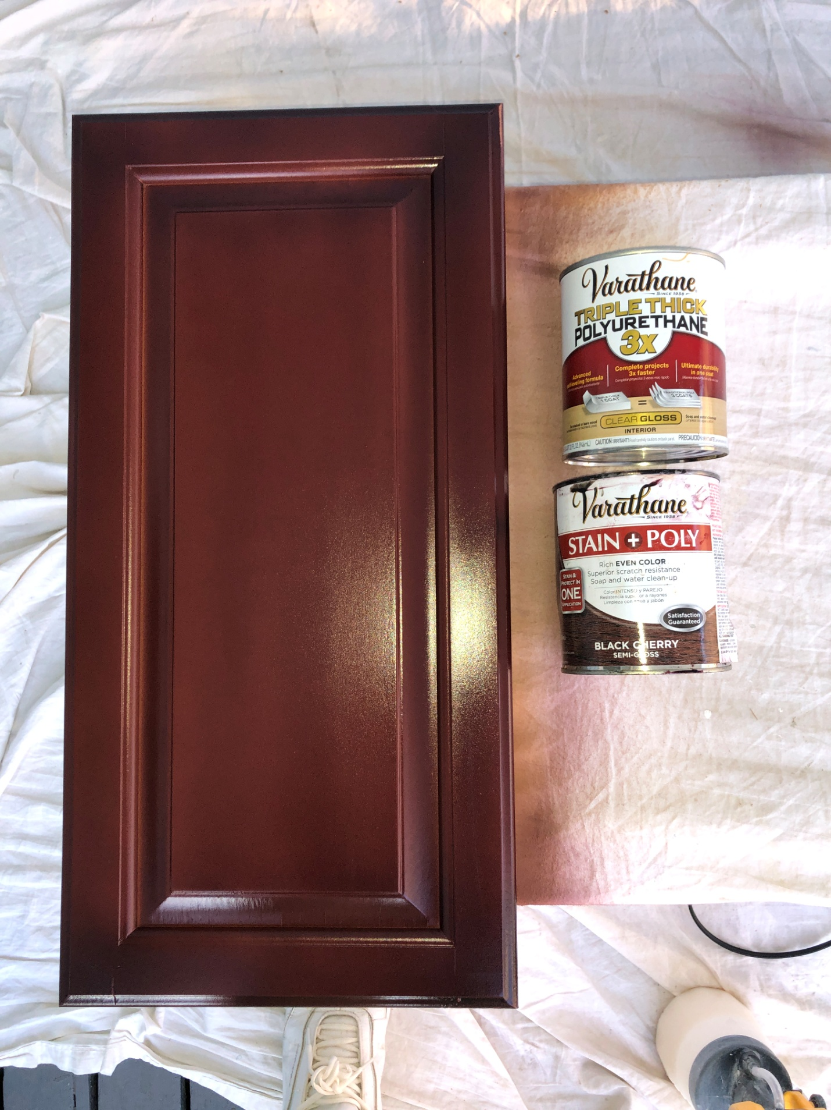

1 Coat Special Clear 3 X Semi gloss
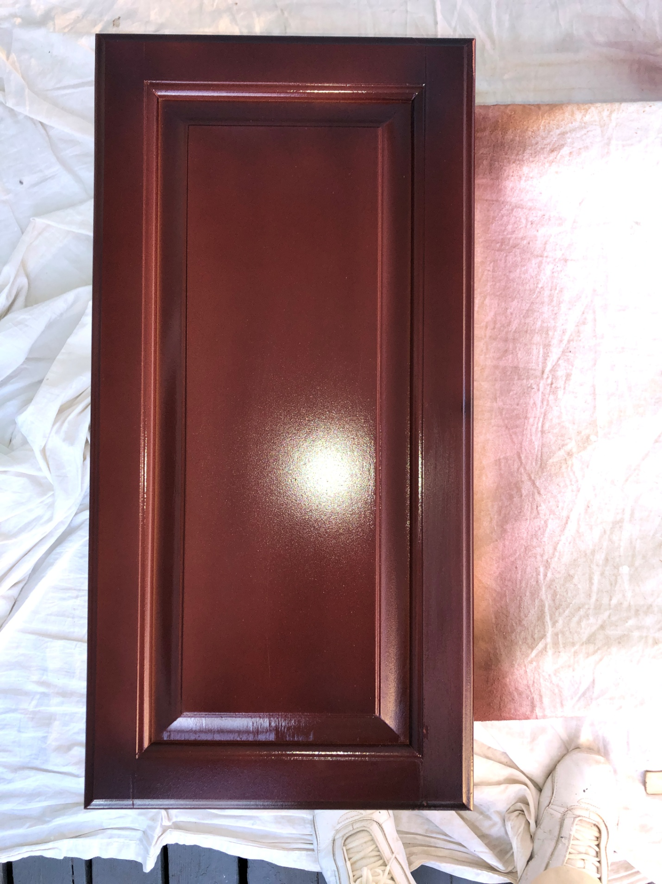

Second Coat Clear semi Gloss and Finish
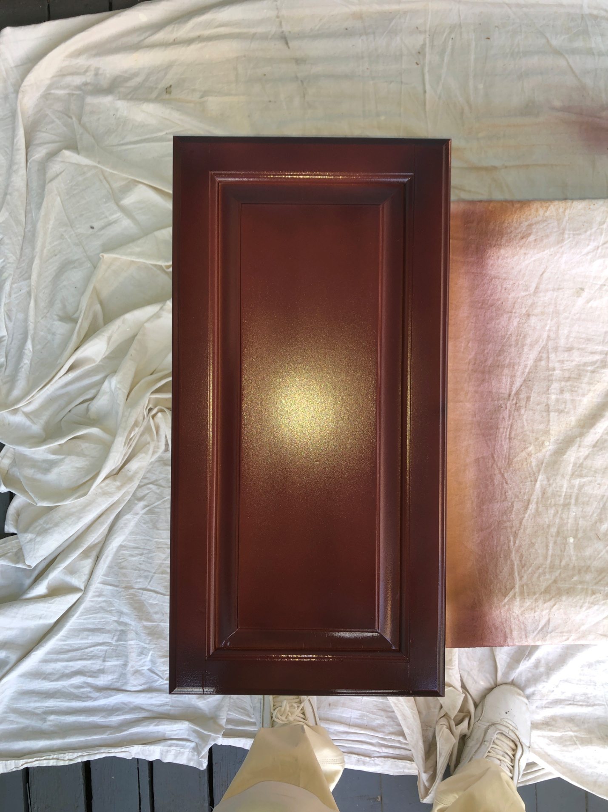

Painter; Wellington Bovenschulte
Cell; 7742795551
https://www.binaton.com/

