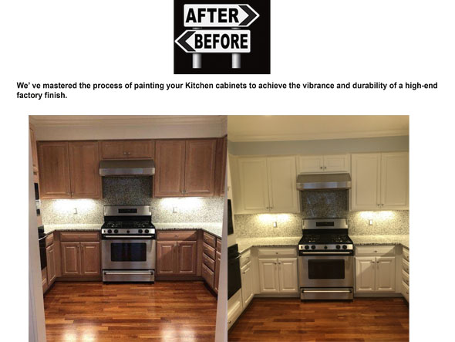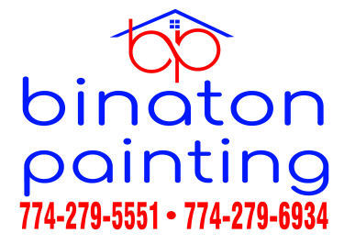
DON'T INCLUDE PAINTING INSIDE THE CABINET.
CABINETS:
COLOR SAME LIKE WITE DOORS 24UNIT
STYLE SMOOTH WOOD FOR SMOOTH DRAWERS 08 UNIT
COMPLETE JOB IN 2 WEEKS
We use only the highest quality materials.
” Thank you so much for trusting me . I do my best, taking care of your house as if it were mine. I take pleasure and love my job. “
Wellington B. Bovenschulte
Master Painter
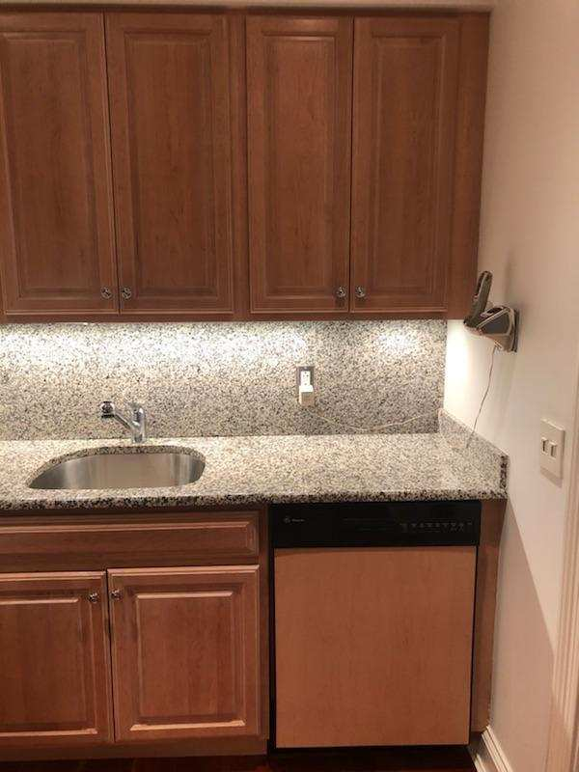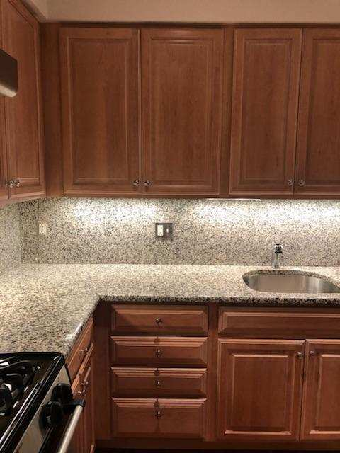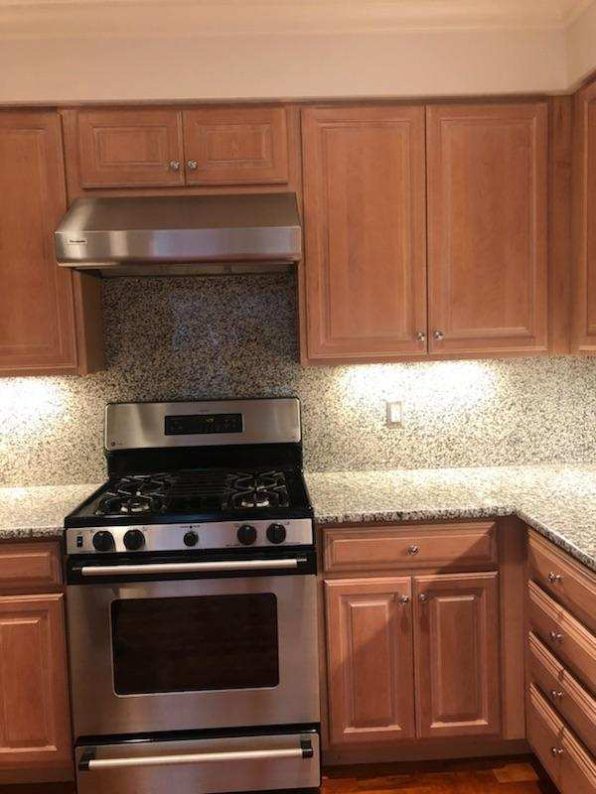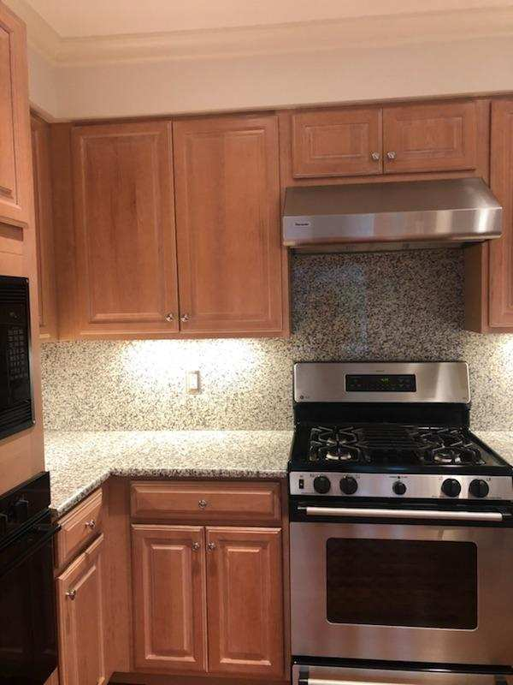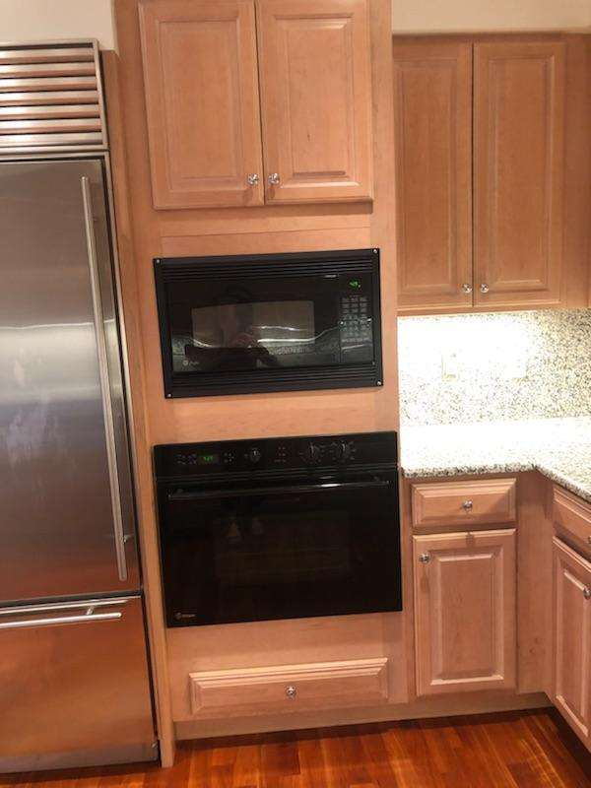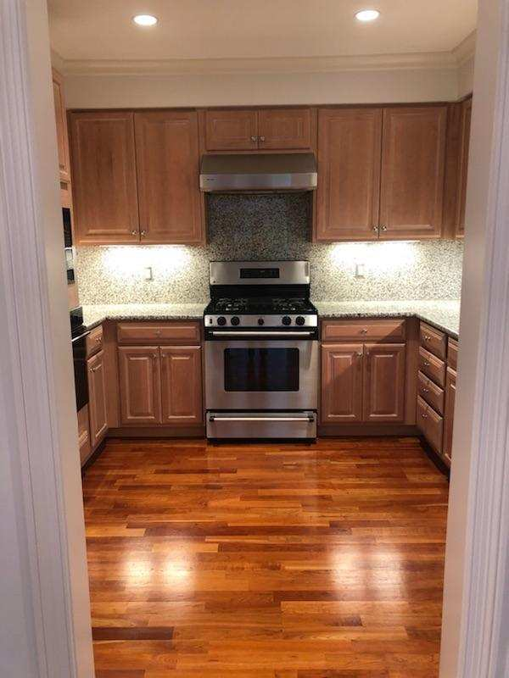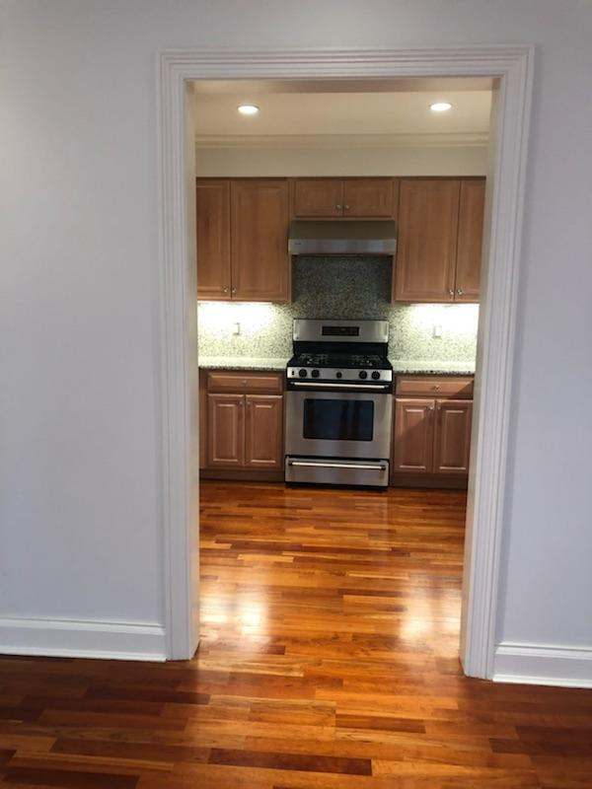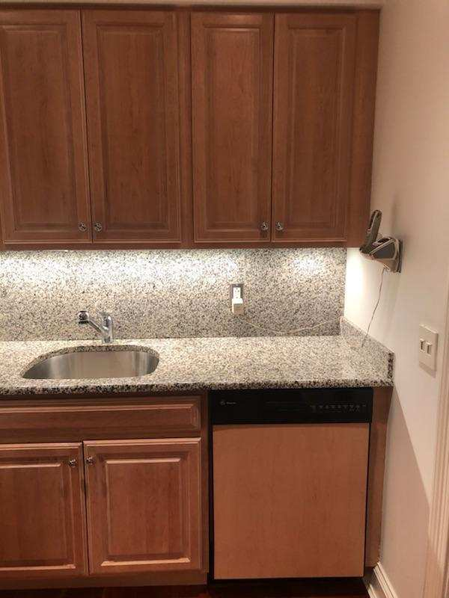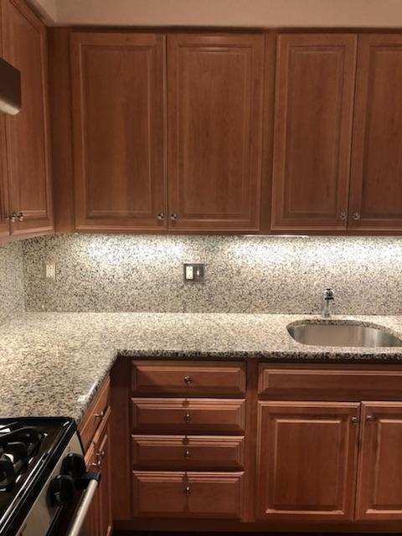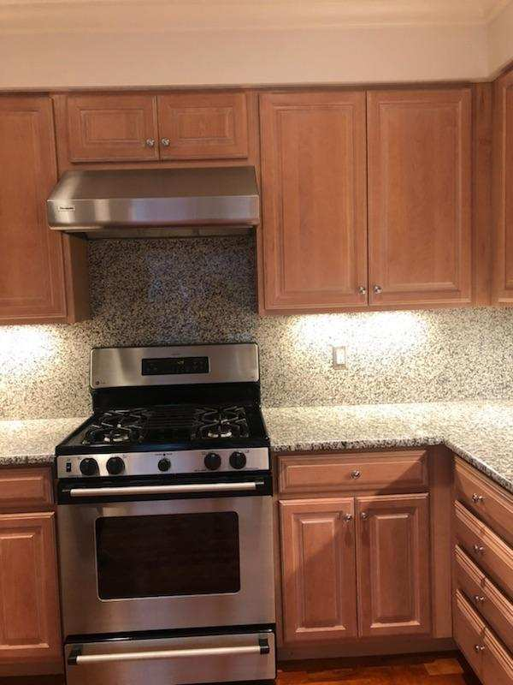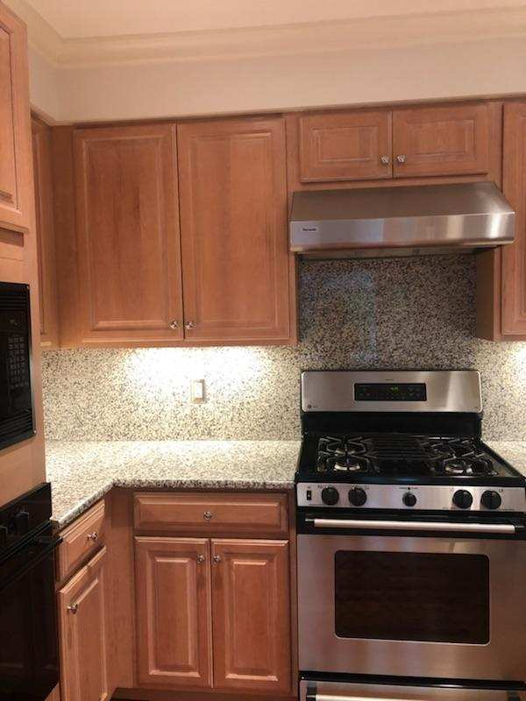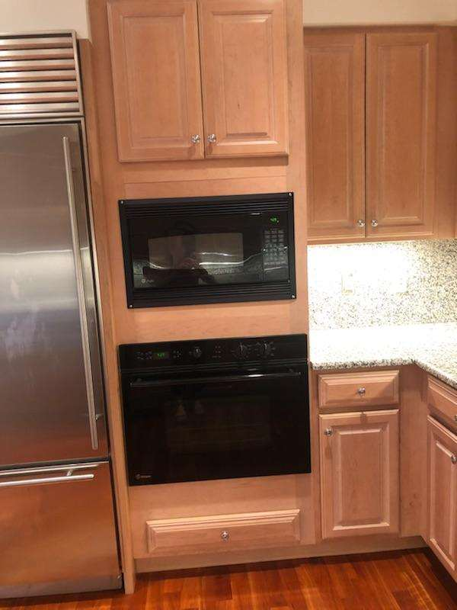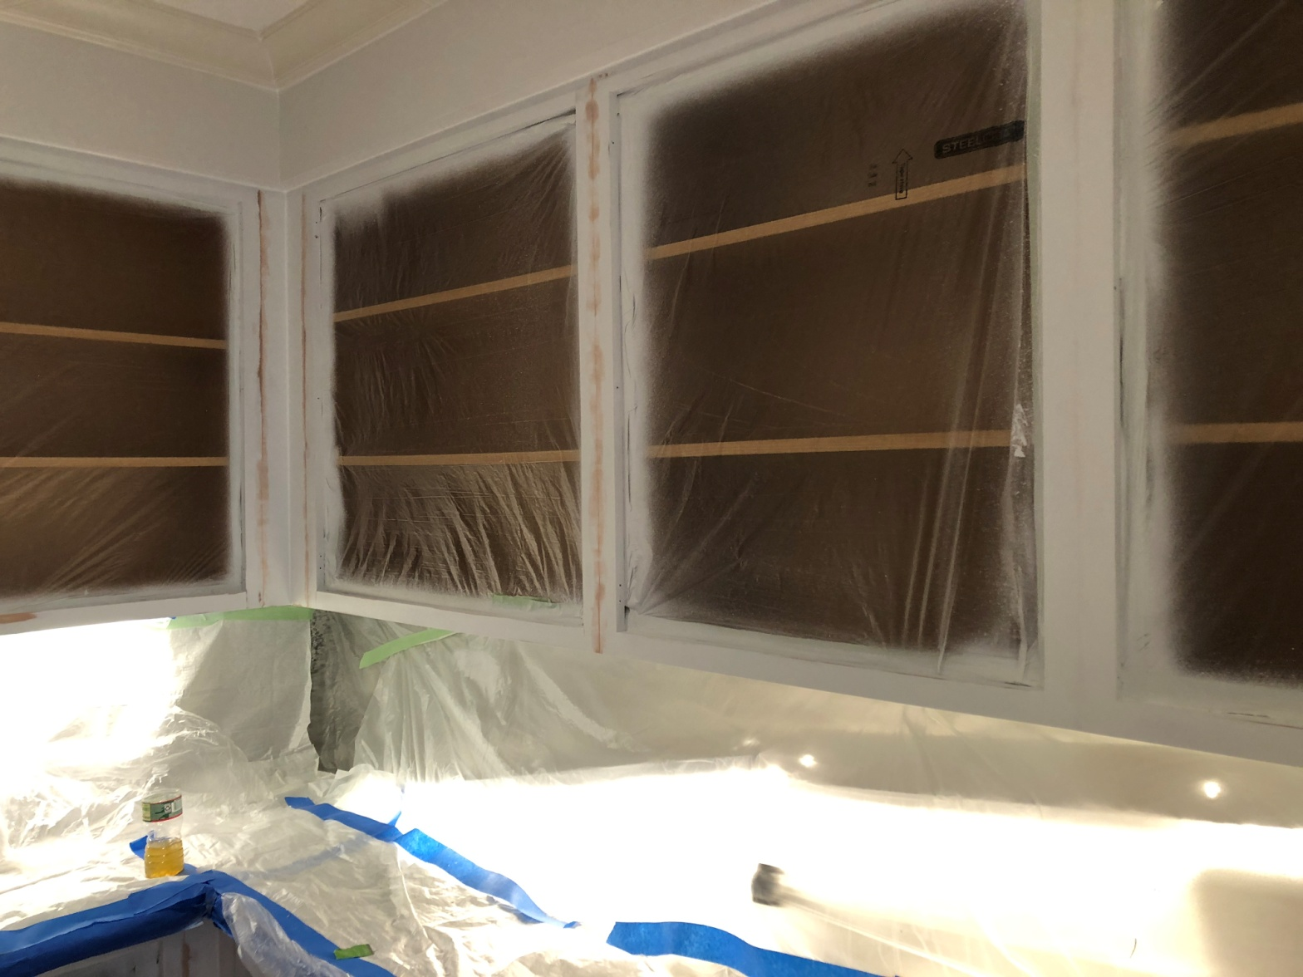
DON'T INCLUDE PAINTING INSIDE THE CABINET.
CABINETS:
COLOR SAME LIKE WITE DOORS 24UNIT
STYLE SMOOTH WOOD FOR SMOOTH DRAWERS 08 UNIT
COMPLETE JOB IN 2 WEEKS
We use only the highest quality materials.
” Thank you so much for trusting me . I do my best, taking care of your house as if it were mine. I take pleasure and love my job. “
Wellington B. Bovenschulte
Master Painter
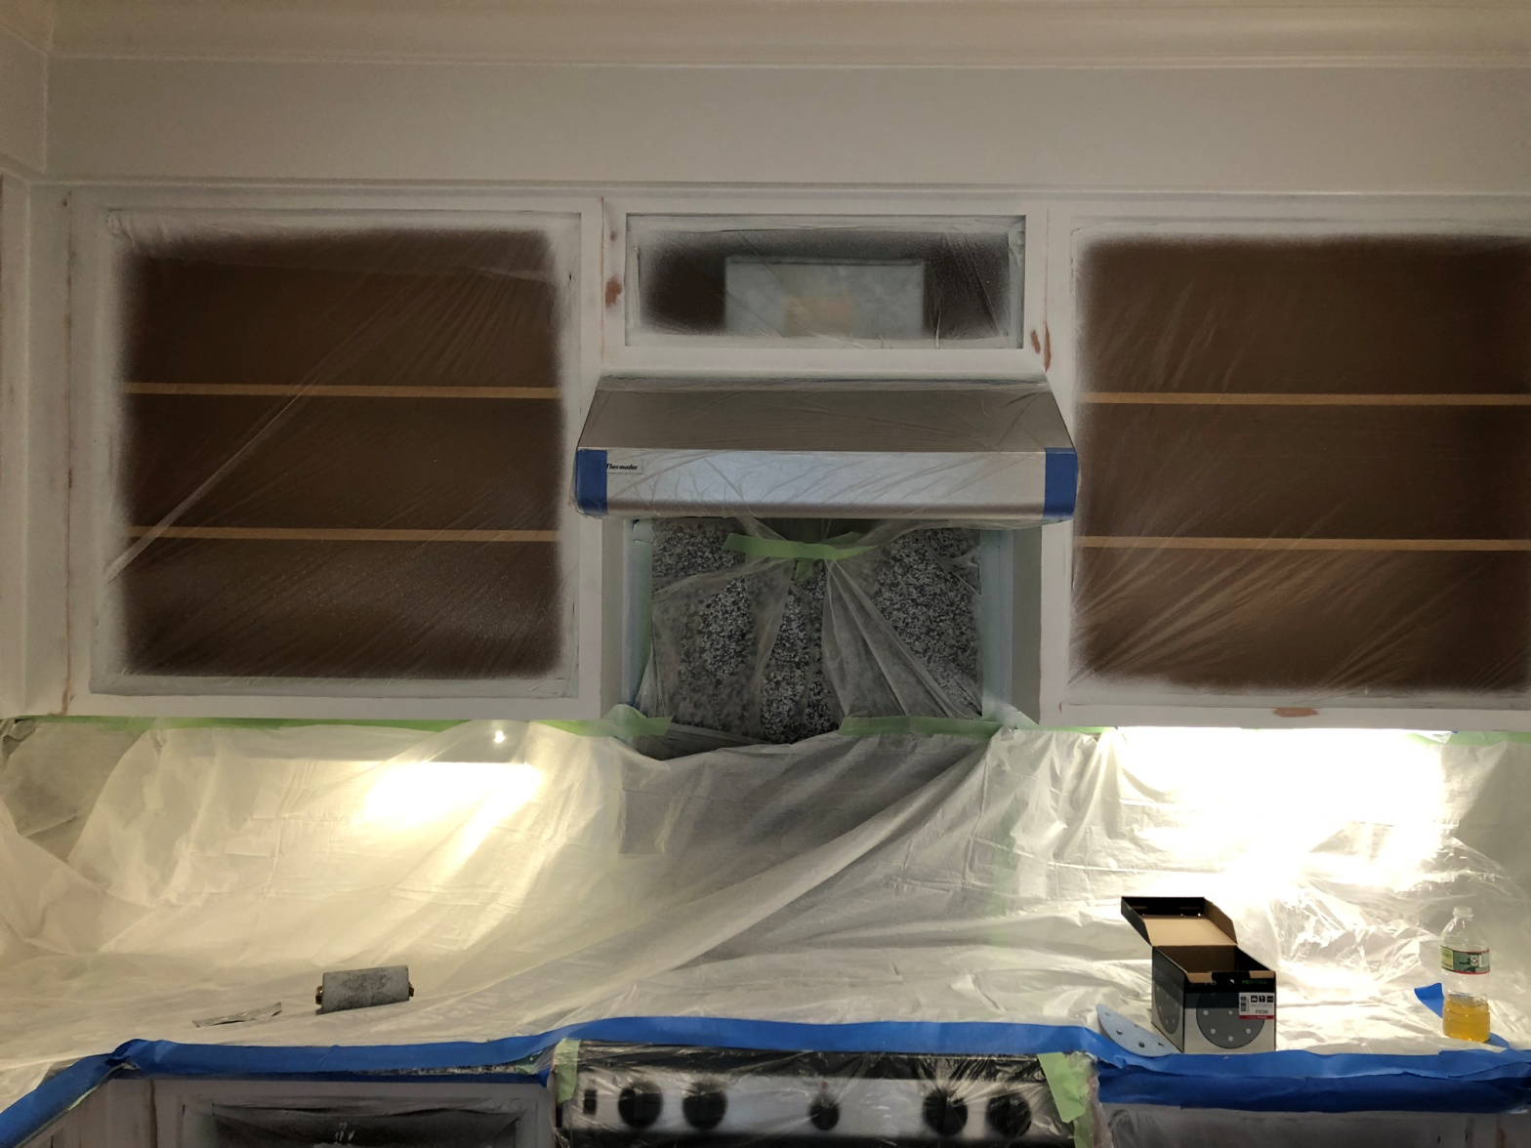
DON'T INCLUDE PAINTING INSIDE THE CABINET.
CABINETS:
COLOR SAME LIKE WITE DOORS 24UNIT
STYLE SMOOTH WOOD FOR SMOOTH DRAWERS 08 UNIT
COMPLETE JOB IN 2 WEEKS
We use only the highest quality materials.
” Thank you so much for trusting me . I do my best, taking care of your house as if it were mine. I take pleasure and love my job. “
Wellington B. Bovenschulte
Master Painter
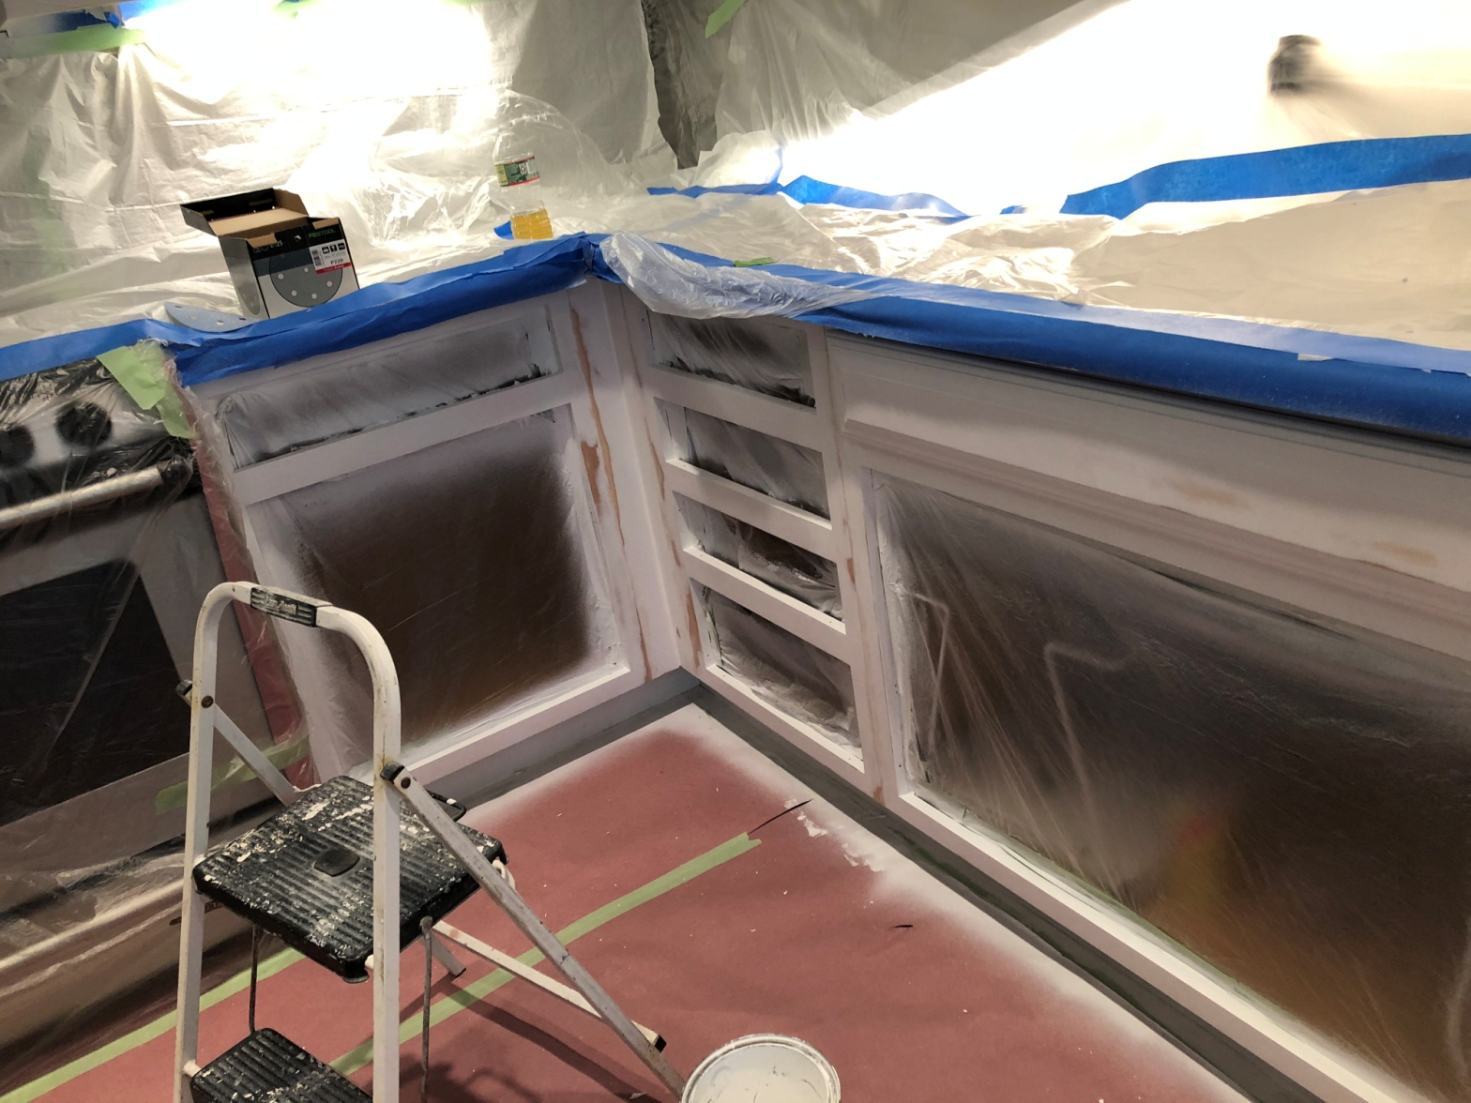
DON'T INCLUDE PAINTING INSIDE THE CABINET.
CABINETS:
COLOR SAME LIKE WITE DOORS 24UNIT
STYLE SMOOTH WOOD FOR SMOOTH DRAWERS 08 UNIT
COMPLETE JOB IN 2 WEEKS
We use only the highest quality materials.
” Thank you so much for trusting me . I do my best, taking care of your house as if it were mine. I take pleasure and love my job. “
Wellington B. Bovenschulte
Master Painter
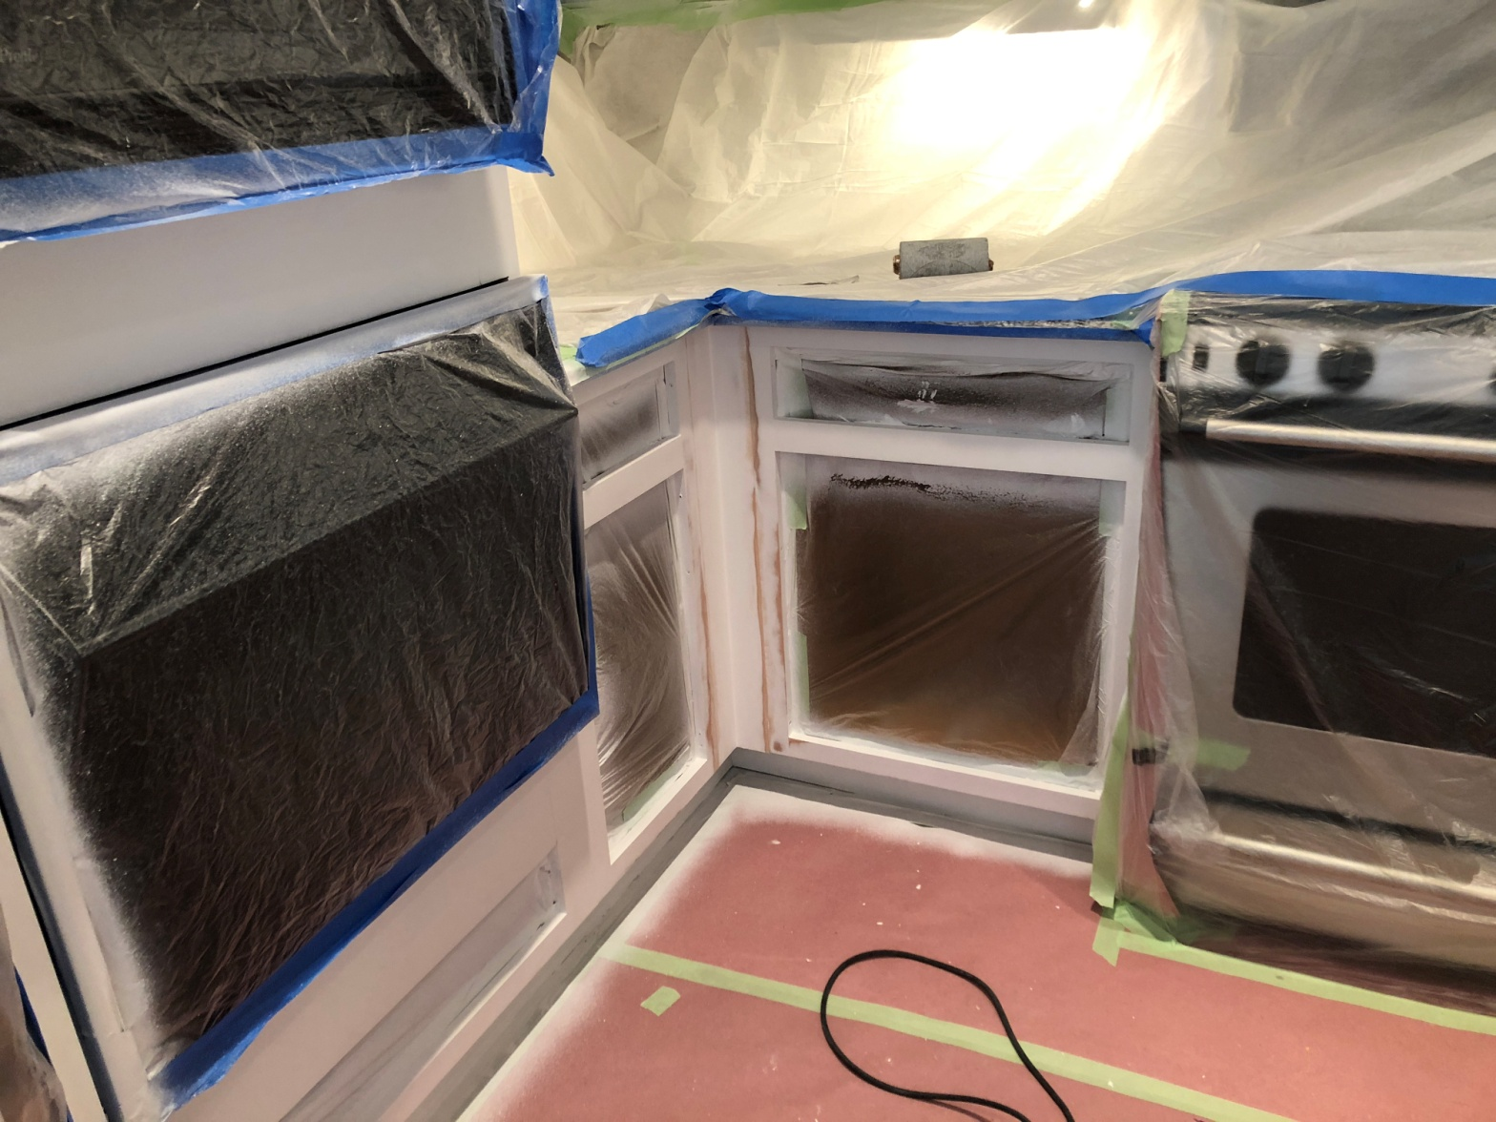
DON'T INCLUDE PAINTING INSIDE THE CABINET.
CABINETS:
COLOR SAME LIKE WITE DOORS 24UNIT
STYLE SMOOTH WOOD FOR SMOOTH DRAWERS 08 UNIT
COMPLETE JOB IN 2 WEEKS
We use only the highest quality materials.
” Thank you so much for trusting me . I do my best, taking care of your house as if it were mine. I take pleasure and love my job. “
Wellington B. Bovenschulte
Master Painter
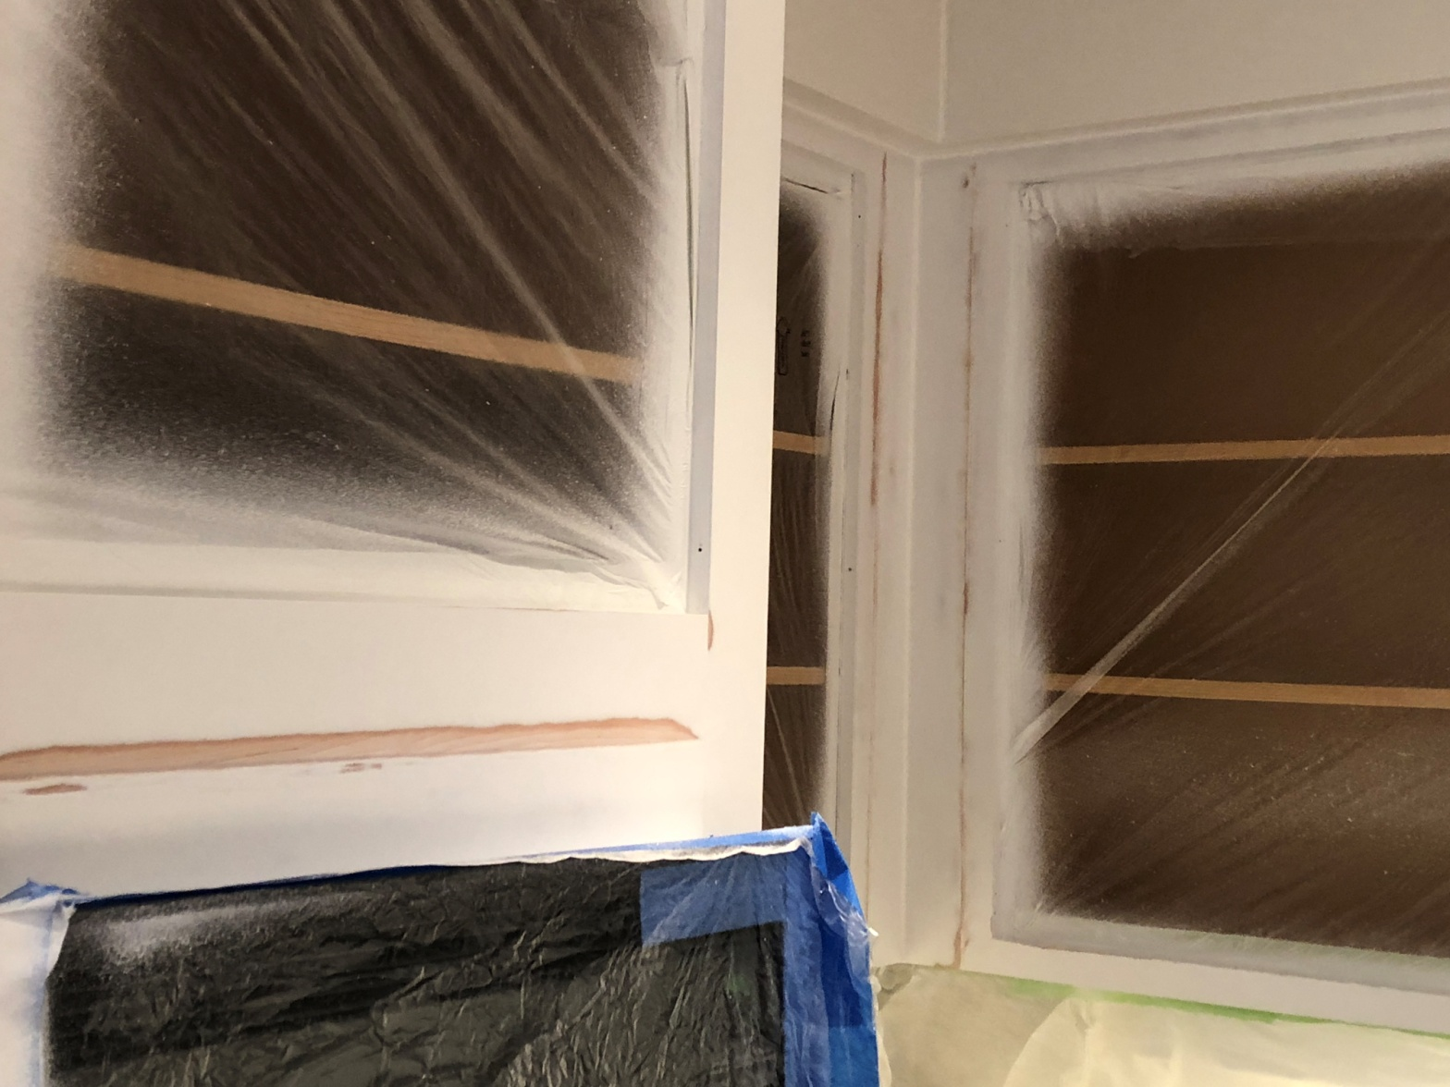
DON'T INCLUDE PAINTING INSIDE THE CABINET.
CABINETS:
COLOR SAME LIKE WITE DOORS 24UNIT
STYLE SMOOTH WOOD FOR SMOOTH DRAWERS 08 UNIT
COMPLETE JOB IN 2 WEEKS
We use only the highest quality materials.
” Thank you so much for trusting me . I do my best, taking care of your house as if it were mine. I take pleasure and love my job. “
Wellington B. Bovenschulte
Master Painter
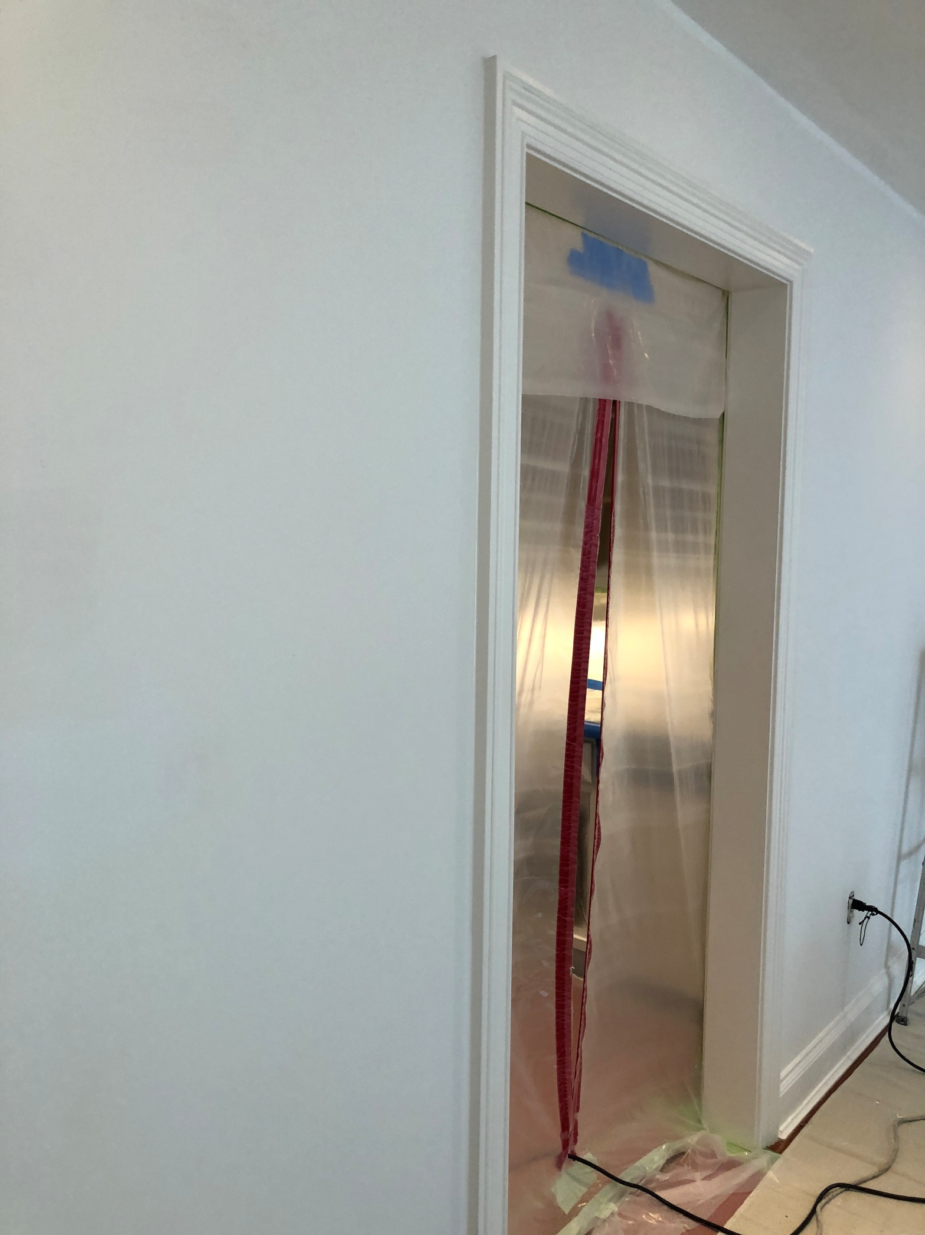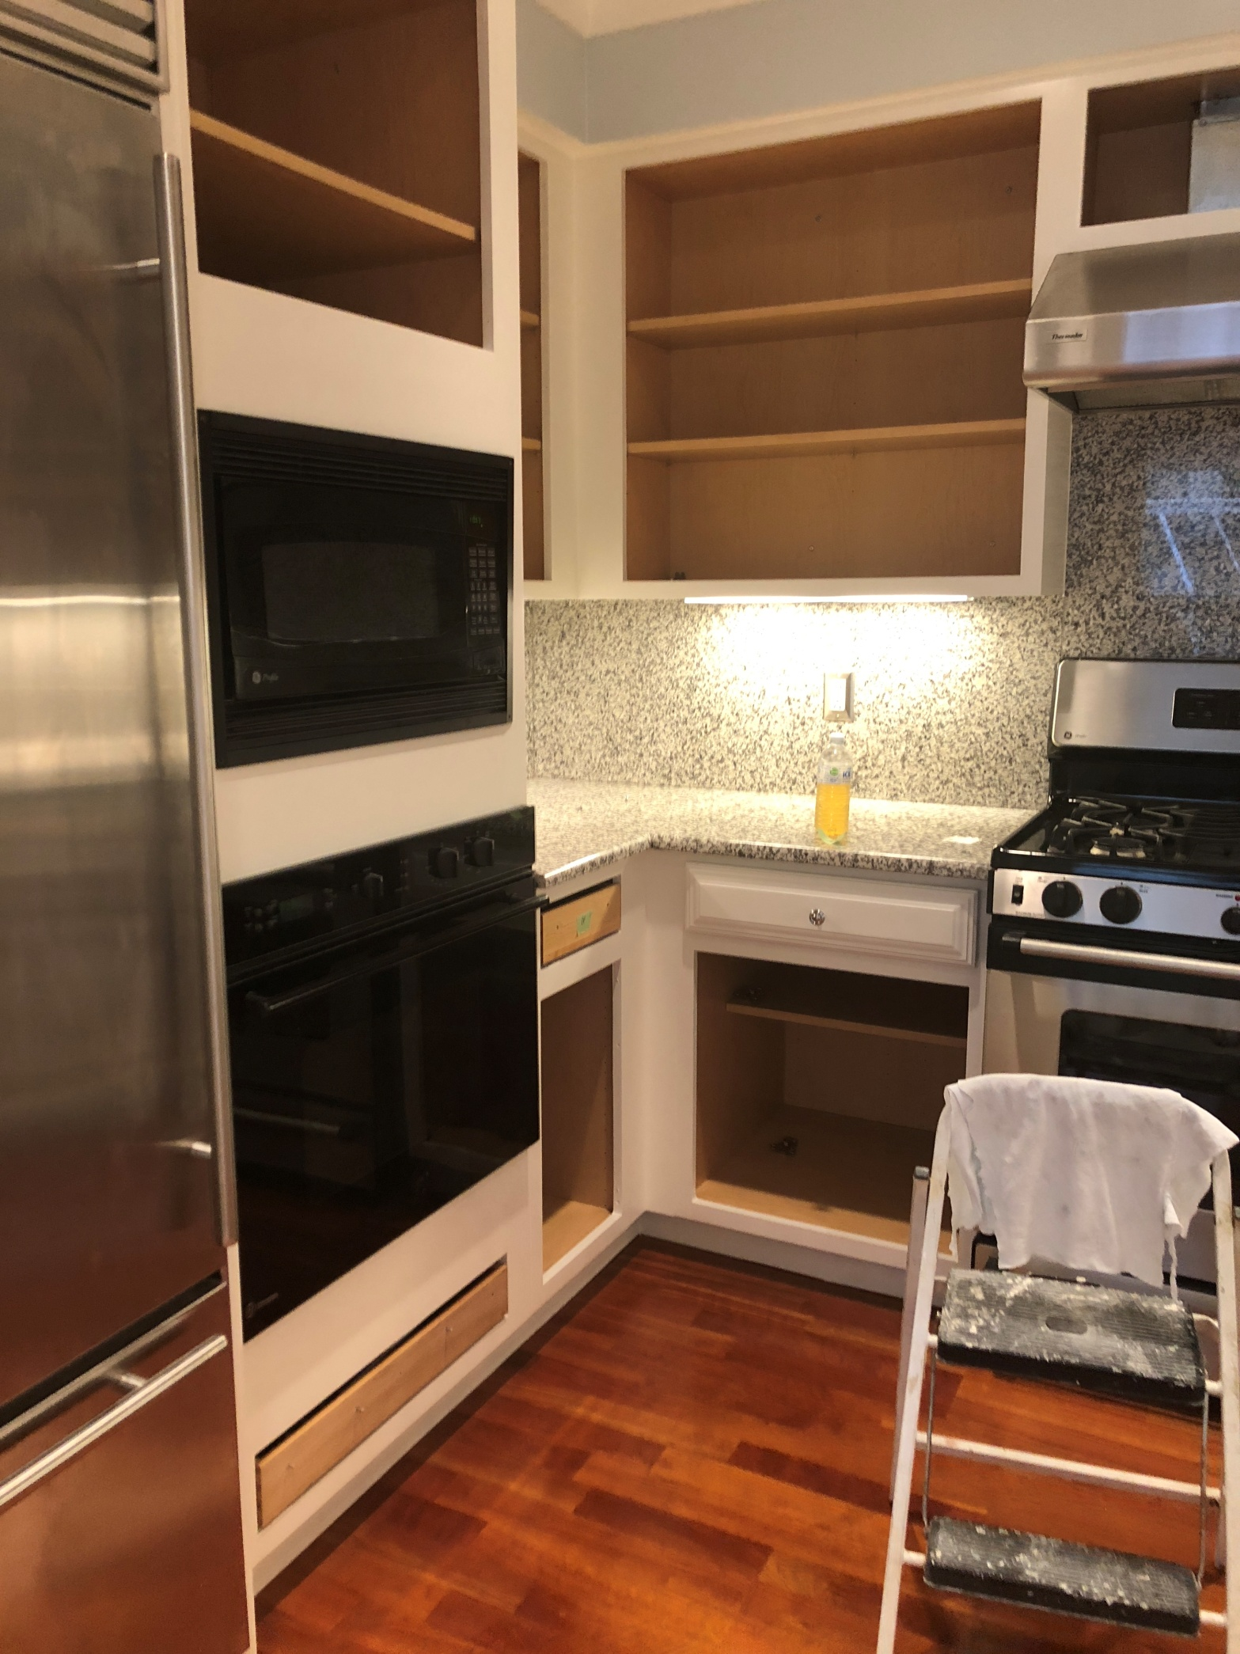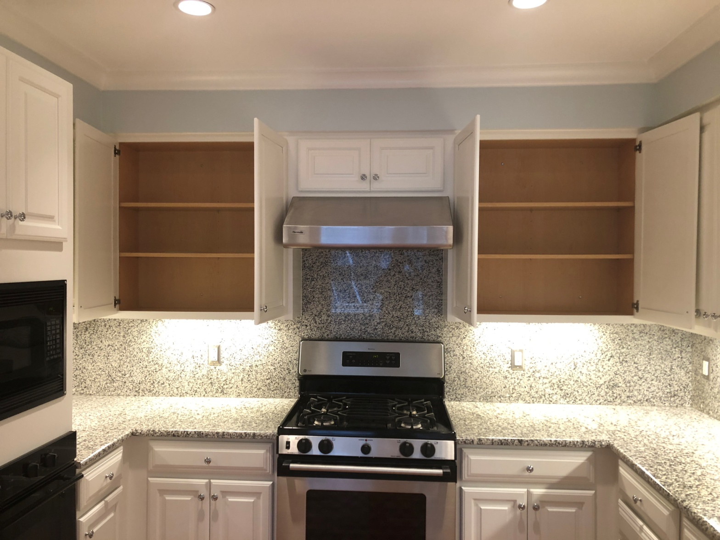
DON'T INCLUDE PAINTING INSIDE THE CABINET.
CABINETS:
COLOR SAME LIKE WITE DOORS 24UNIT
STYLE SMOOTH WOOD FOR SMOOTH DRAWERS 08 UNIT
COMPLETE JOB IN 2 WEEKS
We use only the highest quality materials.
” Thank you so much for trusting me . I do my best, taking care of your house as if it were mine. I take pleasure and love my job. “
Wellington B. Bovenschulte
Master Painter
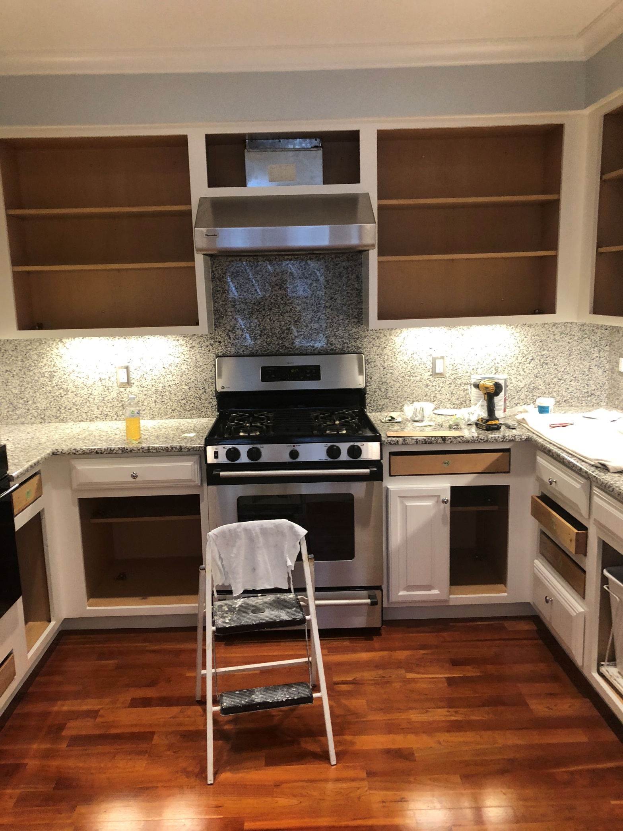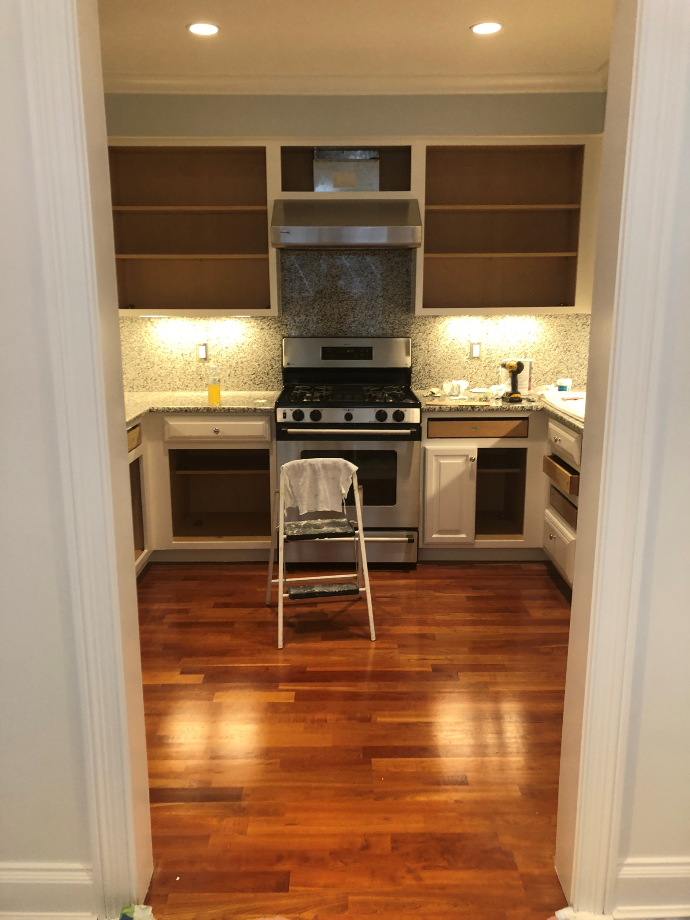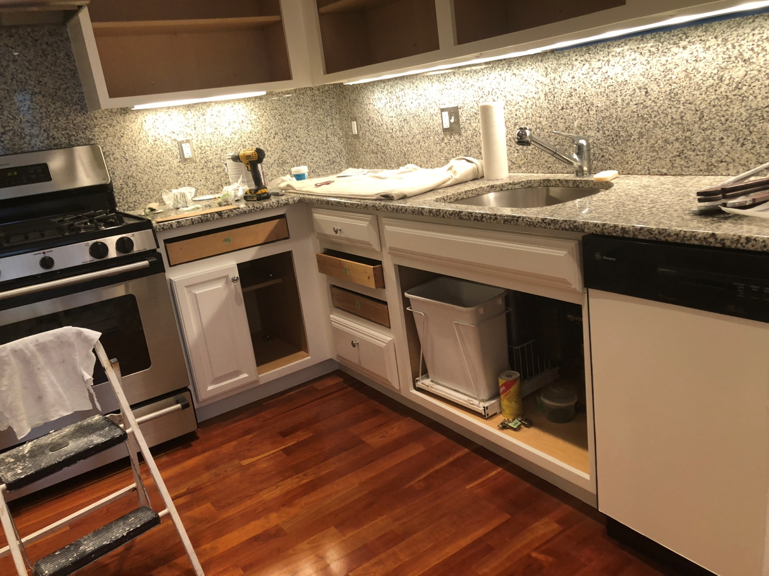
DON'T INCLUDE PAINTING INSIDE THE CABINET.
CABINETS:
COLOR SAME LIKE WITE DOORS 24UNIT
STYLE SMOOTH WOOD FOR SMOOTH DRAWERS 08 UNIT
COMPLETE JOB IN 2 WEEKS
We use only the highest quality materials.
” Thank you so much for trusting me . I do my best, taking care of your house as if it were mine. I take pleasure and love my job. “
Wellington B. Bovenschulte
Master Painter
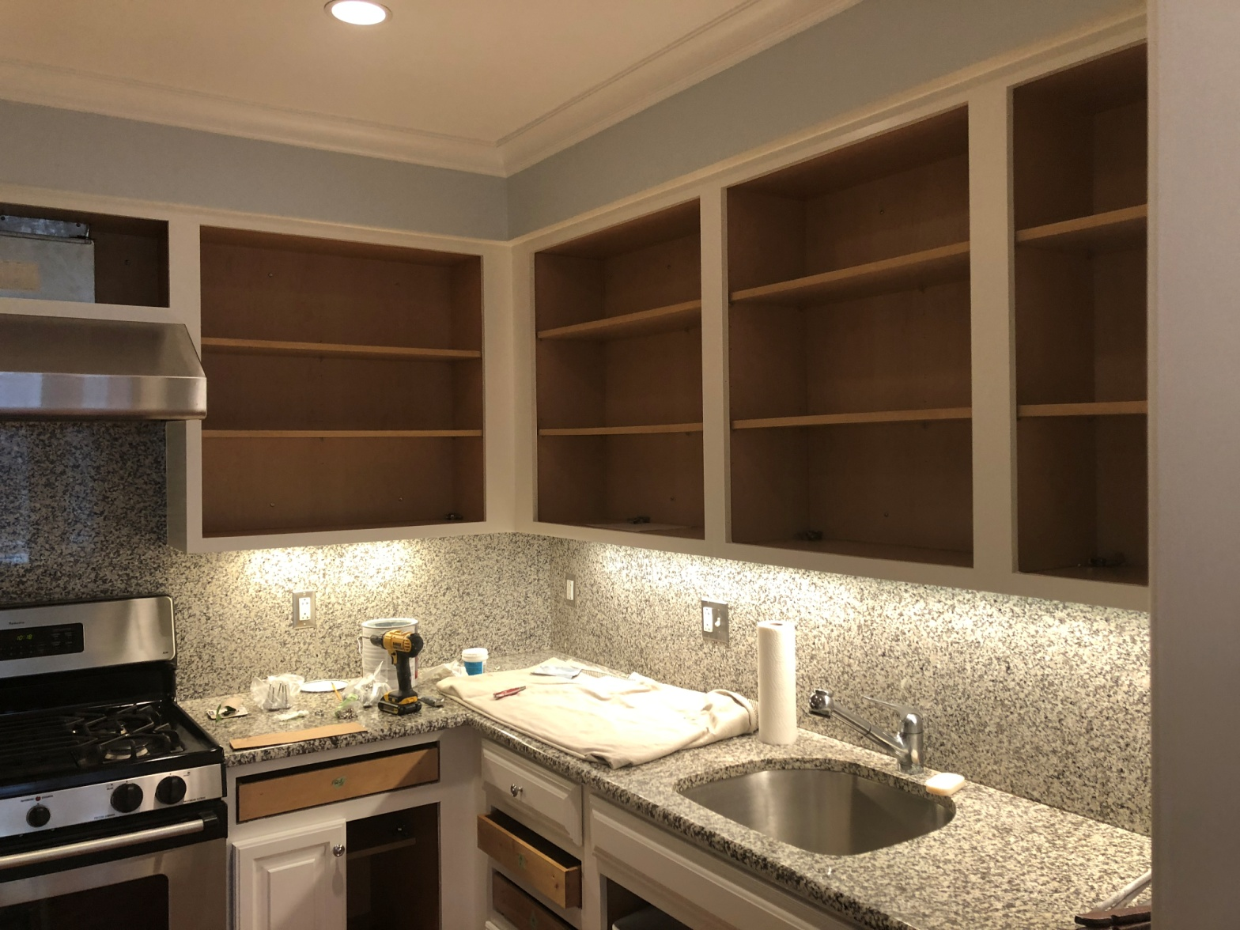
DON'T INCLUDE PAINTING INSIDE THE CABINET.
CABINETS:
COLOR SAME LIKE WITE DOORS 24UNIT
STYLE SMOOTH WOOD FOR SMOOTH DRAWERS 08 UNIT
COMPLETE JOB IN 2 WEEKS
We use only the highest quality materials.
” Thank you so much for trusting me . I do my best, taking care of your house as if it were mine. I take pleasure and love my job. “
Wellington B. Bovenschulte
Master Painter
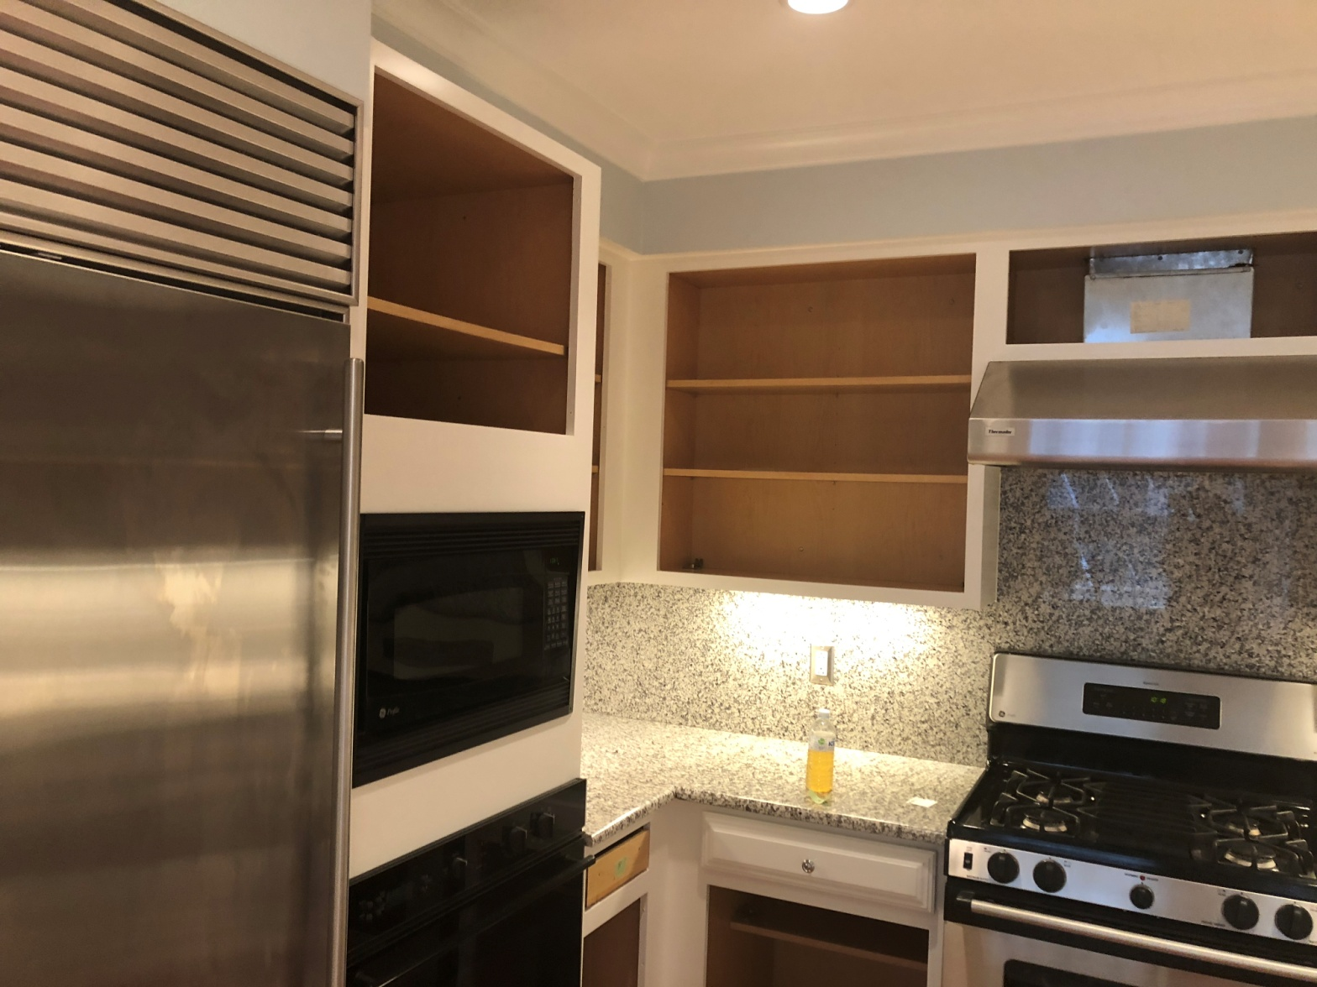
DON'T INCLUDE PAINTING INSIDE THE CABINET.
CABINETS:
COLOR SAME LIKE WITE DOORS 24UNIT
STYLE SMOOTH WOOD FOR SMOOTH DRAWERS 08 UNIT
COMPLETE JOB IN 2 WEEKS
We use only the highest quality materials.
” Thank you so much for trusting me . I do my best, taking care of your house as if it were mine. I take pleasure and love my job. “
Wellington B. Bovenschulte
Master Painter
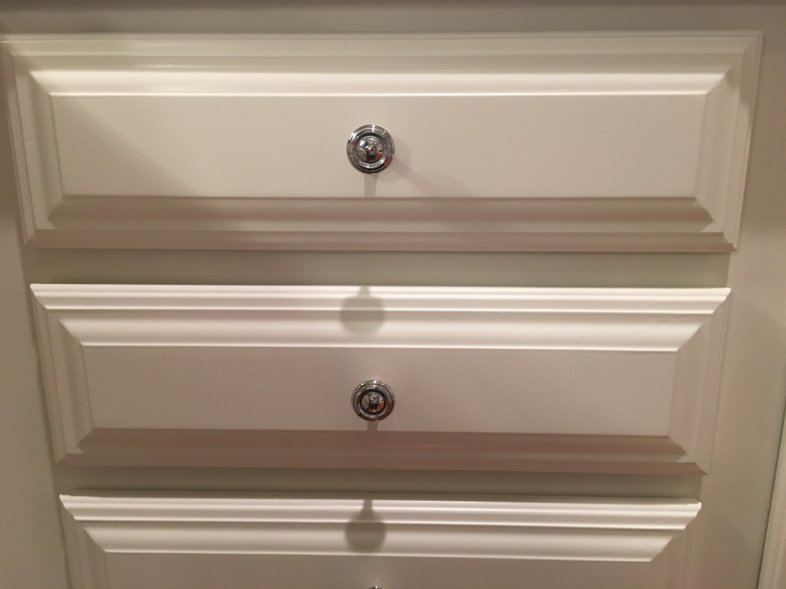
DON'T INCLUDE PAINTING INSIDE THE CABINET.
CABINETS:
COLOR SAME LIKE WITE DOORS 24UNIT
STYLE SMOOTH WOOD FOR SMOOTH DRAWERS 08 UNIT
COMPLETE JOB IN 2 WEEKS
We use only the highest quality materials.
” Thank you so much for trusting me . I do my best, taking care of your house as if it were mine. I take pleasure and love my job. “
Wellington B. Bovenschulte
Master Painter
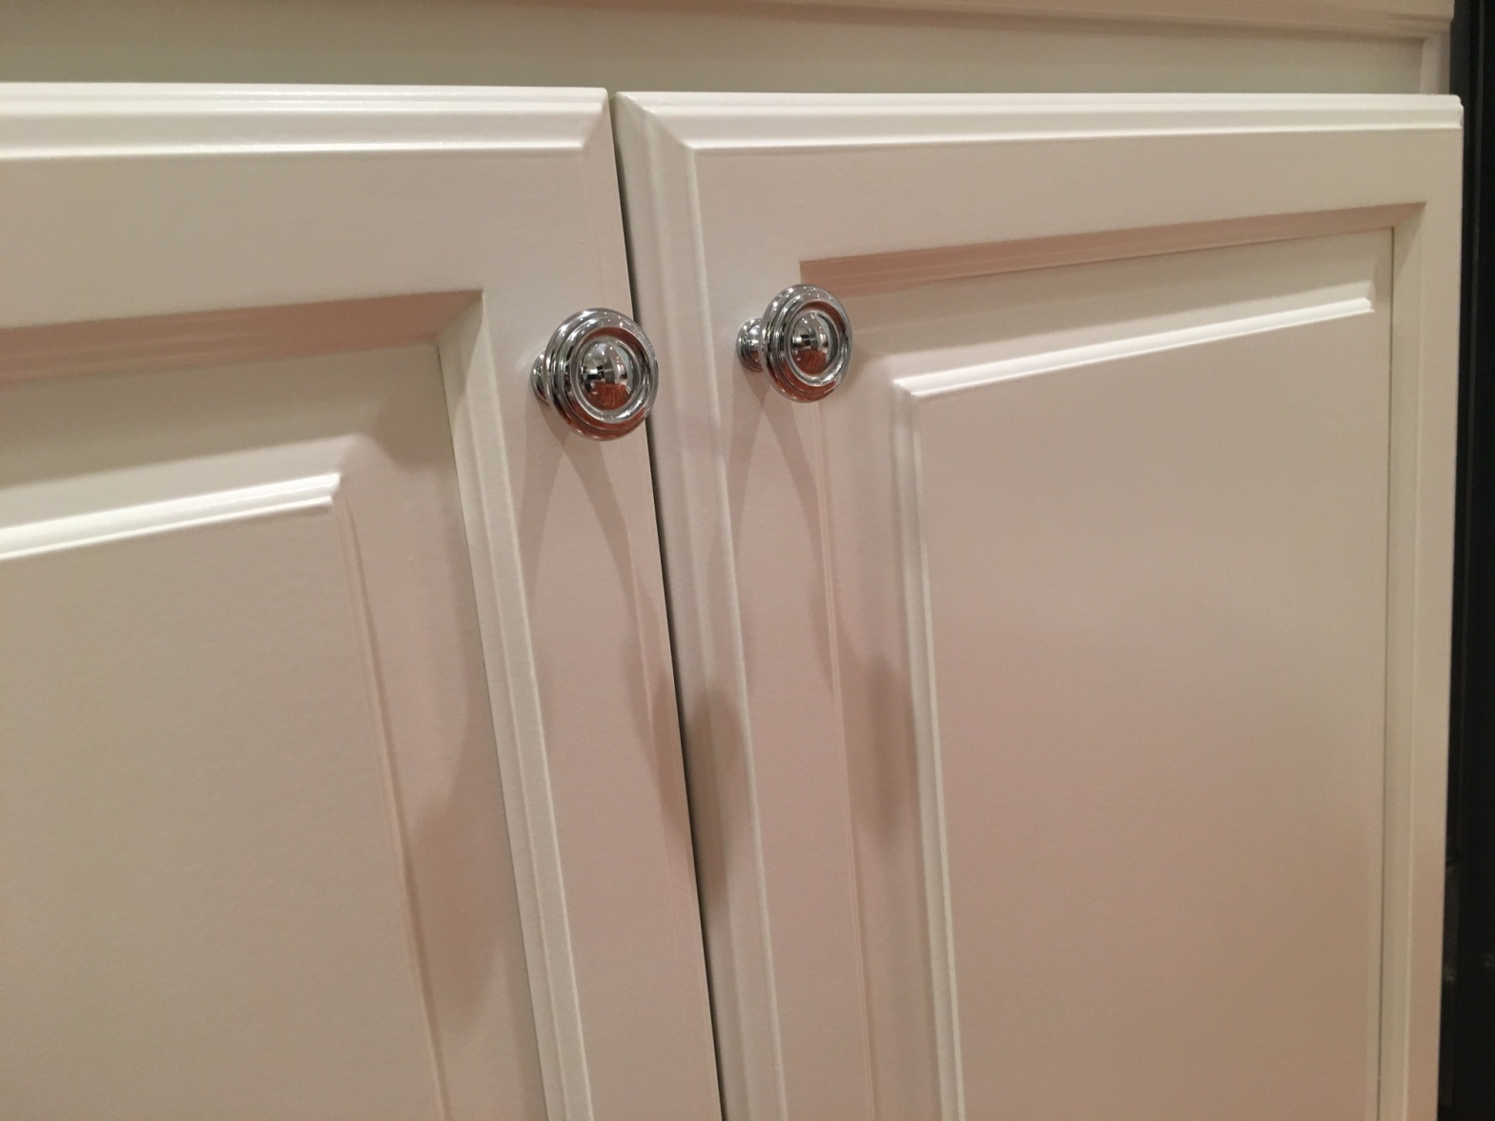
DON'T INCLUDE PAINTING INSIDE THE CABINET.
CABINETS:
COLOR SAME LIKE WITE DOORS 24UNIT
STYLE SMOOTH WOOD FOR SMOOTH DRAWERS 08 UNIT
COMPLETE JOB IN 2 WEEKS
We use only the highest quality materials.
” Thank you so much for trusting me . I do my best, taking care of your house as if it were mine. I take pleasure and love my job. “
Wellington B. Bovenschulte
Master Painter
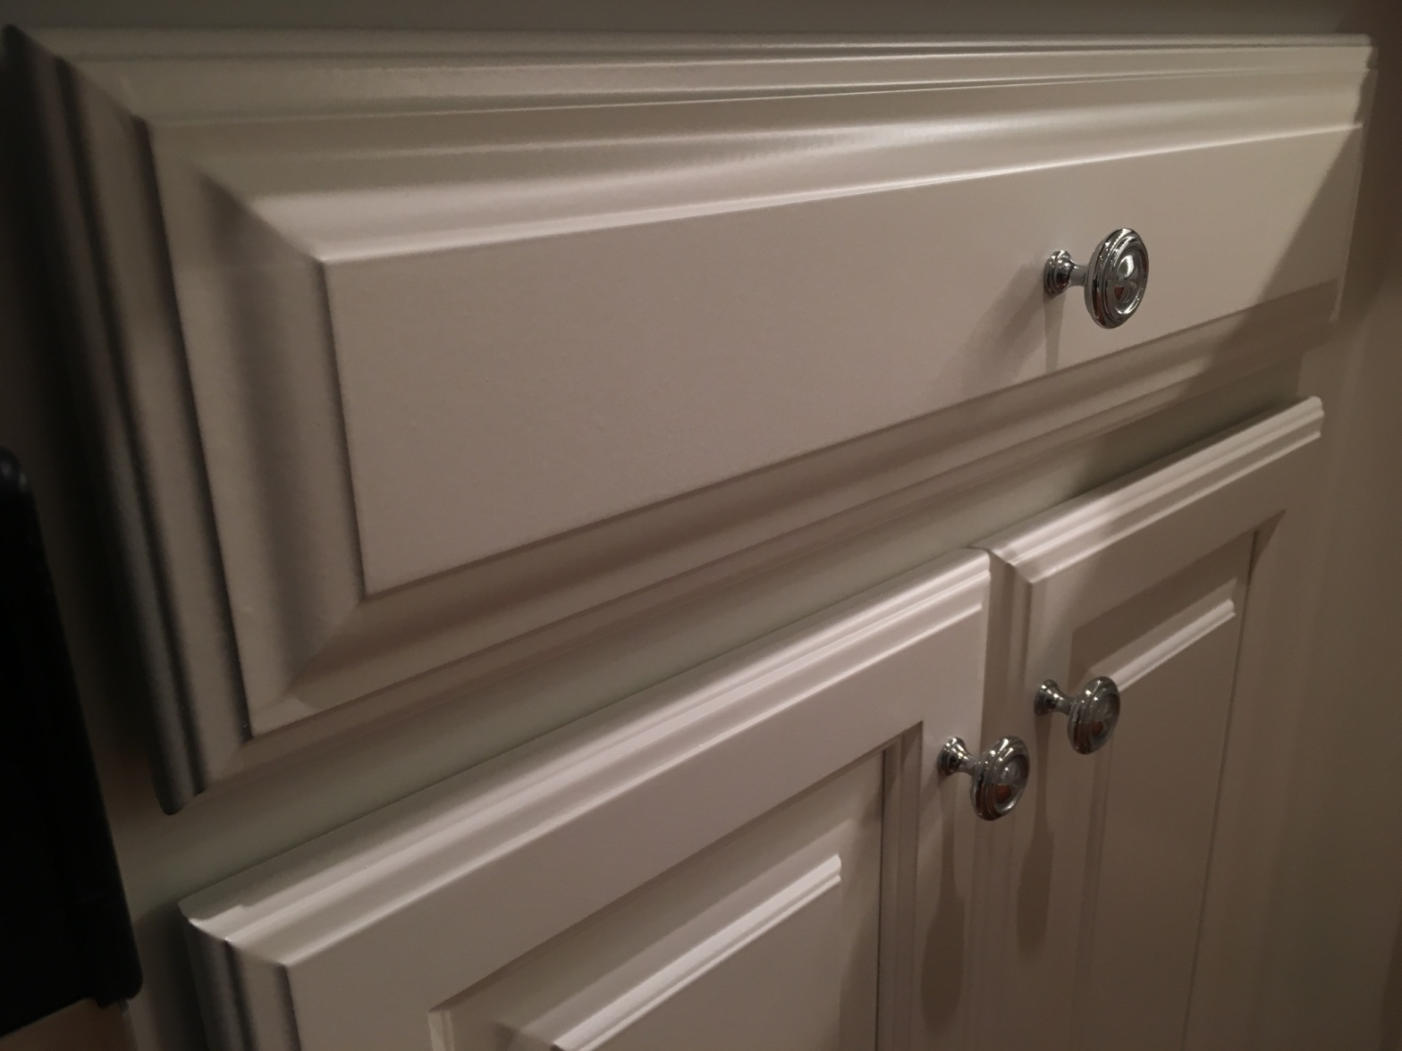
DON'T INCLUDE PAINTING INSIDE THE CABINET.
CABINETS:
COLOR SAME LIKE WITE DOORS 24UNIT
STYLE SMOOTH WOOD FOR SMOOTH DRAWERS 08 UNIT
COMPLETE JOB IN 2 WEEKS
We use only the highest quality materials.
” Thank you so much for trusting me . I do my best, taking care of your house as if it were mine. I take pleasure and love my job. “
Wellington B. Bovenschulte
Master Painter
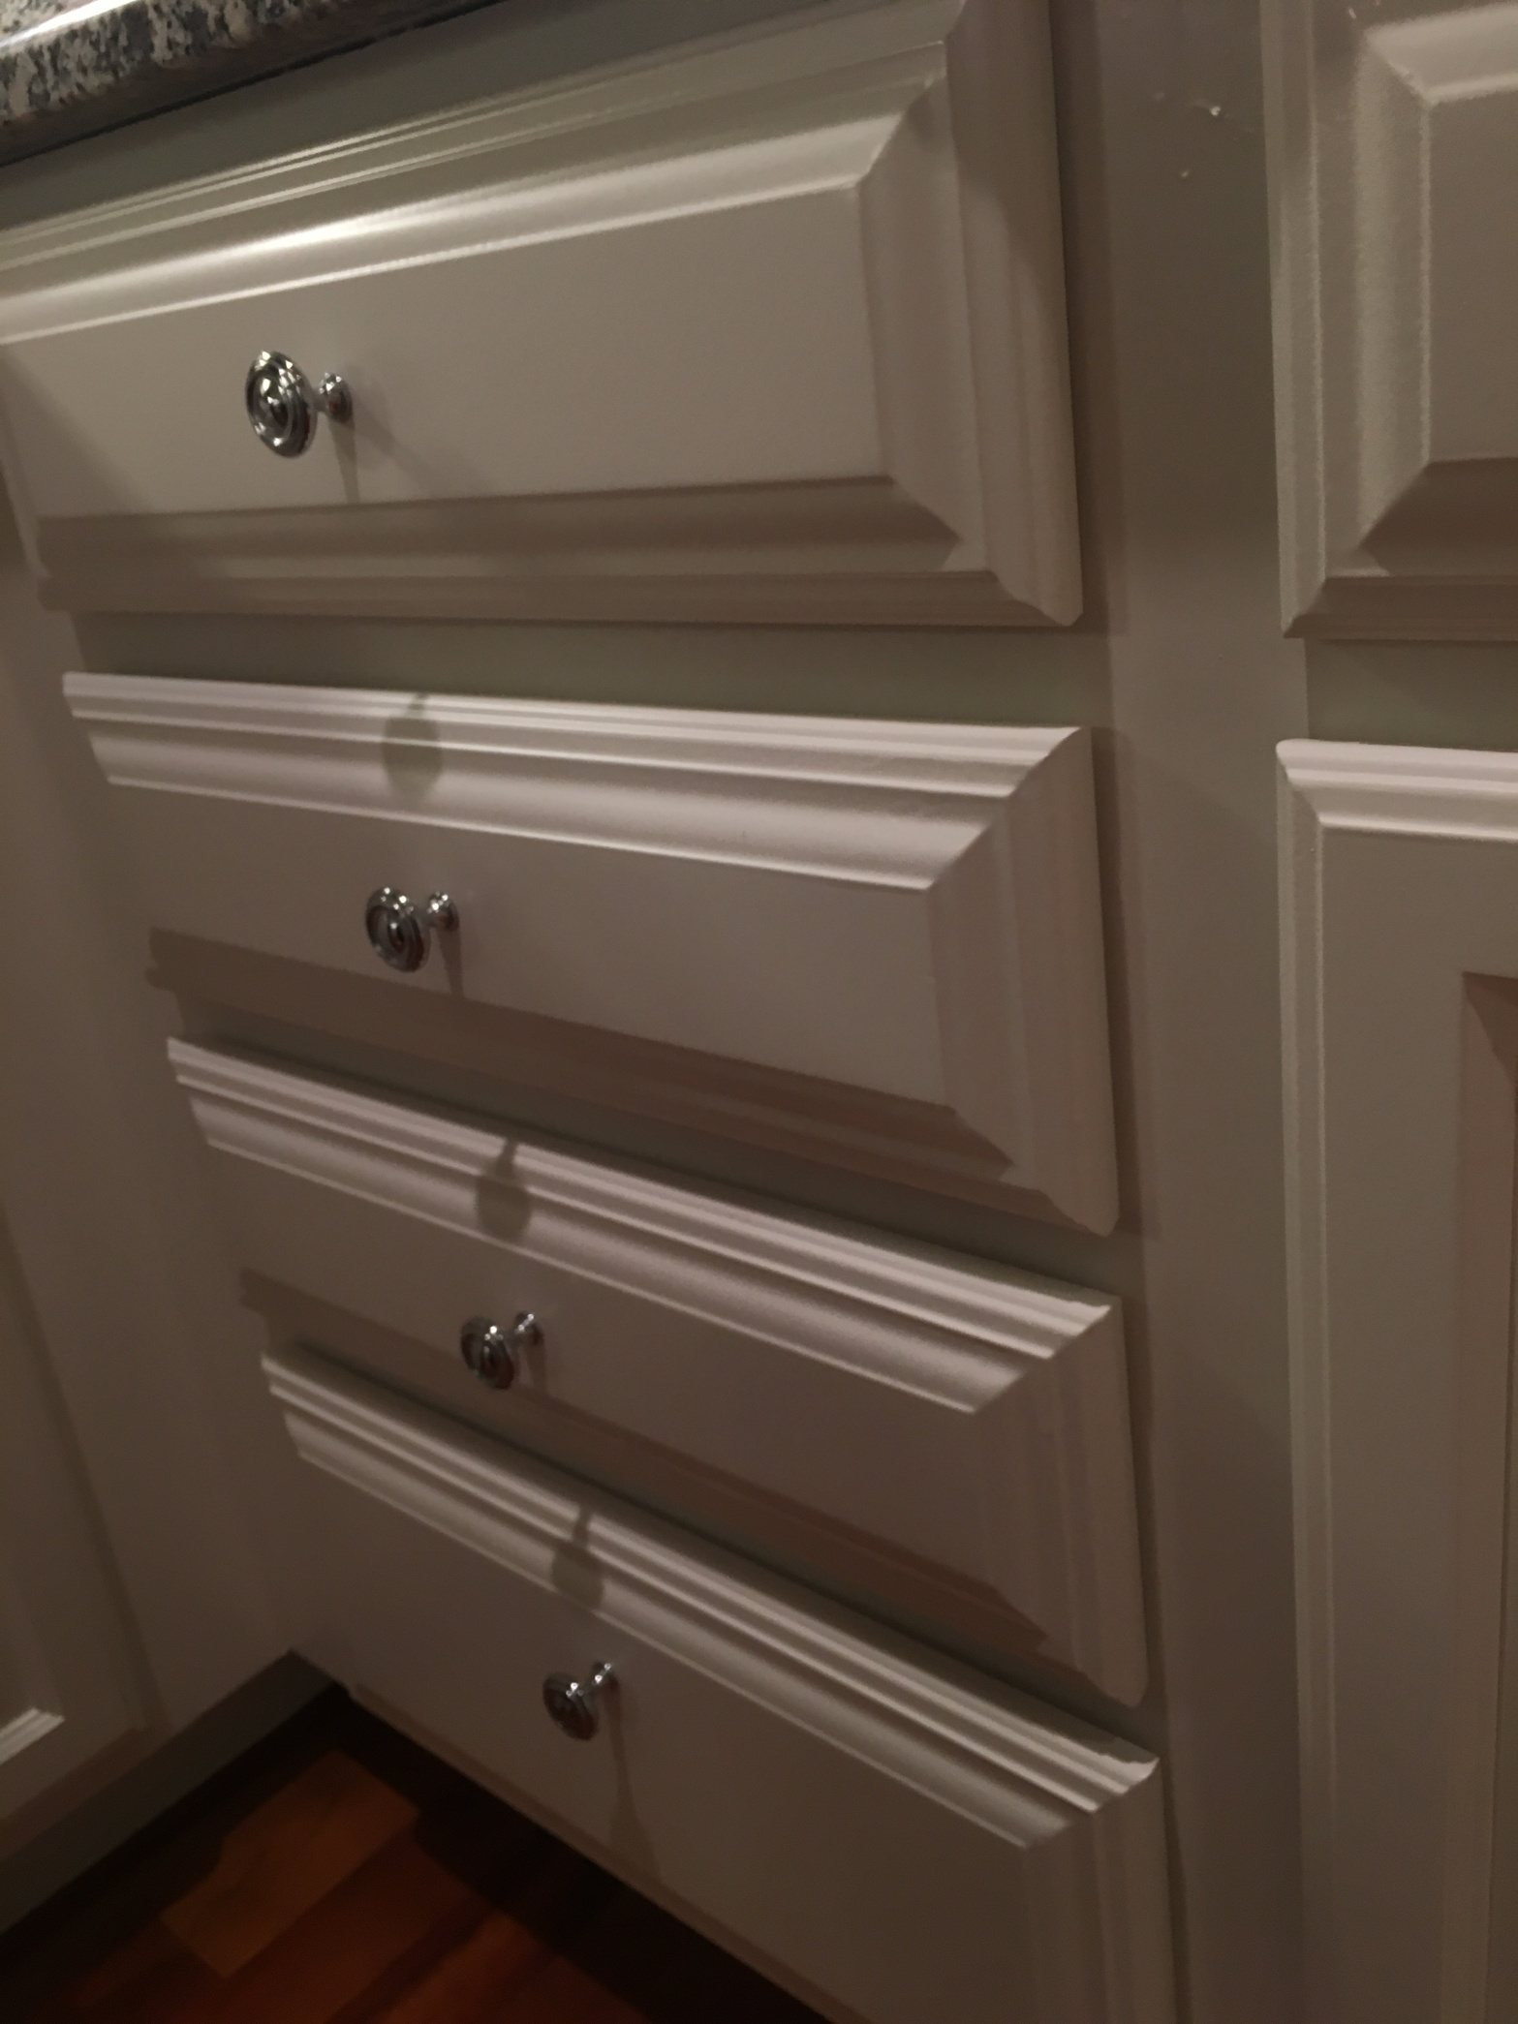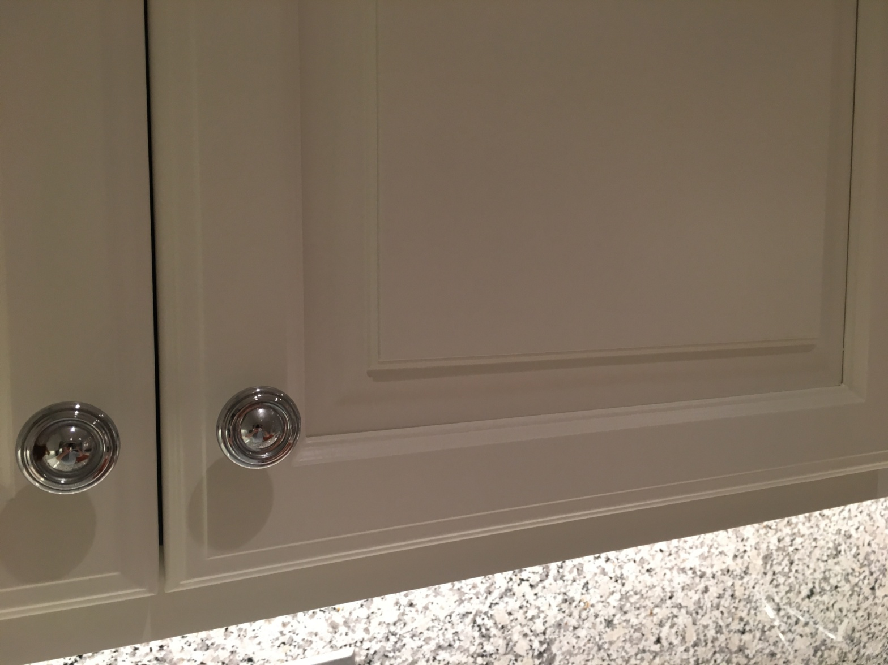
DON'T INCLUDE PAINTING INSIDE THE CABINET.
CABINETS:
COLOR SAME LIKE WITE DOORS 24UNIT
STYLE SMOOTH WOOD FOR SMOOTH DRAWERS 08 UNIT
COMPLETE JOB IN 2 WEEKS
We use only the highest quality materials.
” Thank you so much for trusting me . I do my best, taking care of your house as if it were mine. I take pleasure and love my job. “
Wellington B. Bovenschulte
Master Painter
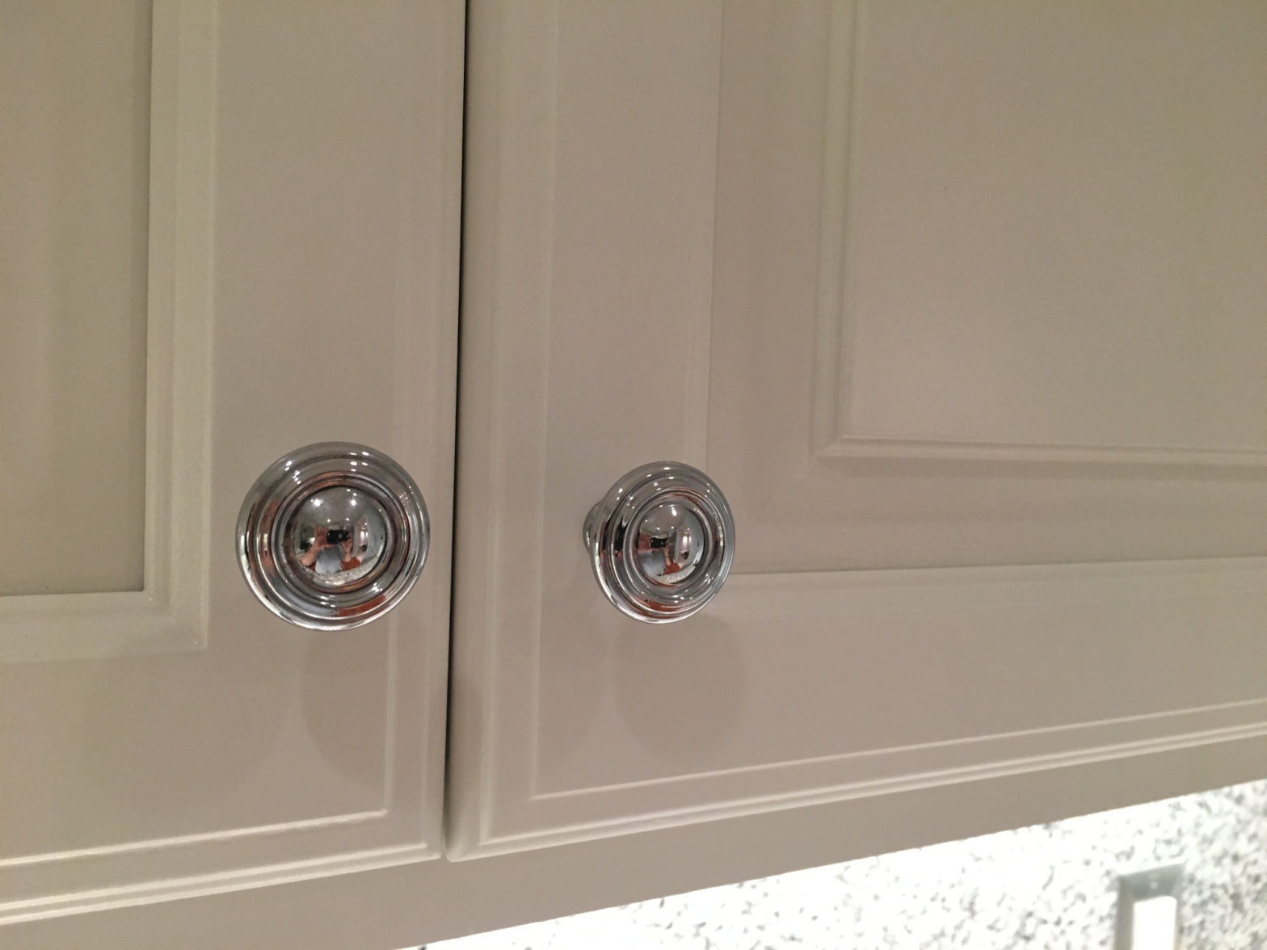
DON'T INCLUDE PAINTING INSIDE THE CABINET.
CABINETS:
COLOR SAME LIKE WITE DOORS 24UNIT
STYLE SMOOTH WOOD FOR SMOOTH DRAWERS 08 UNIT
COMPLETE JOB IN 2 WEEKS
We use only the highest quality materials.
” Thank you so much for trusting me . I do my best, taking care of your house as if it were mine. I take pleasure and love my job. “
Wellington B. Bovenschulte
Master Painter
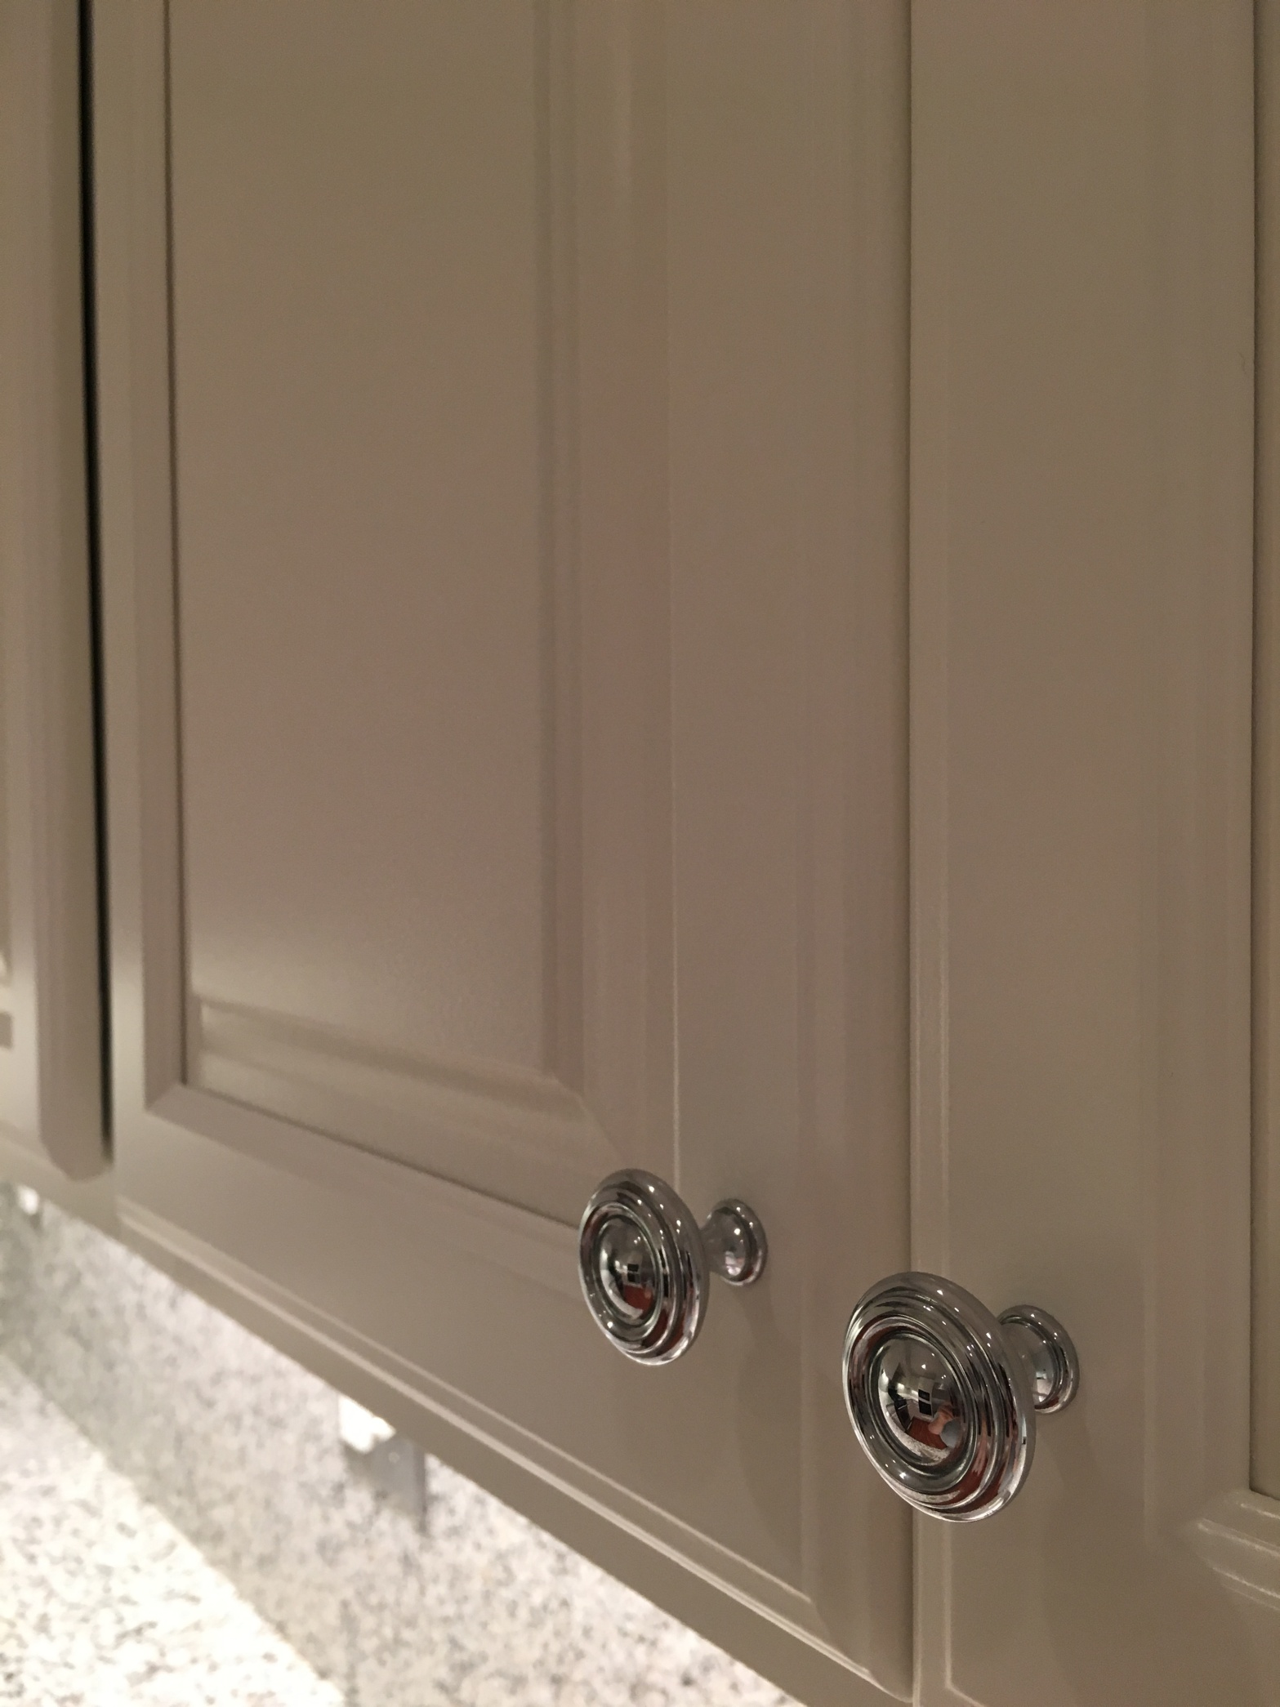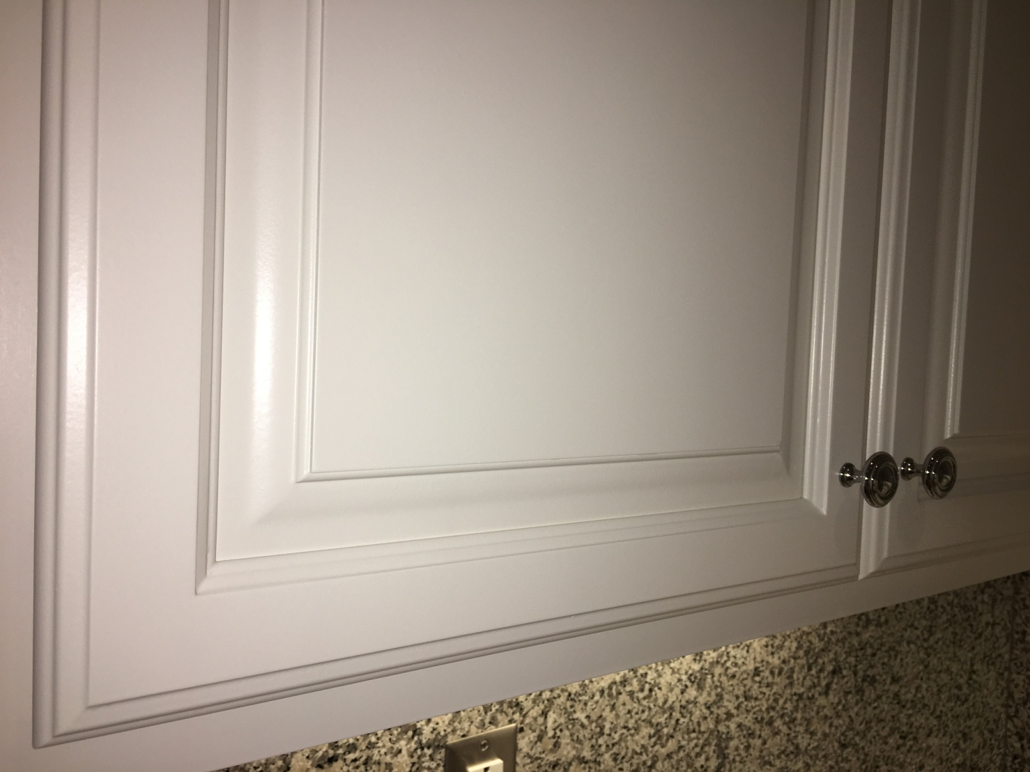
DON'T INCLUDE PAINTING INSIDE THE CABINET.
CABINETS:
COLOR SAME LIKE WITE DOORS 24UNIT
STYLE SMOOTH WOOD FOR SMOOTH DRAWERS 08 UNIT
COMPLETE JOB IN 2 WEEKS
We use only the highest quality materials.
” Thank you so much for trusting me . I do my best, taking care of your house as if it were mine. I take pleasure and love my job. “
Wellington B. Bovenschulte
Master Painter
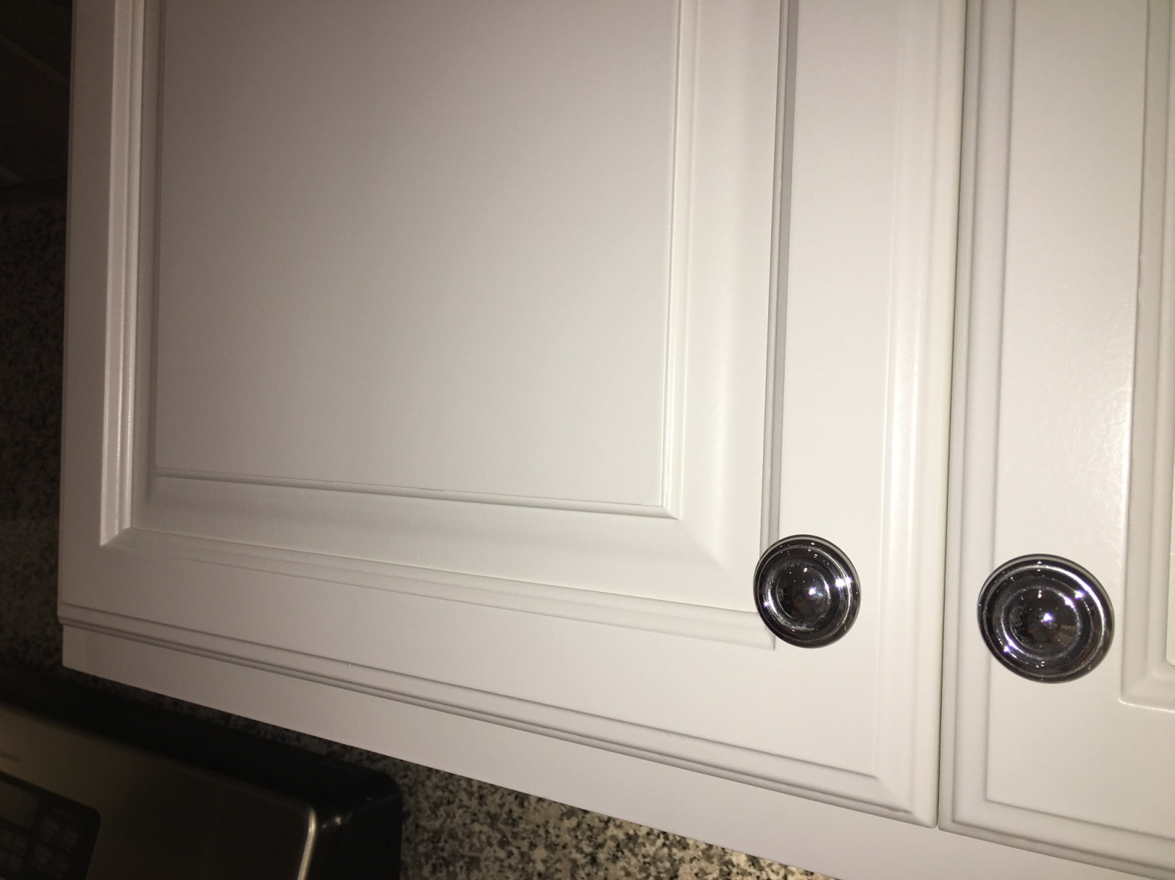
DON'T INCLUDE PAINTING INSIDE THE CABINET.
CABINETS:
COLOR SAME LIKE WITE DOORS 24UNIT
STYLE SMOOTH WOOD FOR SMOOTH DRAWERS 08 UNIT
COMPLETE JOB IN 2 WEEKS
We use only the highest quality materials.
” Thank you so much for trusting me . I do my best, taking care of your house as if it were mine. I take pleasure and love my job. “
Wellington B. Bovenschulte
Master Painter
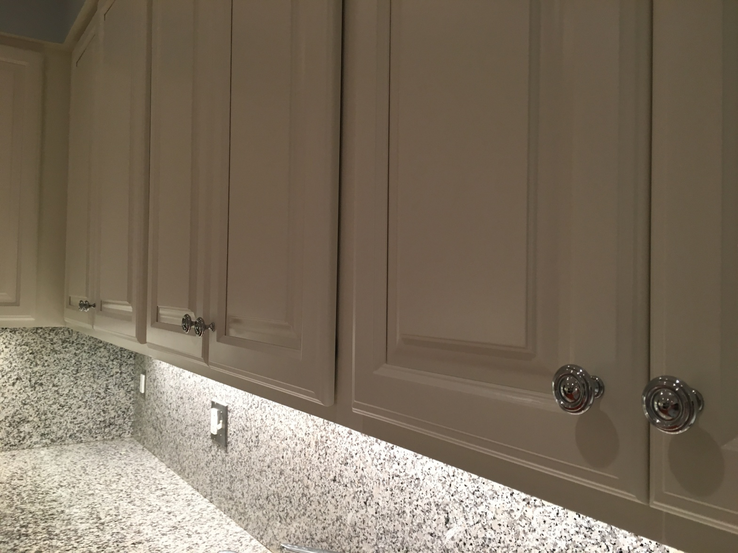
DON'T INCLUDE PAINTING INSIDE THE CABINET.
CABINETS:
COLOR SAME LIKE WITE DOORS 24UNIT
STYLE SMOOTH WOOD FOR SMOOTH DRAWERS 08 UNIT
COMPLETE JOB IN 2 WEEKS
We use only the highest quality materials.
” Thank you so much for trusting me . I do my best, taking care of your house as if it were mine. I take pleasure and love my job. “
Wellington B. Bovenschulte
Master Painter
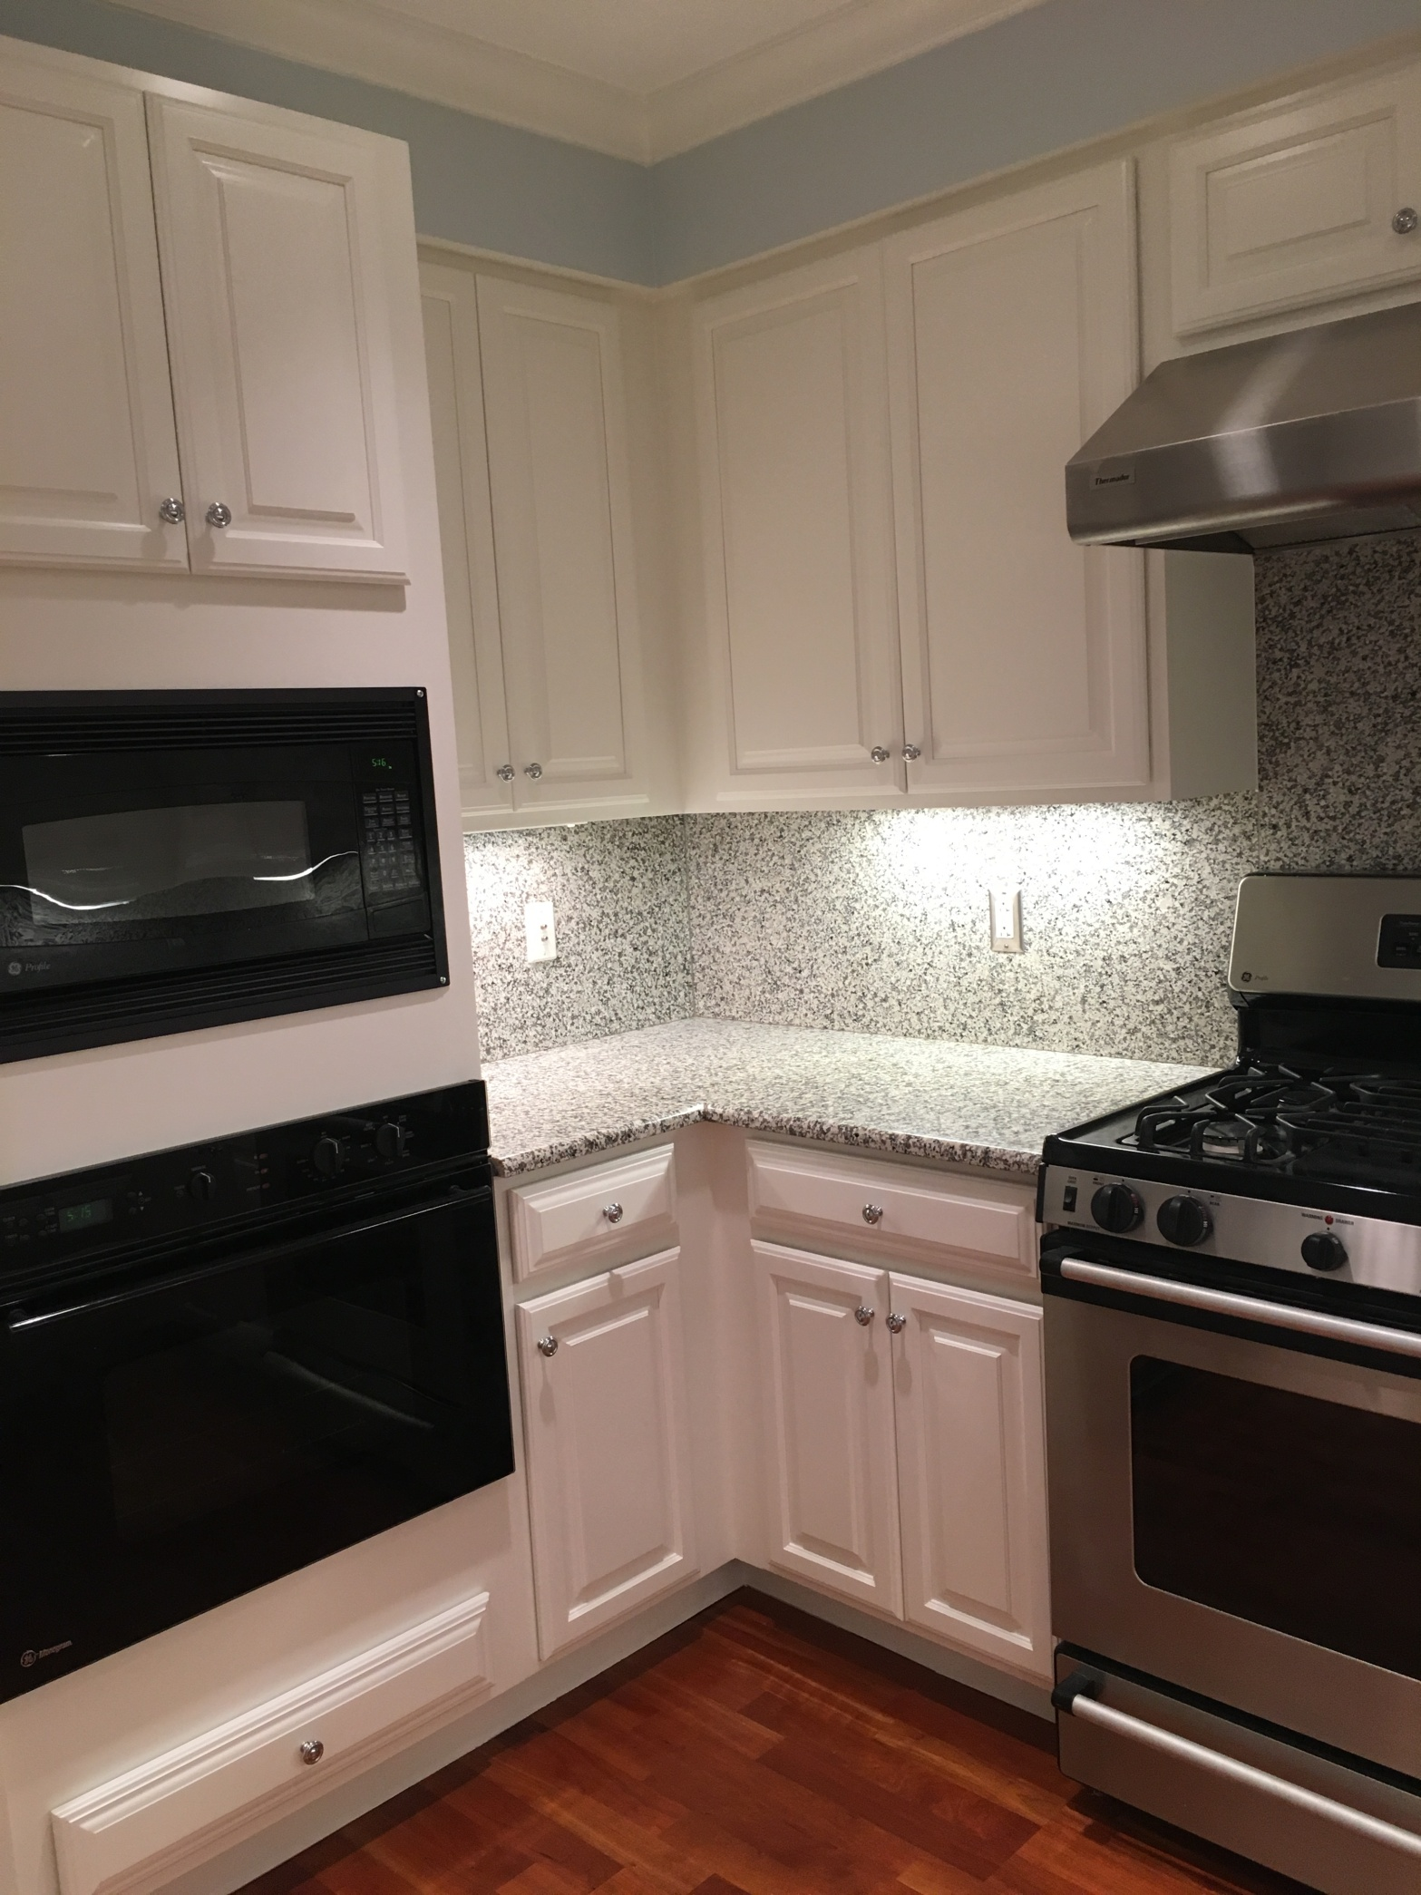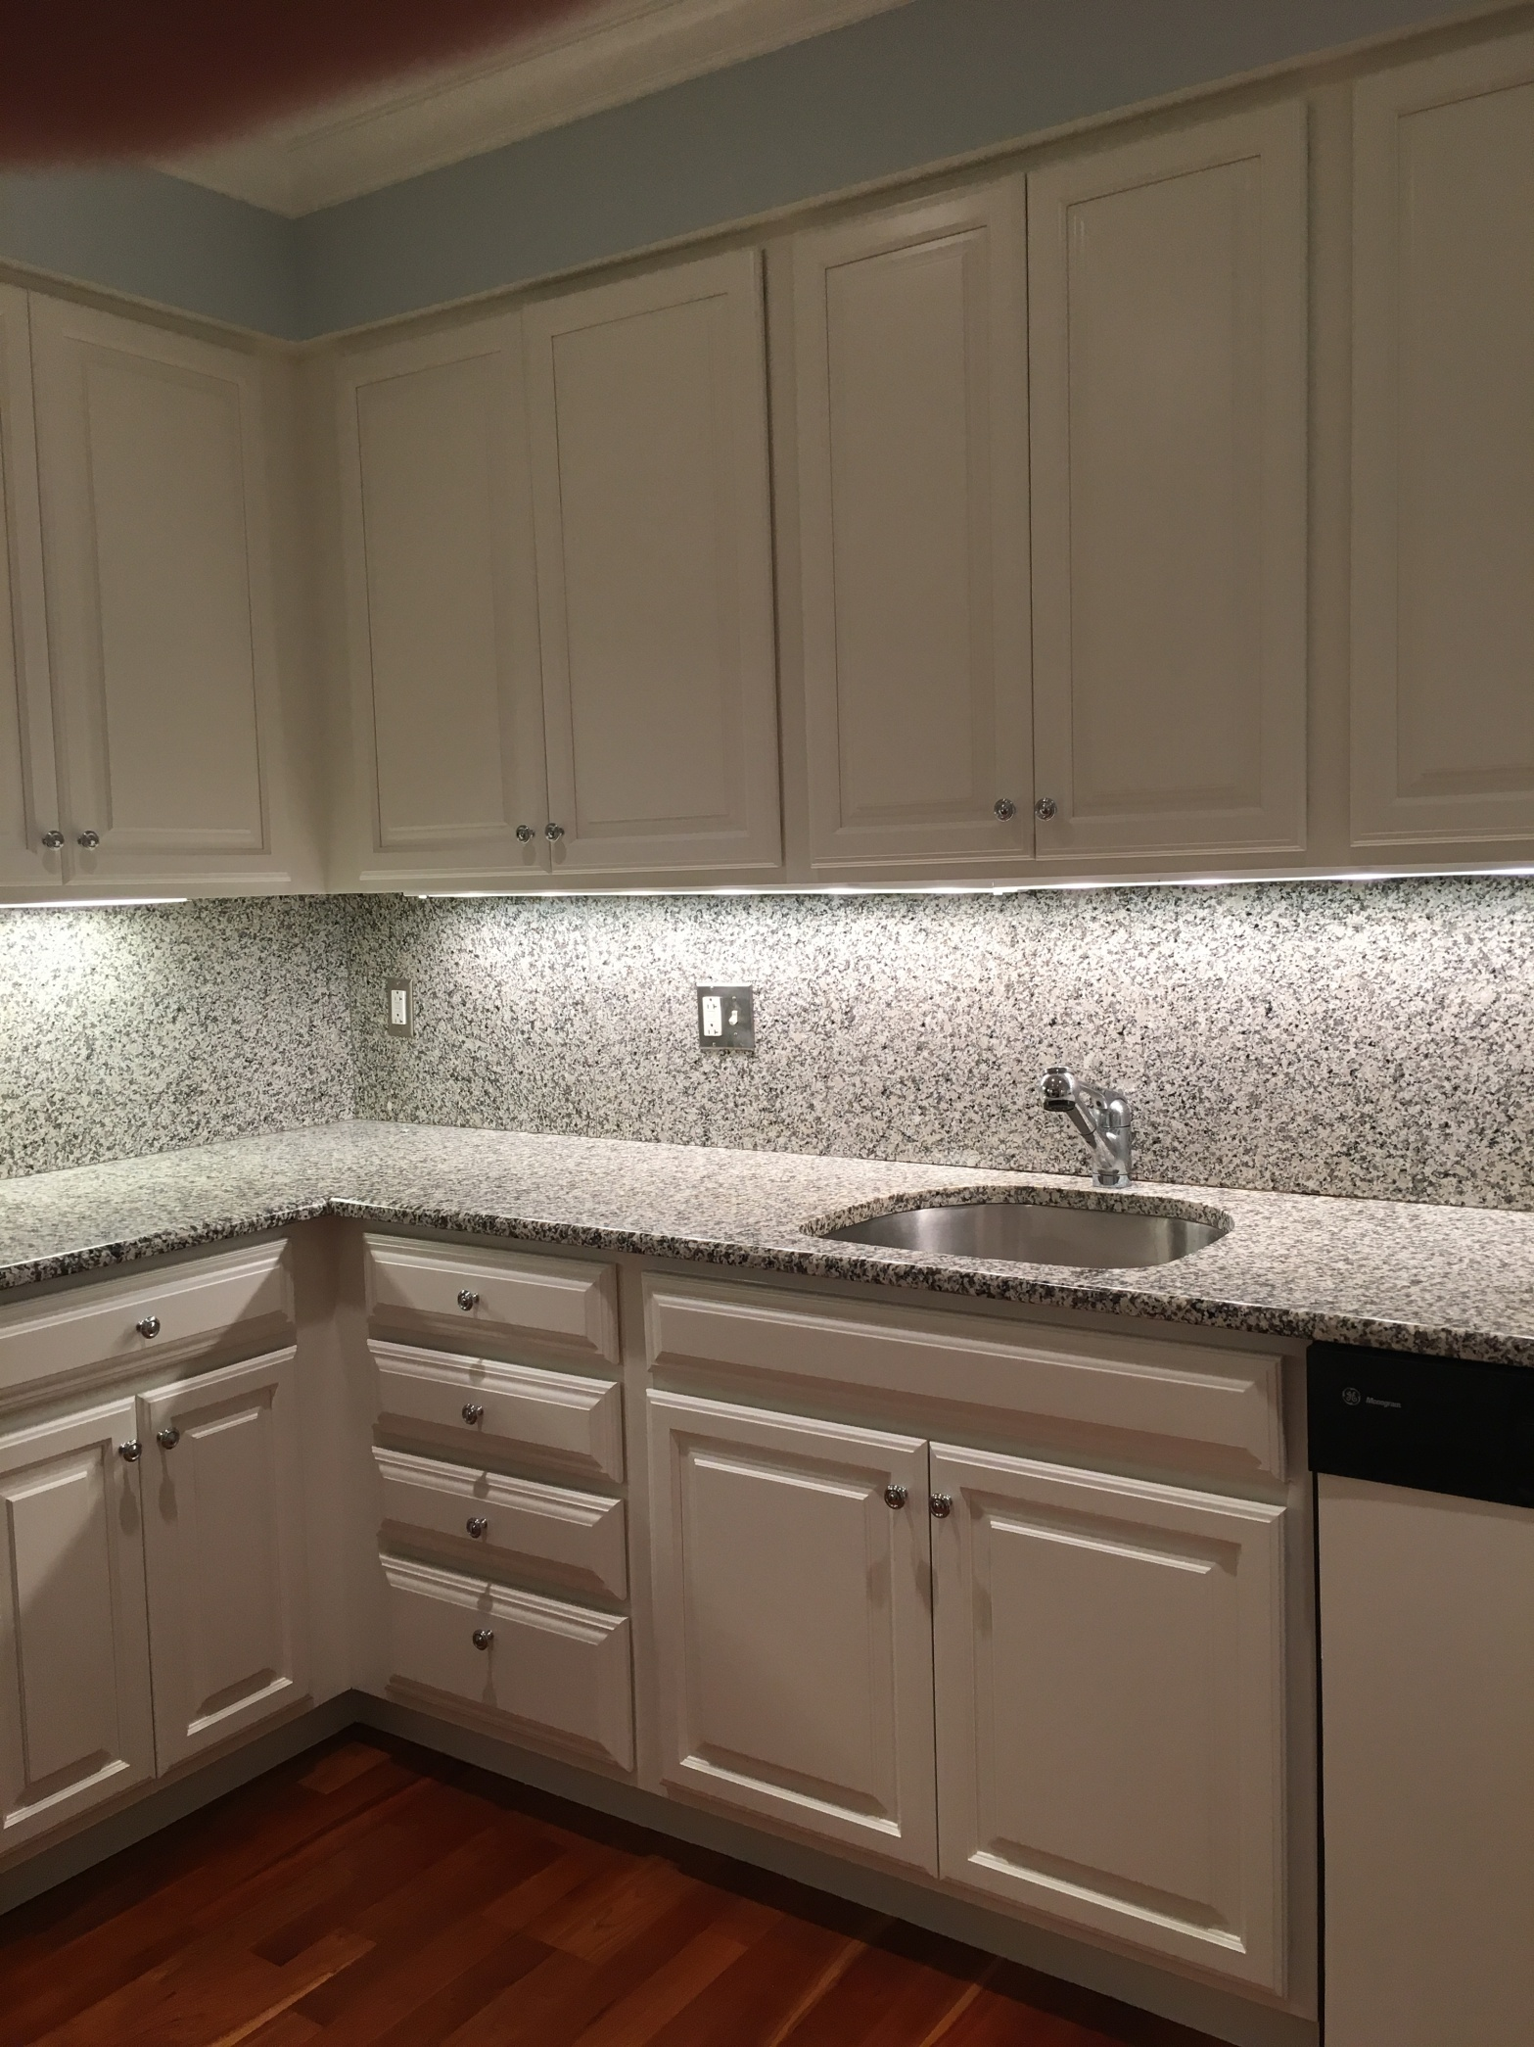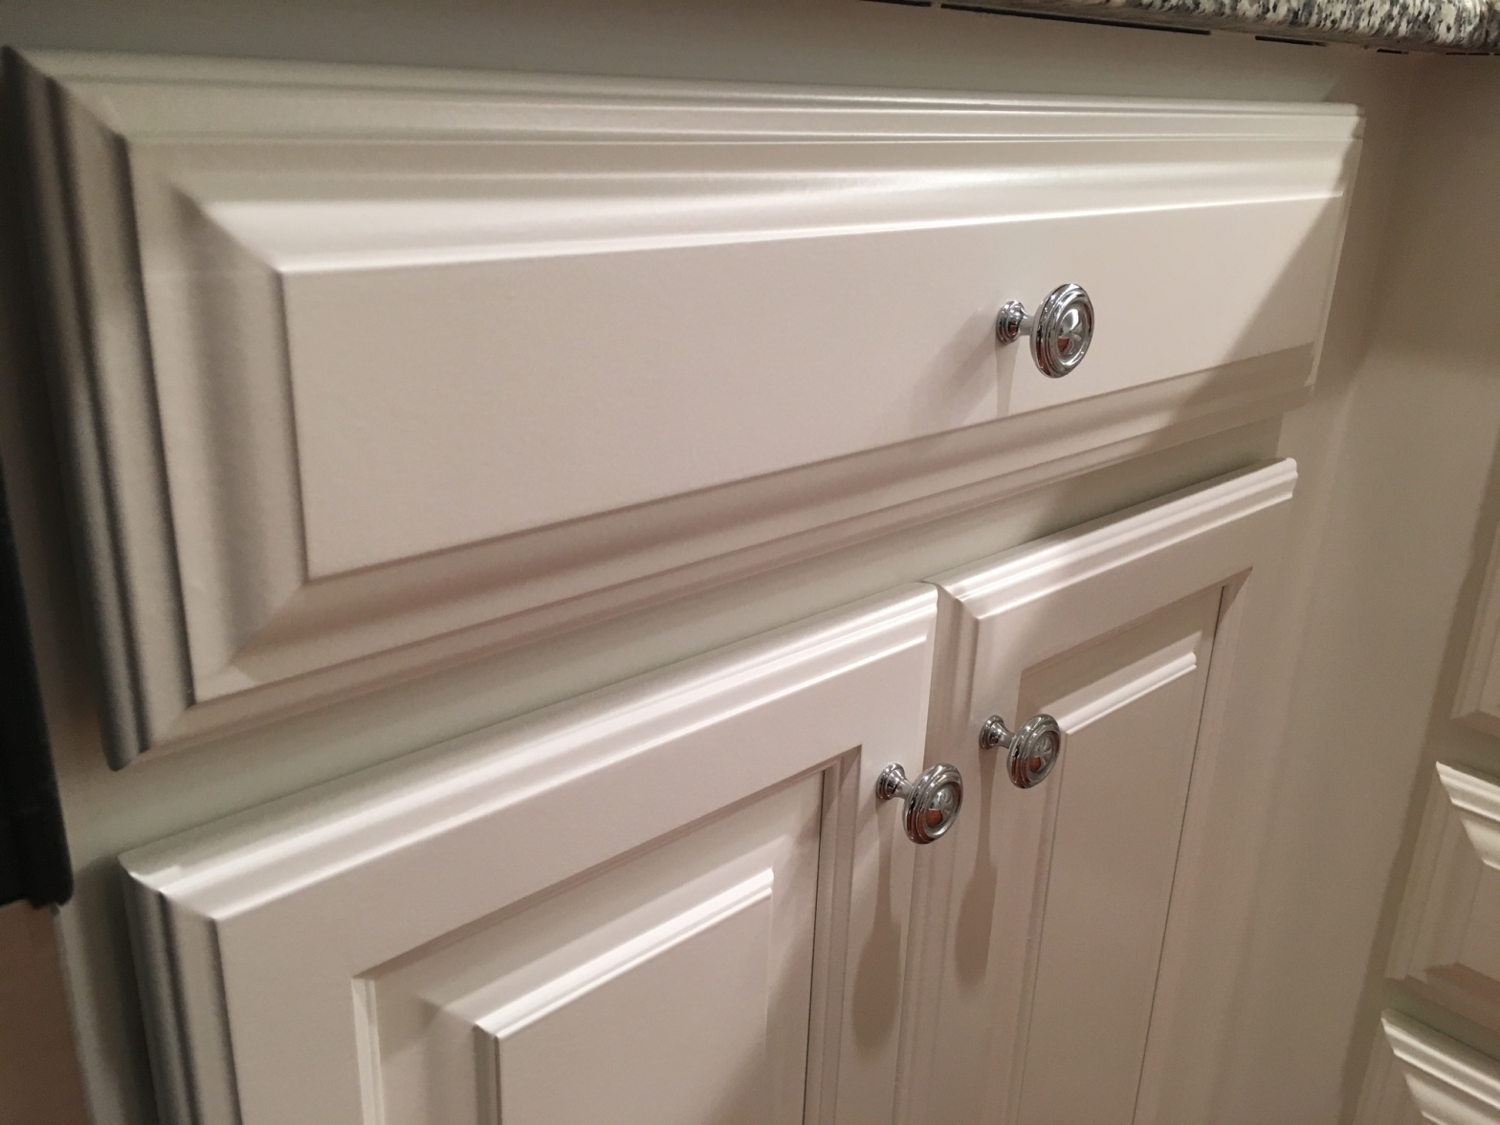
DON'T INCLUDE PAINTING INSIDE THE CABINET.
CABINETS:
COLOR SAME LIKE WITE DOORS 24UNIT
STYLE SMOOTH WOOD FOR SMOOTH DRAWERS 08 UNIT
COMPLETE JOB IN 2 WEEKS
We use only the highest quality materials.
” Thank you so much for trusting me . I do my best, taking care of your house as if it were mine. I take pleasure and love my job. “
Wellington B. Bovenschulte
Master Painter
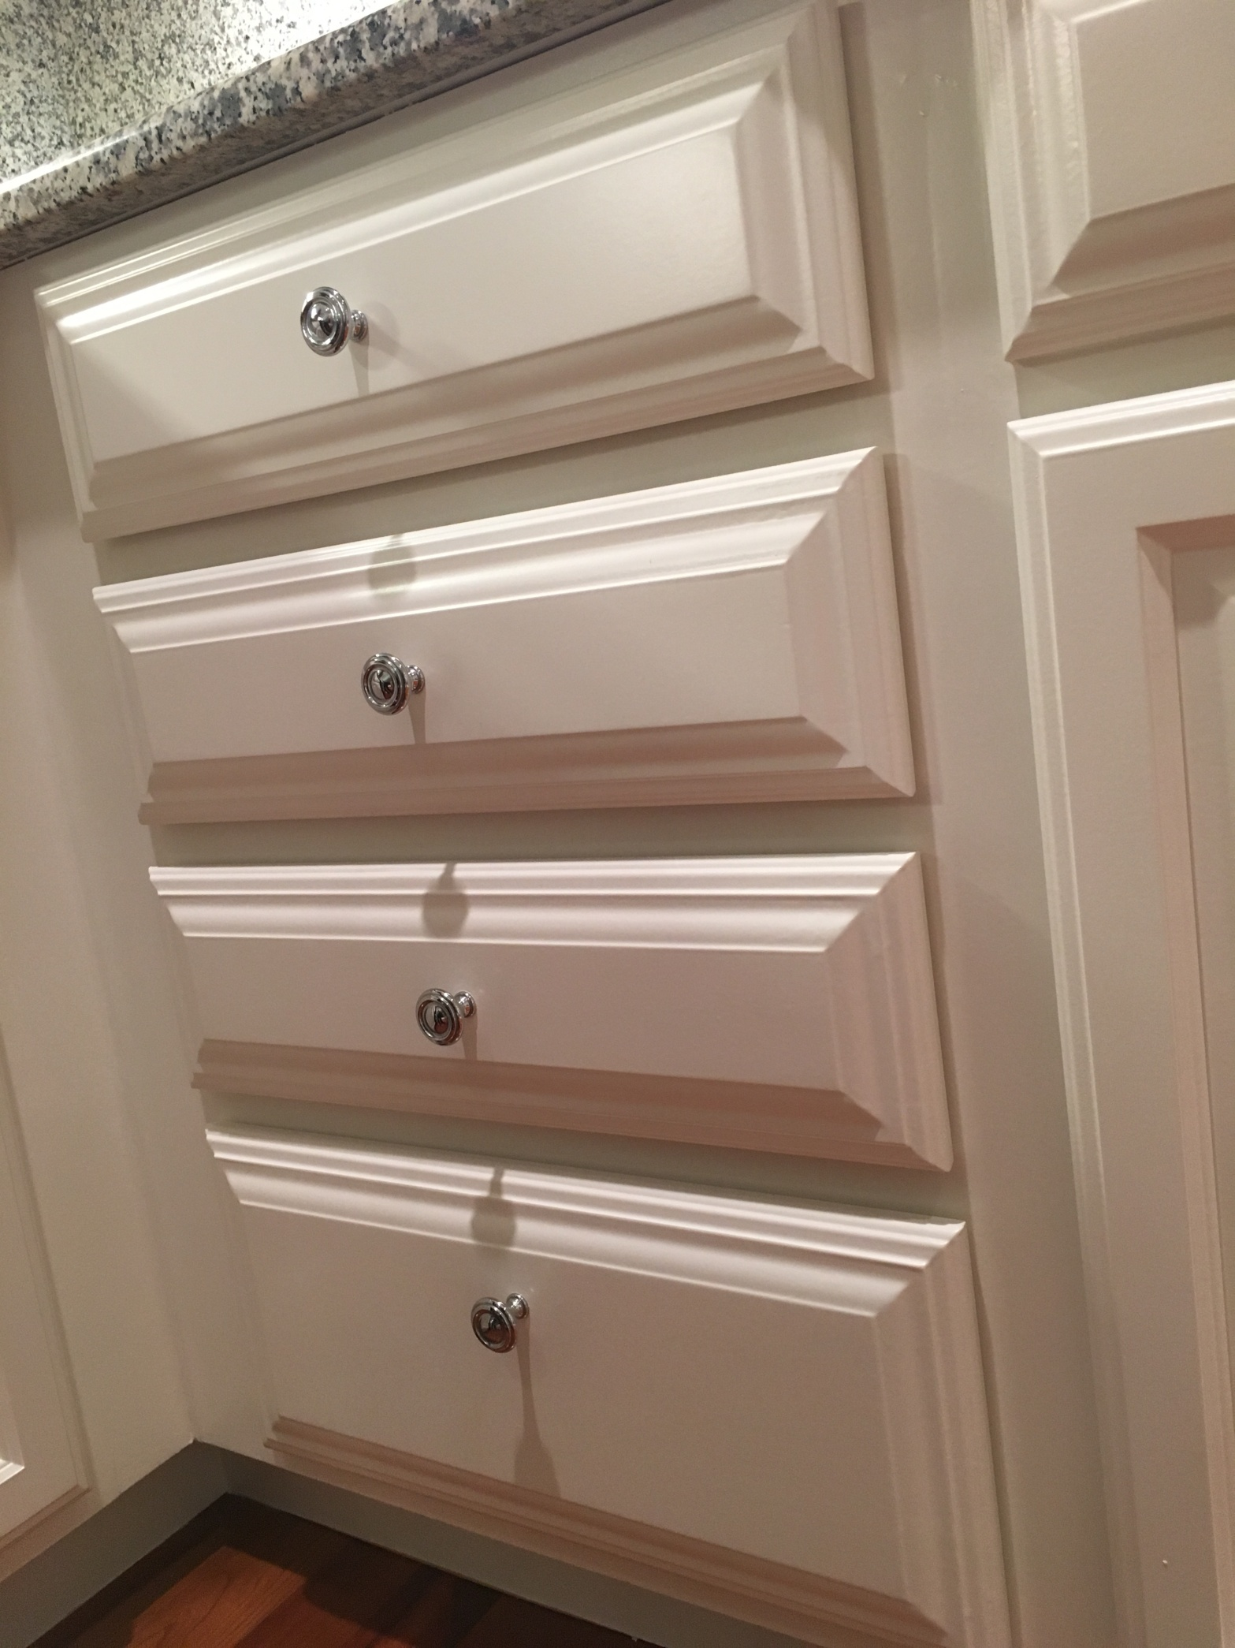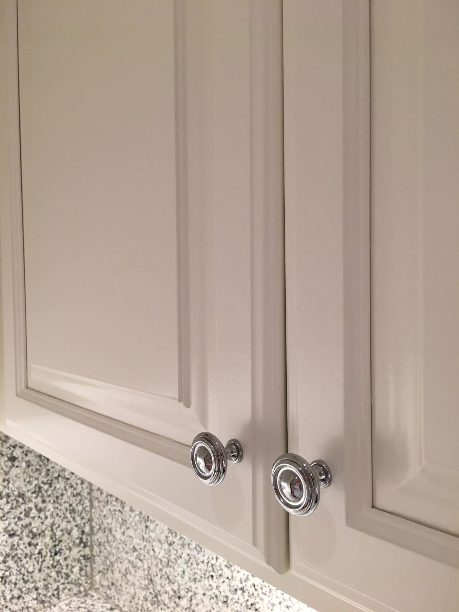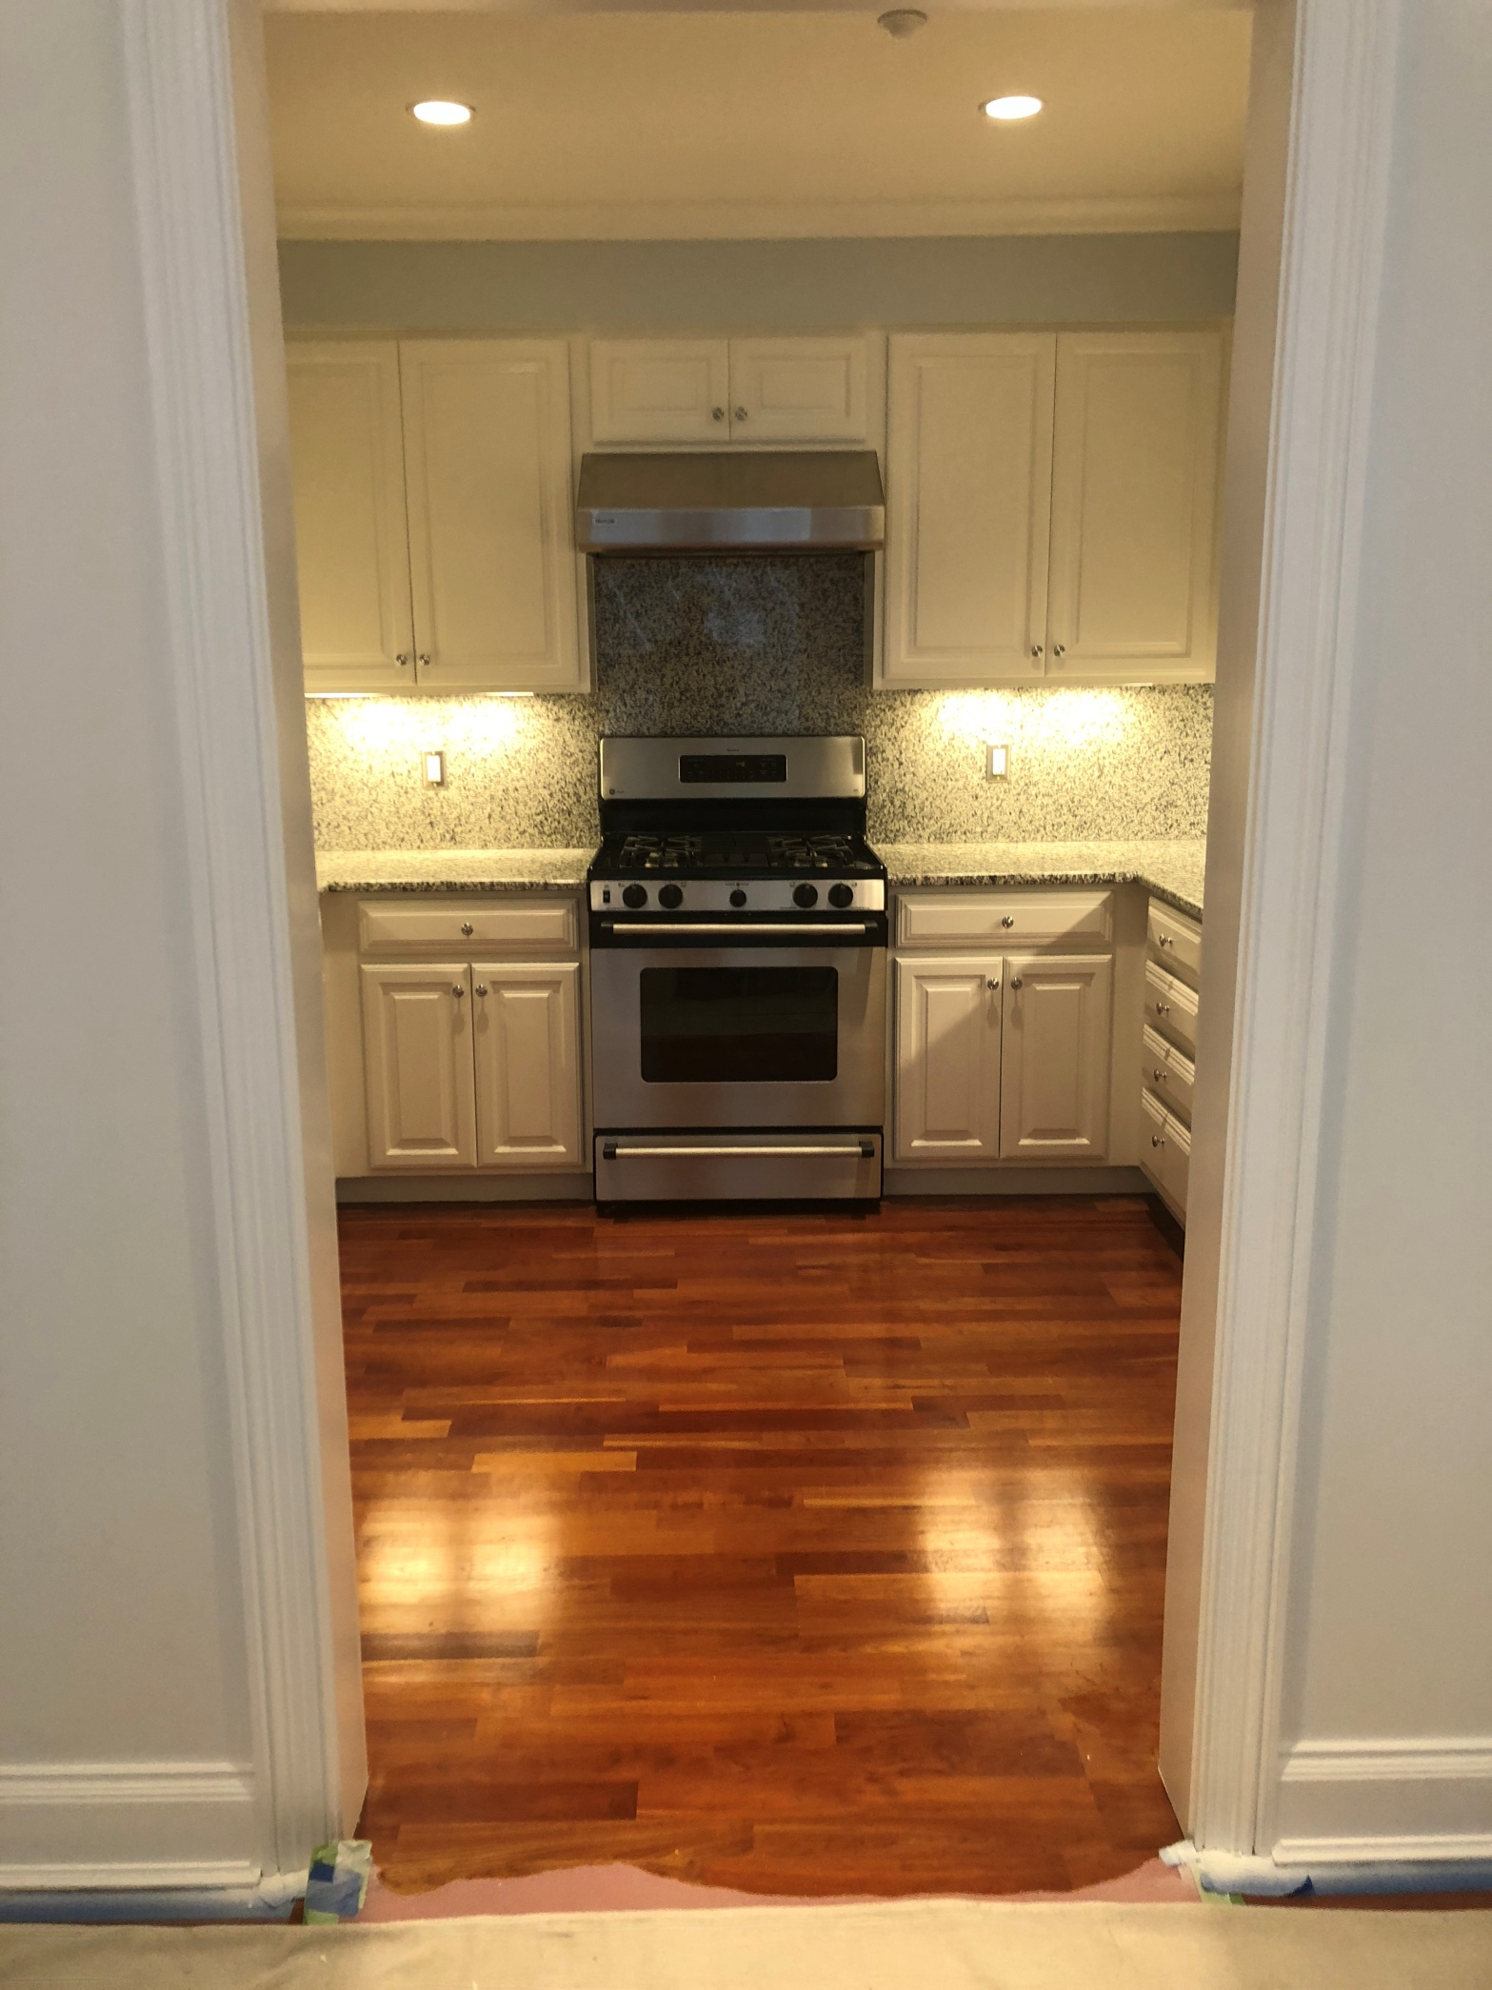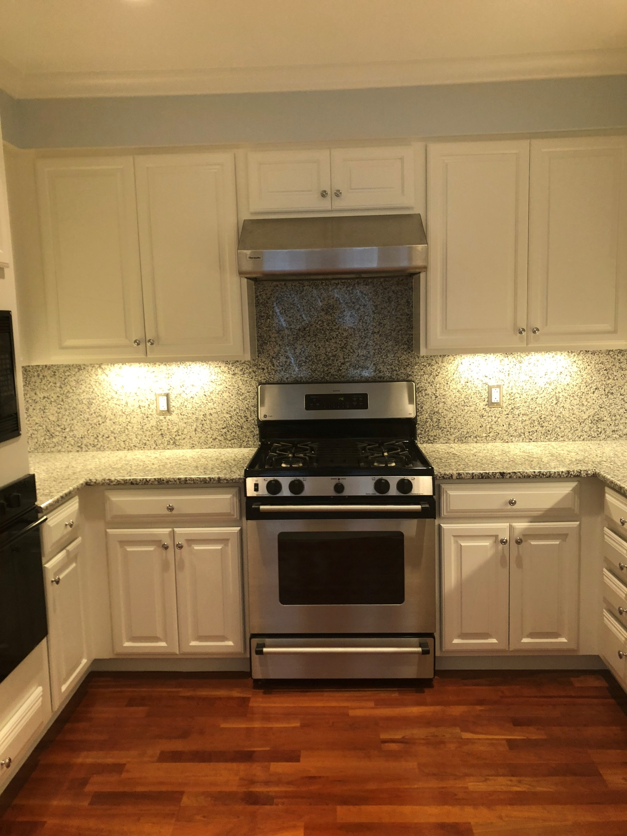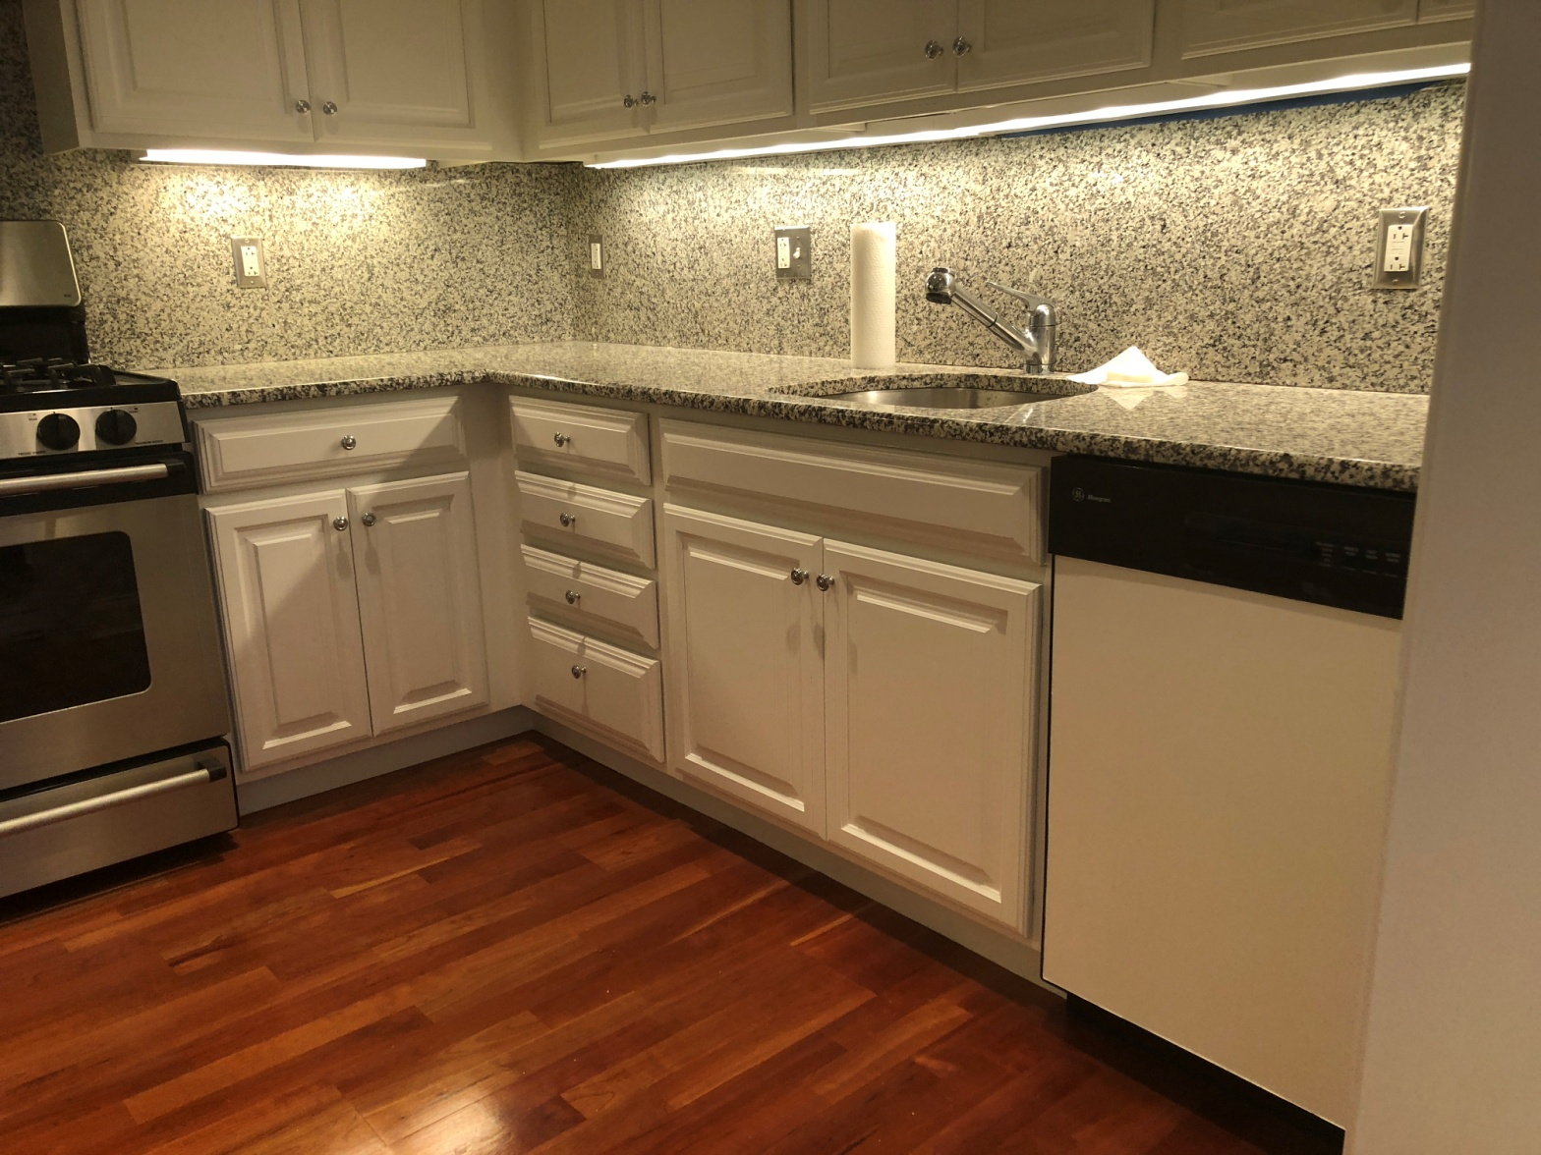
DON'T INCLUDE PAINTING INSIDE THE CABINET.
CABINETS:
COLOR SAME LIKE WITE DOORS 24UNIT
STYLE SMOOTH WOOD FOR SMOOTH DRAWERS 08 UNIT
COMPLETE JOB IN 2 WEEKS
We use only the highest quality materials.
” Thank you so much for trusting me . I do my best, taking care of your house as if it were mine. I take pleasure and love my job. “
Wellington B. Bovenschulte
Master Painter
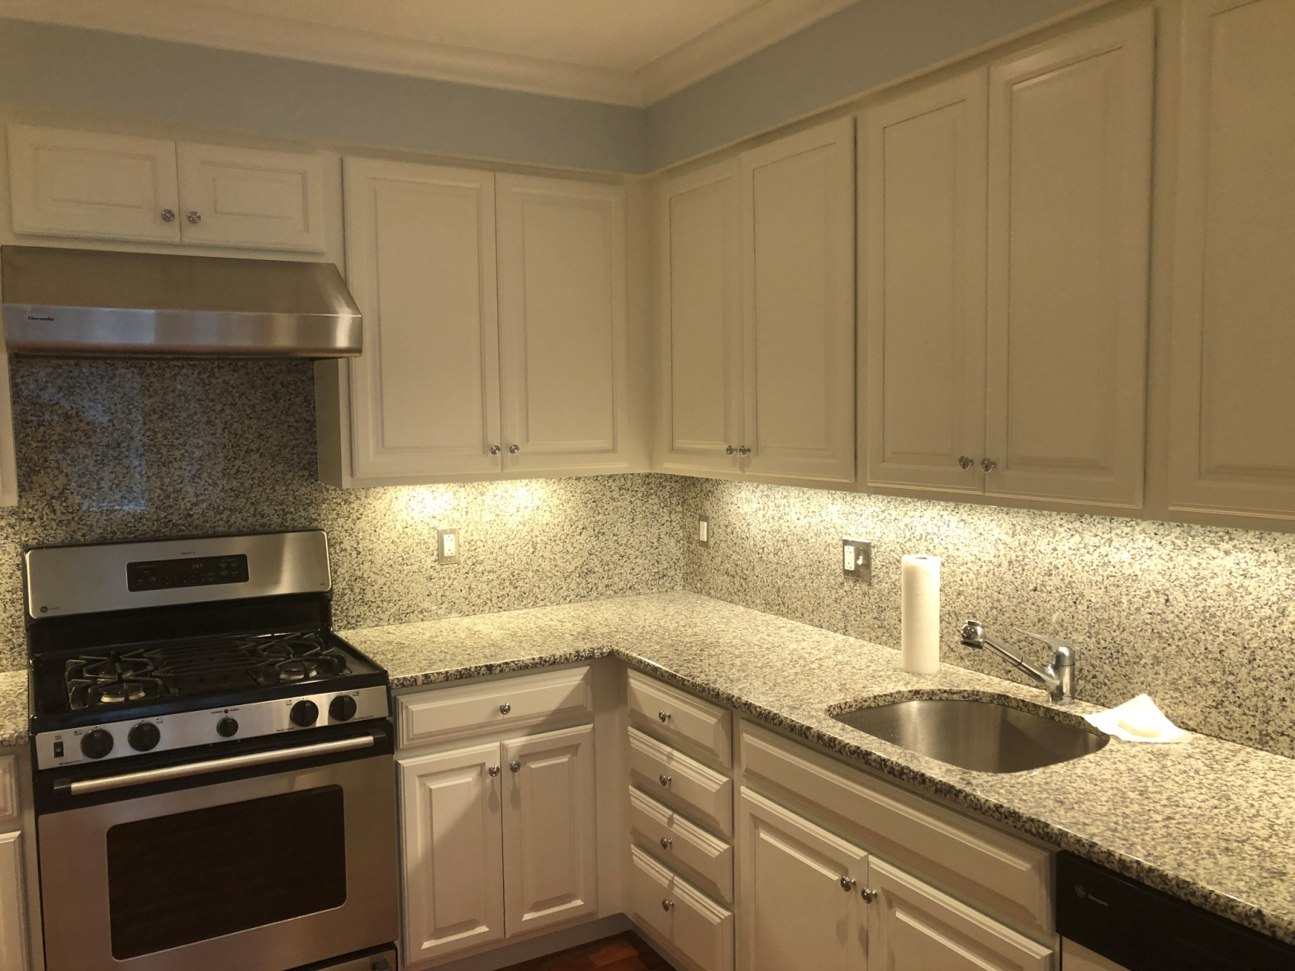
DON'T INCLUDE PAINTING INSIDE THE CABINET.
CABINETS:
COLOR SAME LIKE WITE DOORS 24UNIT
STYLE SMOOTH WOOD FOR SMOOTH DRAWERS 08 UNIT
COMPLETE JOB IN 2 WEEKS
We use only the highest quality materials.
” Thank you so much for trusting me . I do my best, taking care of your house as if it were mine. I take pleasure and love my job. “
Wellington B. Bovenschulte
Master Painter
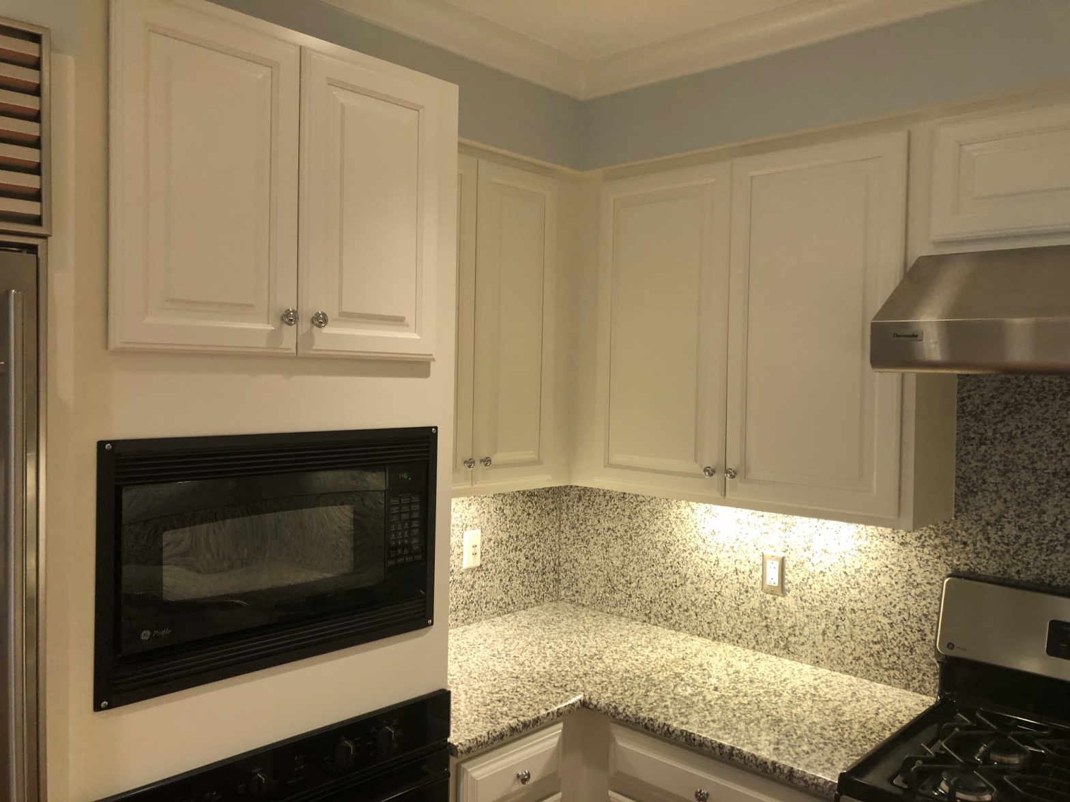
DON'T INCLUDE PAINTING INSIDE THE CABINET.
CABINETS:
COLOR SAME LIKE WITE DOORS 24UNIT
STYLE SMOOTH WOOD FOR SMOOTH DRAWERS 08 UNIT
COMPLETE JOB IN 2 WEEKS
We use only the highest quality materials.
” Thank you so much for trusting me . I do my best, taking care of your house as if it were mine. I take pleasure and love my job. “
Wellington B. Bovenschulte
Master Painter
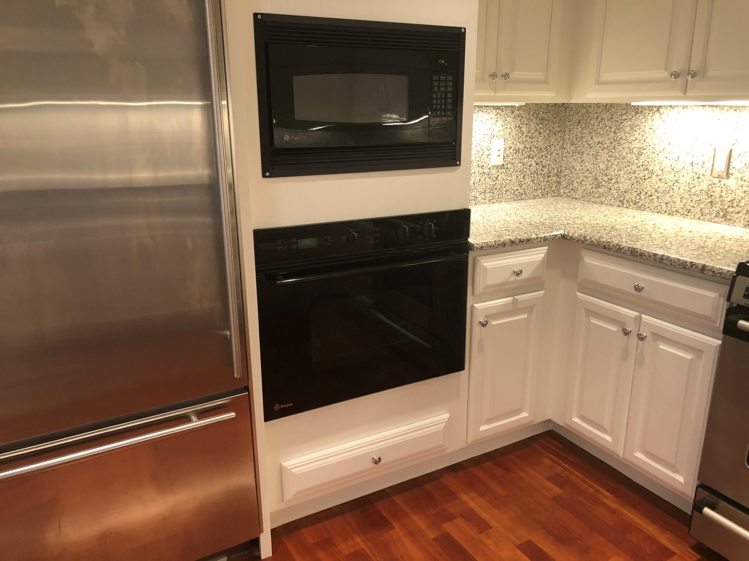
DON'T INCLUDE PAINTING INSIDE THE CABINET.
CABINETS:
COLOR SAME LIKE WITE DOORS 24UNIT
STYLE SMOOTH WOOD FOR SMOOTH DRAWERS 08 UNIT
COMPLETE JOB IN 2 WEEKS
We use only the highest quality materials.
” Thank you so much for trusting me . I do my best, taking care of your house as if it were mine. I take pleasure and love my job. “
Wellington B. Bovenschulte
Master Painter
DON'T INCLUDE PAINTING INSIDE THE CABINET.
CABINETS:
COLOR SAME LIKE WITE DOORS 24UNIT
STYLE SMOOTH WOOD FOR SMOOTH DRAWERS 08 UNIT
COMPLETE JOB IN 2 WEEKS
We use only the highest quality materials.
” Thank you so much for trusting me . I do my best, taking care of your house as if it were mine. I take pleasure and love my job. “
Wellington B. Bovenschulte
Master Painter
DON'T INCLUDE PAINTING INSIDE THE CABINET.
CABINETS:
COLOR SAME LIKE WITE DOORS 24UNIT
STYLE SMOOTH WOOD FOR SMOOTH DRAWERS 08 UNIT
COMPLETE JOB IN 2 WEEKS
We use only the highest quality materials.
” Thank you so much for trusting me . I do my best, taking care of your house as if it were mine. I take pleasure and love my job. “
Wellington B. Bovenschulte
Master Painter
DON'T INCLUDE PAINTING INSIDE THE CABINET.
CABINETS:
COLOR SAME LIKE WITE DOORS 24UNIT
STYLE SMOOTH WOOD FOR SMOOTH DRAWERS 08 UNIT
COMPLETE JOB IN 2 WEEKS
We use only the highest quality materials.
” Thank you so much for trusting me . I do my best, taking care of your house as if it were mine. I take pleasure and love my job. “
Wellington B. Bovenschulte
Master Painter
DON'T INCLUDE PAINTING INSIDE THE CABINET.
CABINETS:
COLOR SAME LIKE WITE DOORS 24UNIT
STYLE SMOOTH WOOD FOR SMOOTH DRAWERS 08 UNIT
COMPLETE JOB IN 2 WEEKS
We use only the highest quality materials.
” Thank you so much for trusting me . I do my best, taking care of your house as if it were mine. I take pleasure and love my job. “
Wellington B. Bovenschulte
Master Painter
DON'T INCLUDE PAINTING INSIDE THE CABINET.
CABINETS:
COLOR SAME LIKE WITE DOORS 24UNIT
STYLE SMOOTH WOOD FOR SMOOTH DRAWERS 08 UNIT
COMPLETE JOB IN 2 WEEKS
We use only the highest quality materials.
” Thank you so much for trusting me . I do my best, taking care of your house as if it were mine. I take pleasure and love my job. “
Wellington B. Bovenschulte
Master Painter
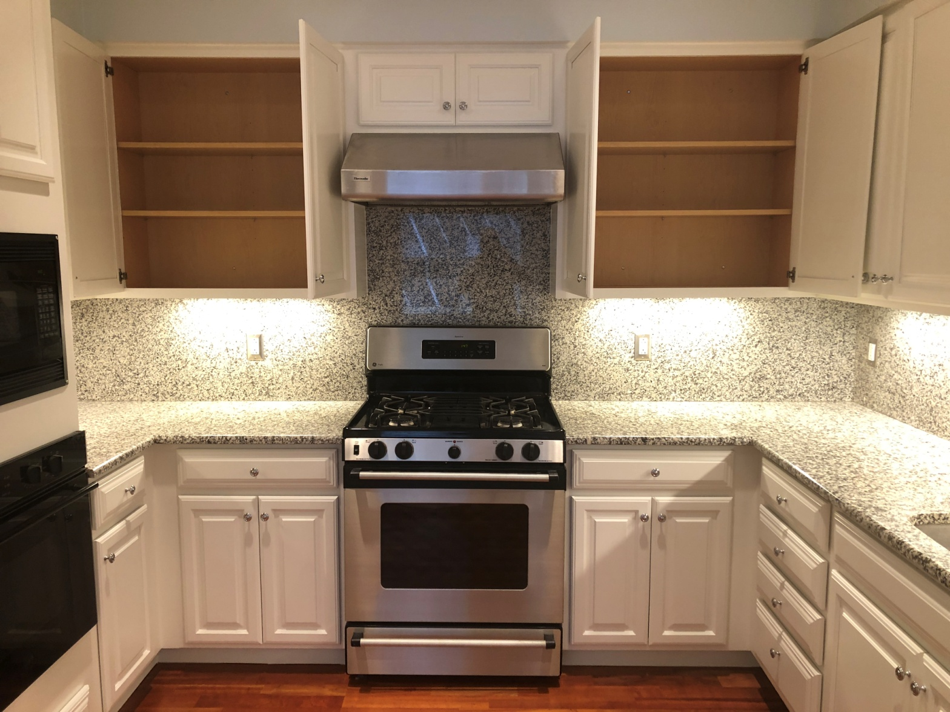
DON'T INCLUDE PAINTING INSIDE THE CABINET.
CABINETS:
COLOR SAME LIKE WITE DOORS 24UNIT
STYLE SMOOTH WOOD FOR SMOOTH DRAWERS 08 UNIT
COMPLETE JOB IN 2 WEEKS
We use only the highest quality materials.
” Thank you so much for trusting me . I do my best, taking care of your house as if it were mine. I take pleasure and love my job. “
Wellington B. Bovenschulte
Master Painter
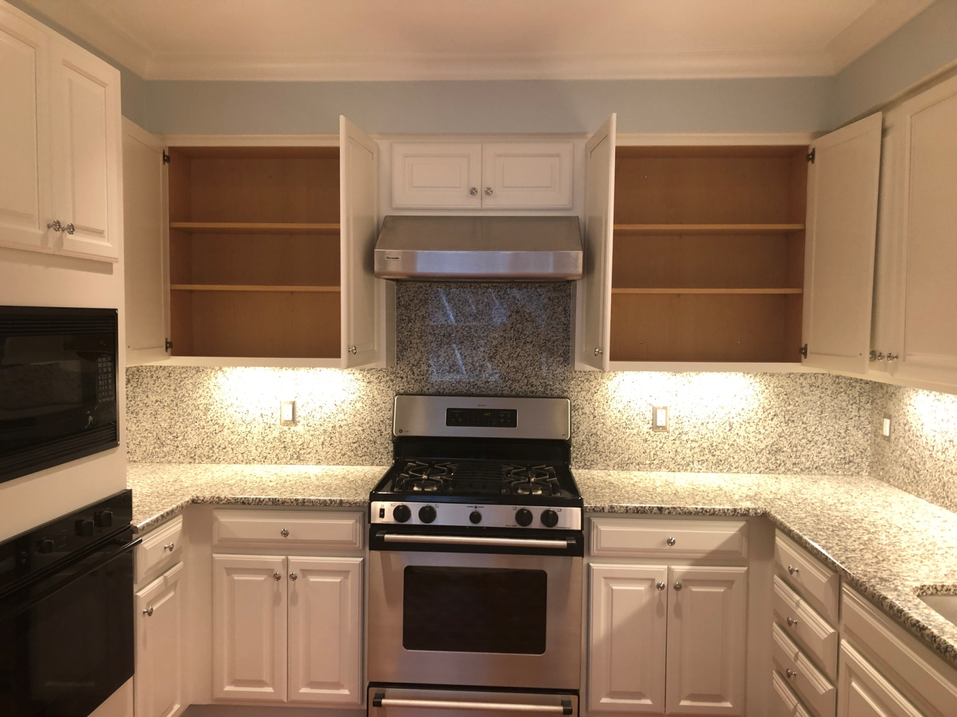
DON'T INCLUDE PAINTING INSIDE THE CABINET.
CABINETS:
COLOR SAME LIKE WITE DOORS 24UNIT
STYLE SMOOTH WOOD FOR SMOOTH DRAWERS 08 UNIT
COMPLETE JOB IN 2 WEEKS
We use only the highest quality materials.
” Thank you so much for trusting me . I do my best, taking care of your house as if it were mine. I take pleasure and love my job. “
Wellington B. Bovenschulte
Master Painter
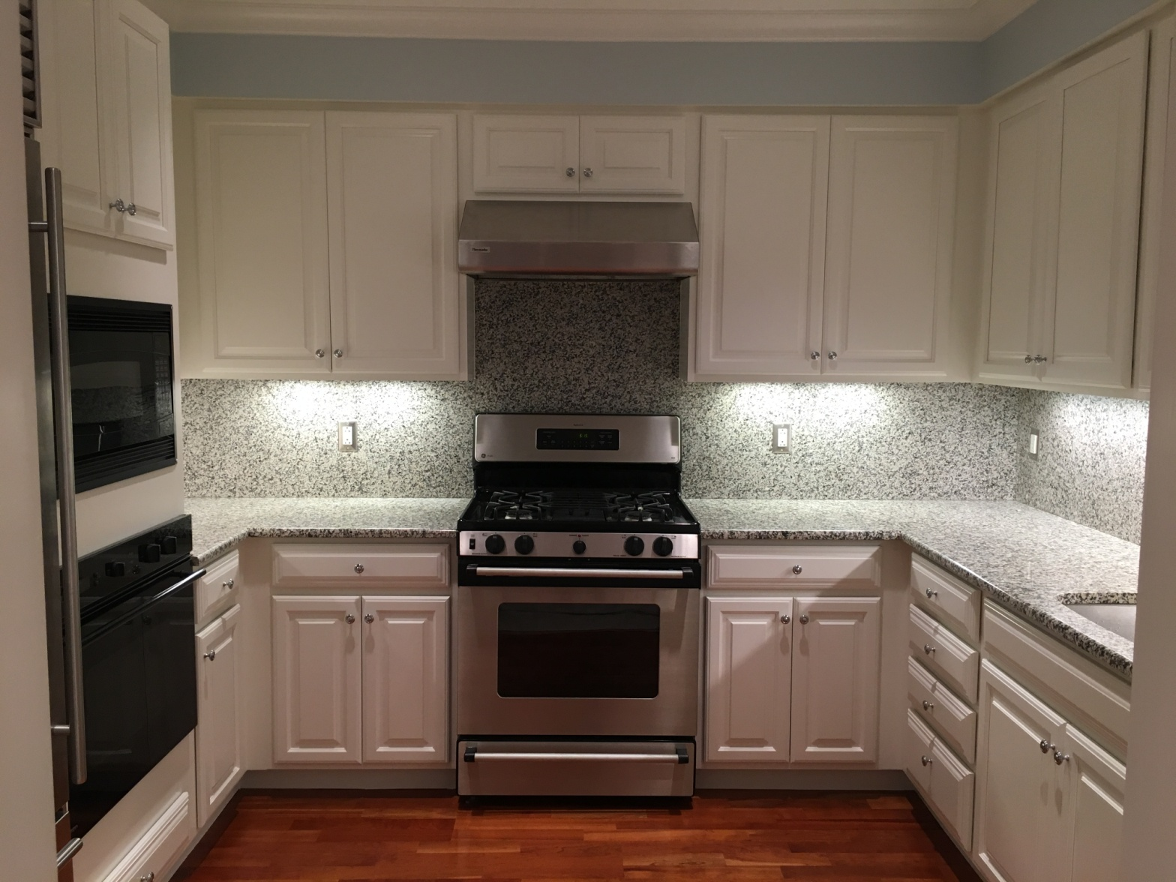
DON'T INCLUDE PAINTING INSIDE THE CABINET.
CABINETS:
COLOR SAME LIKE WITE DOORS 24UNIT
STYLE SMOOTH WOOD FOR SMOOTH DRAWERS 08 UNIT
COMPLETE JOB IN 2 WEEKS
We use only the highest quality materials.
” Thank you so much for trusting me . I do my best, taking care of your house as if it were mine. I take pleasure and love my job. “
Wellington B. Bovenschulte
Master Painter
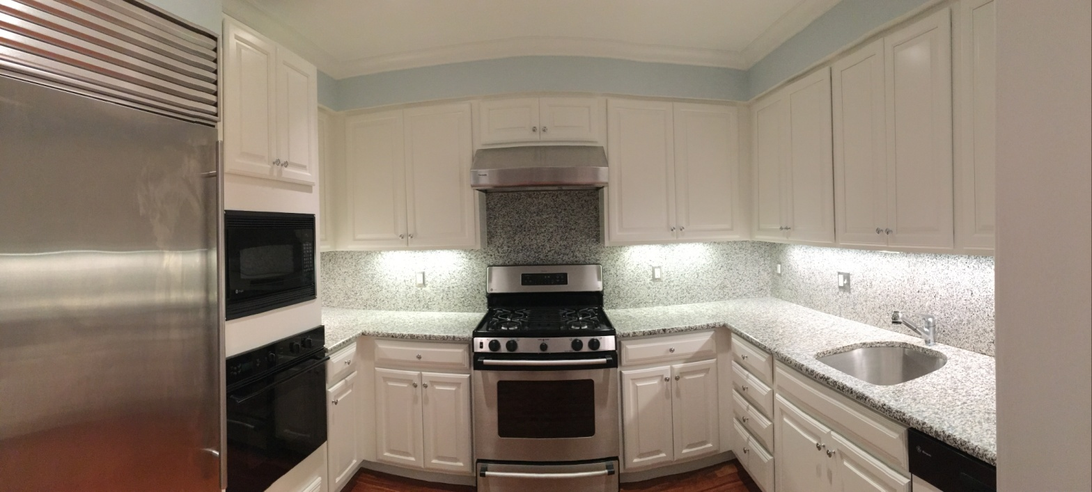
DON'T INCLUDE PAINTING INSIDE THE CABINET.
CABINETS:
COLOR SAME LIKE WITE DOORS 24UNIT
STYLE SMOOTH WOOD FOR SMOOTH DRAWERS 08 UNIT
COMPLETE JOB IN 2 WEEKS
We use only the highest quality materials.
” Thank you so much for trusting me . I do my best, taking care of your house as if it were mine. I take pleasure and love my job. “
Wellington B. Bovenschulte
Master Painter
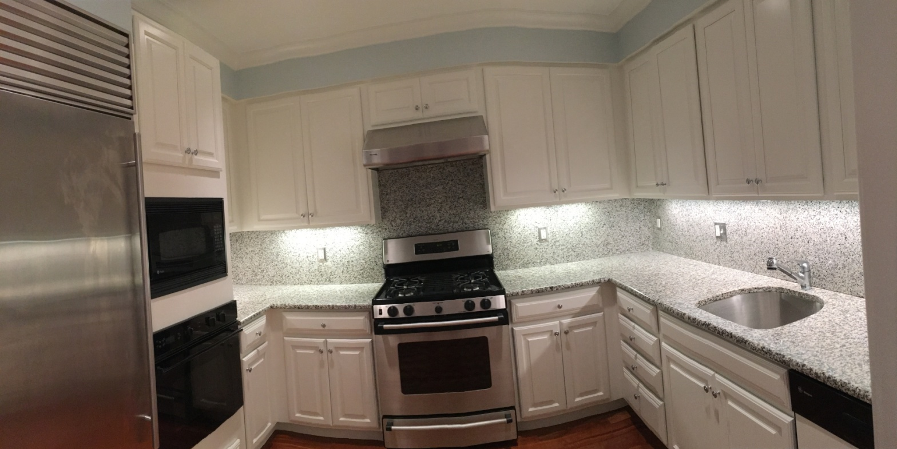
DON'T INCLUDE PAINTING INSIDE THE CABINET.
CABINETS:
COLOR SAME LIKE WITE DOORS 24UNIT
STYLE SMOOTH WOOD FOR SMOOTH DRAWERS 08 UNIT
COMPLETE JOB IN 2 WEEKS
We use only the highest quality materials.
” Thank you so much for trusting me . I do my best, taking care of your house as if it were mine. I take pleasure and love my job. “
Wellington B. Bovenschulte
Master Painter

