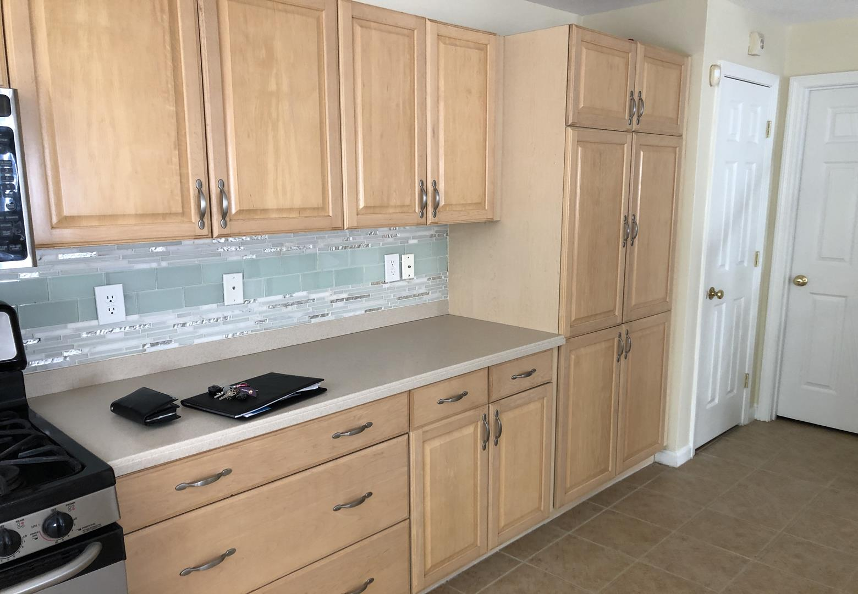
DON'T INCLUDE STAIN INSIDE THE CABINET.
33 AMERICAN BLVD ASHLAND MA 01721
CABINETS:
COLOR CHERRY DARK DOORS 34Unit
STYLE SMOOTH DRAWERS 11 Unit
COMPLETE JOB IN 2 WEEKS

We use only the highest quality materials.
” Thank you so much for trusting me . I do my best, taking care of your house as if it were mine. I take pleasure and love my job. “
Wellington B. Bovenschulte
Master Painter

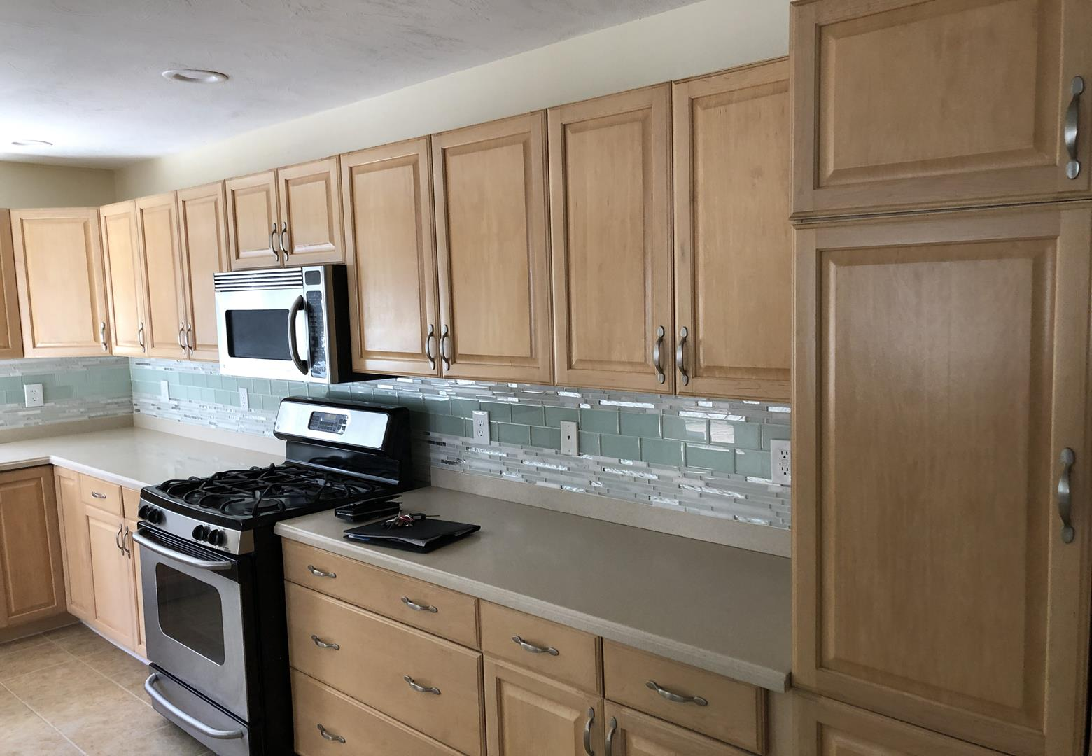
DON'T INCLUDE STAIN INSIDE THE CABINET.
33 AMERICAN BLVD ASHLAND MA 01721
CABINETS:
COLOR CHERRY DARK DOORS 34Unit
STYLE SMOOTH DRAWERS 11 Unit
COMPLETE JOB IN 2 WEEKS

We use only the highest quality materials.
” Thank you so much for trusting me . I do my best, taking care of your house as if it were mine. I take pleasure and love my job. “
Wellington B. Bovenschulte
Master Painter

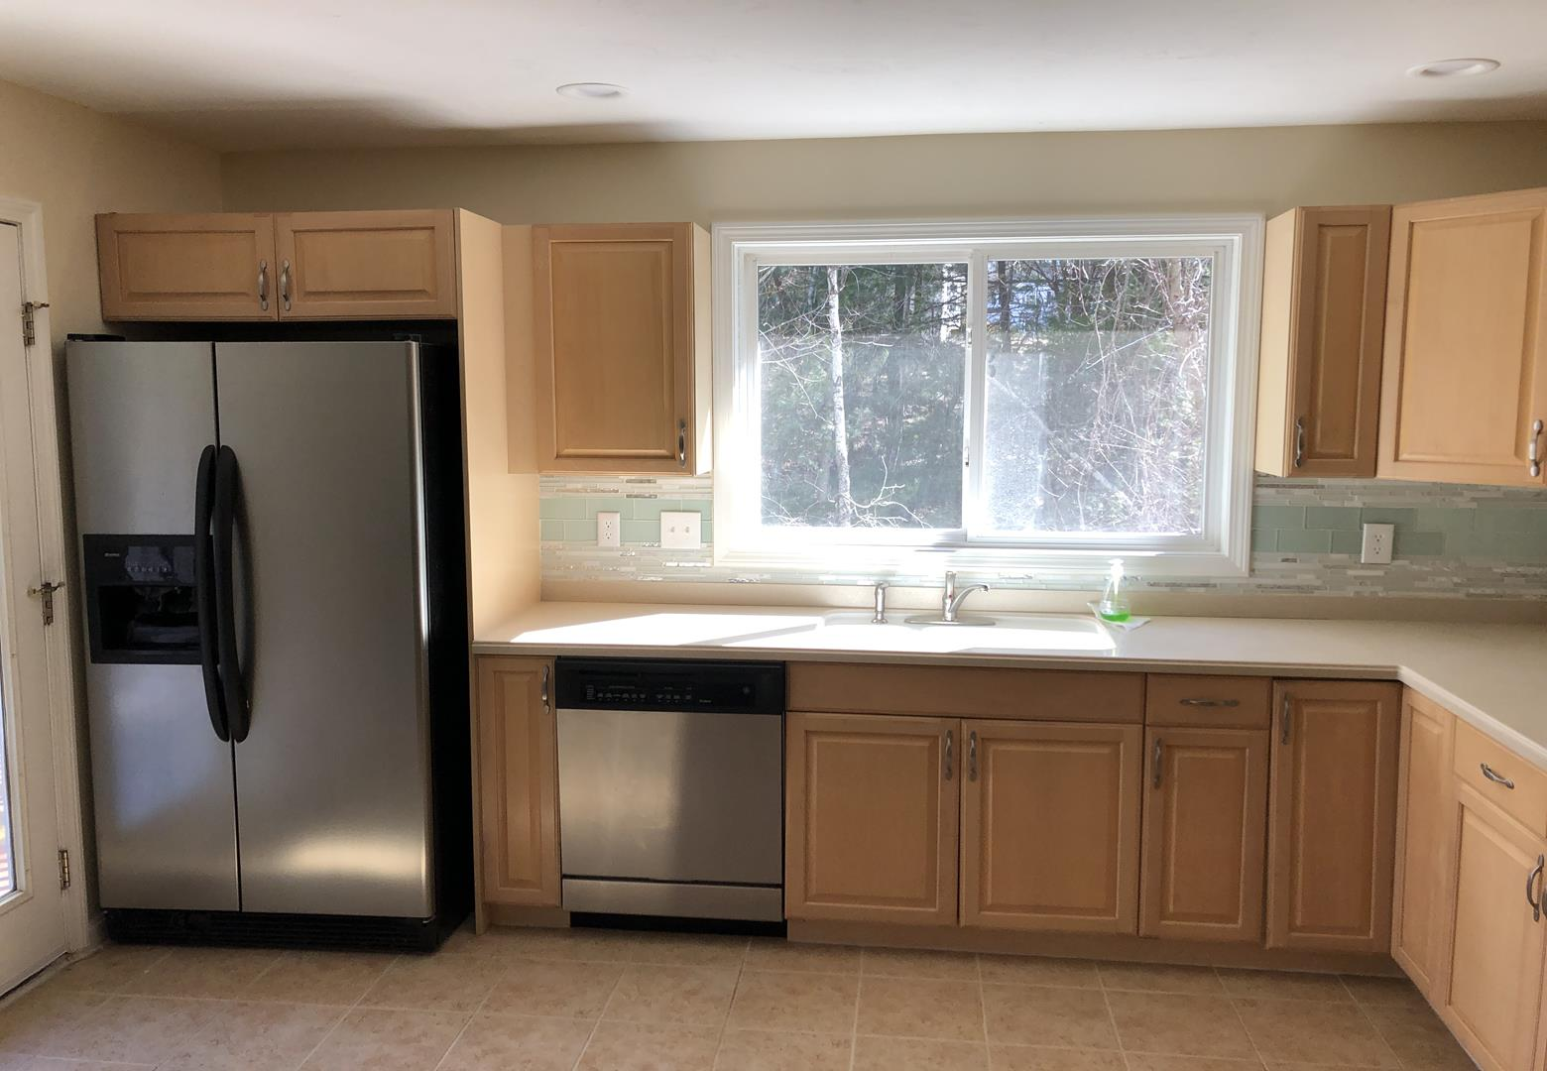
DON'T INCLUDE STAIN INSIDE THE CABINET.
33 AMERICAN BLVD ASHLAND MA 01721
CABINETS:
COLOR CHERRY DARK DOORS 34Unit
STYLE SMOOTH DRAWERS 11 Unit
COMPLETE JOB IN 2 WEEKS

We use only the highest quality materials.
” Thank you so much for trusting me . I do my best, taking care of your house as if it were mine. I take pleasure and love my job. “
Wellington B. Bovenschulte
Master Painter
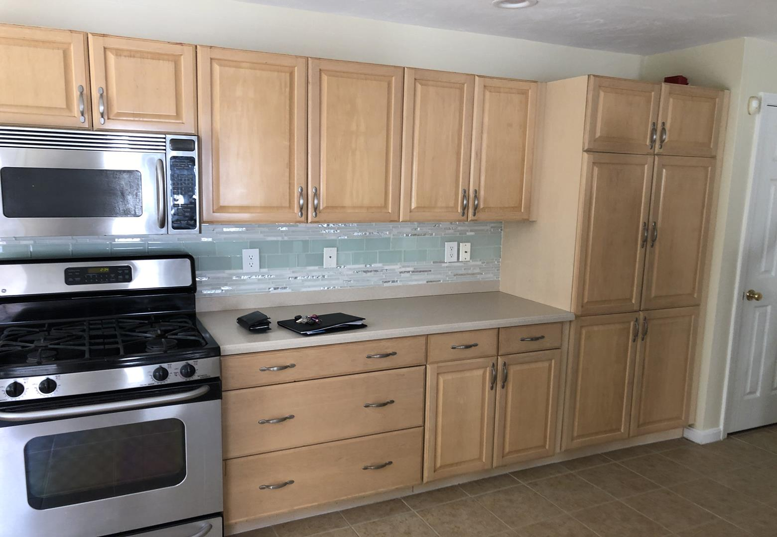
DON'T INCLUDE STAIN INSIDE THE CABINET.
33 AMERICAN BLVD ASHLAND MA 01721
CABINETS:
COLOR CHERRY DARK DOORS 34Unit
STYLE SMOOTH DRAWERS 11 Unit
COMPLETE JOB IN 2 WEEKS

We use only the highest quality materials.
” Thank you so much for trusting me . I do my best, taking care of your house as if it were mine. I take pleasure and love my job. “
Wellington B. Bovenschulte
Master Painter

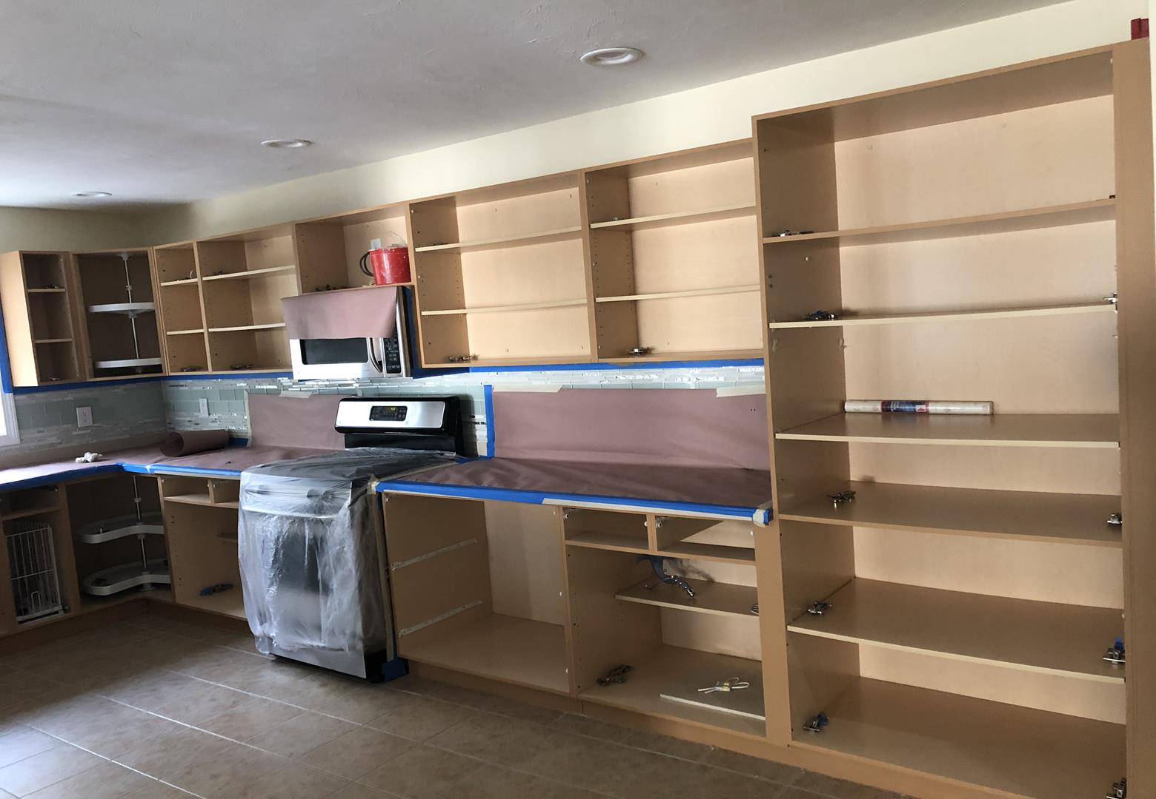
DON'T INCLUDE STAIN INSIDE THE CABINET.
33 AMERICAN BLVD ASHLAND MA 01721
CABINETS:
COLOR CHERRY DARK DOORS 34Unit
STYLE SMOOTH DRAWERS 11 Unit
COMPLETE JOB IN 2 WEEKS

We use only the highest quality materials.
” Thank you so much for trusting me . I do my best, taking care of your house as if it were mine. I take pleasure and love my job. “
Wellington B. Bovenschulte
Master Painter

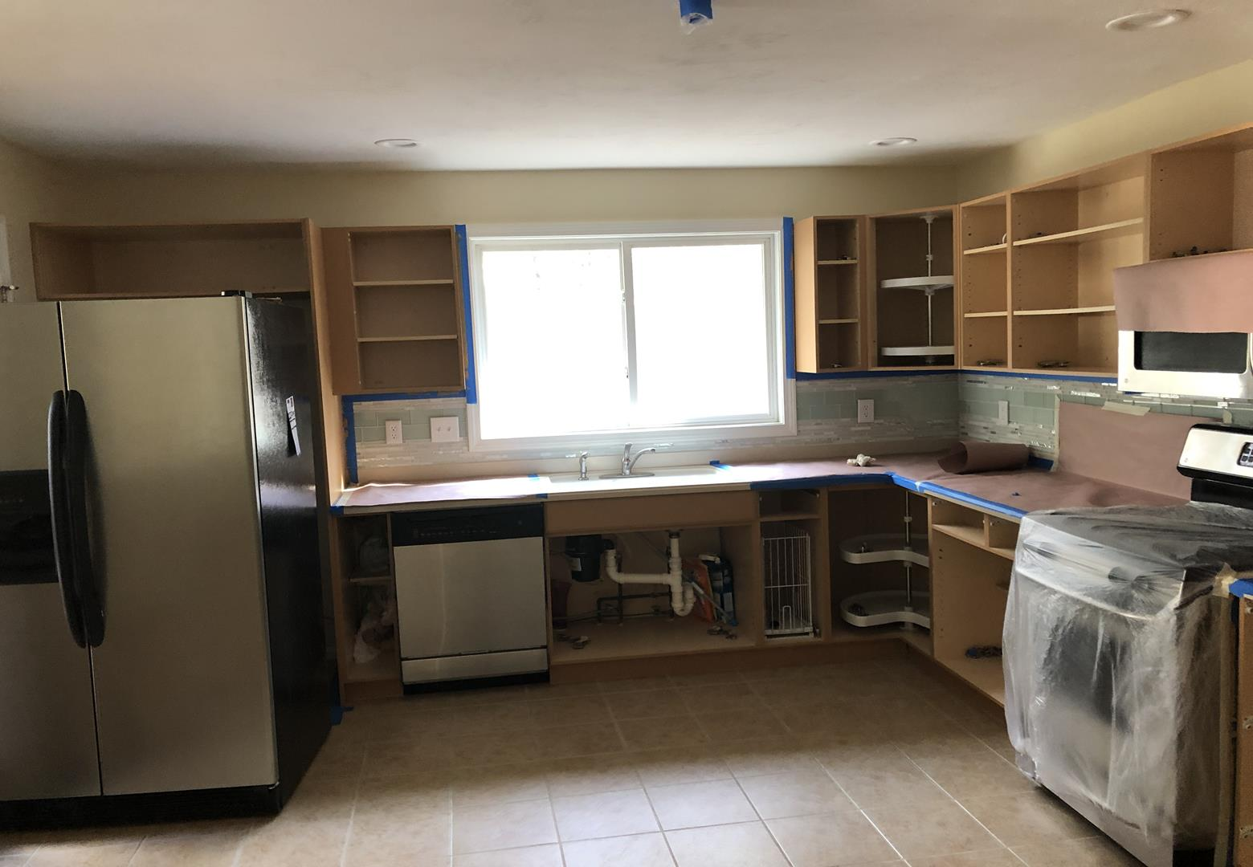
DON'T INCLUDE STAIN INSIDE THE CABINET.
33 AMERICAN BLVD ASHLAND MA 01721
CABINETS:
COLOR CHERRY DARK DOORS 34Unit
STYLE SMOOTH DRAWERS 11 Unit
COMPLETE JOB IN 2 WEEKS

We use only the highest quality materials.
” Thank you so much for trusting me . I do my best, taking care of your house as if it were mine. I take pleasure and love my job. “
Wellington B. Bovenschulte
Master Painter
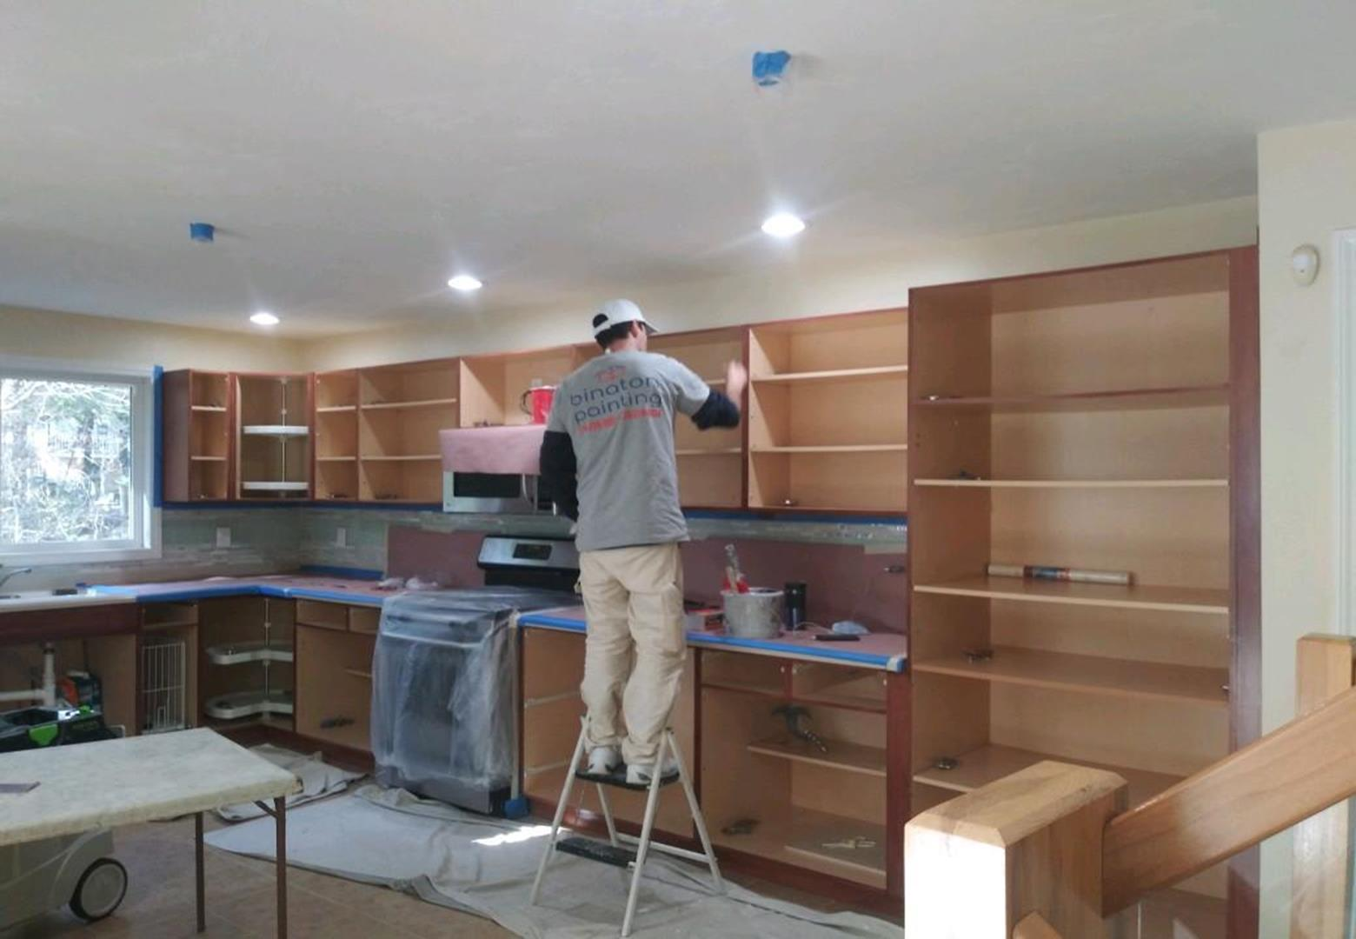
DON'T INCLUDE STAIN INSIDE THE CABINET.
33 AMERICAN BLVD ASHLAND MA 01721
CABINETS:
COLOR CHERRY DARK DOORS 34Unit
STYLE SMOOTH DRAWERS 11 Unit
COMPLETE JOB IN 2 WEEKS

We use only the highest quality materials.
” Thank you so much for trusting me . I do my best, taking care of your house as if it were mine. I take pleasure and love my job. “
Wellington B. Bovenschulte
Master Painter
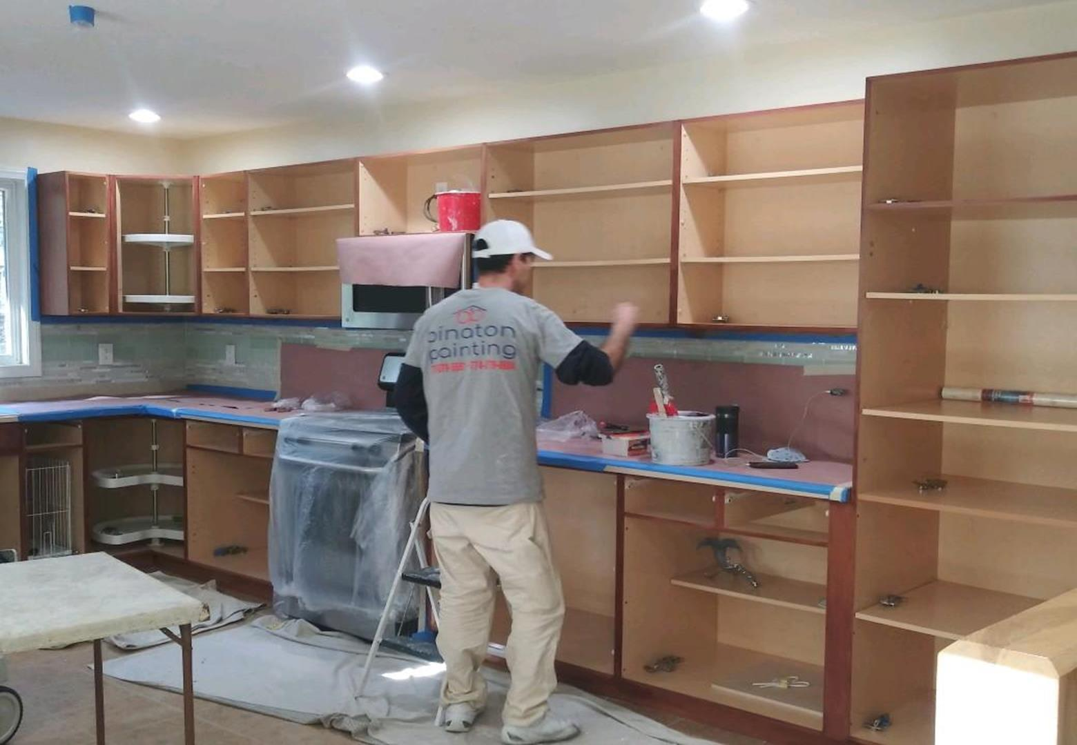
DON'T INCLUDE STAIN INSIDE THE CABINET.
33 AMERICAN BLVD ASHLAND MA 01721
CABINETS:
COLOR CHERRY DARK DOORS 34Unit
STYLE SMOOTH DRAWERS 11 Unit
COMPLETE JOB IN 2 WEEKS

We use only the highest quality materials.
” Thank you so much for trusting me . I do my best, taking care of your house as if it were mine. I take pleasure and love my job. “
Wellington B. Bovenschulte
Master Painter
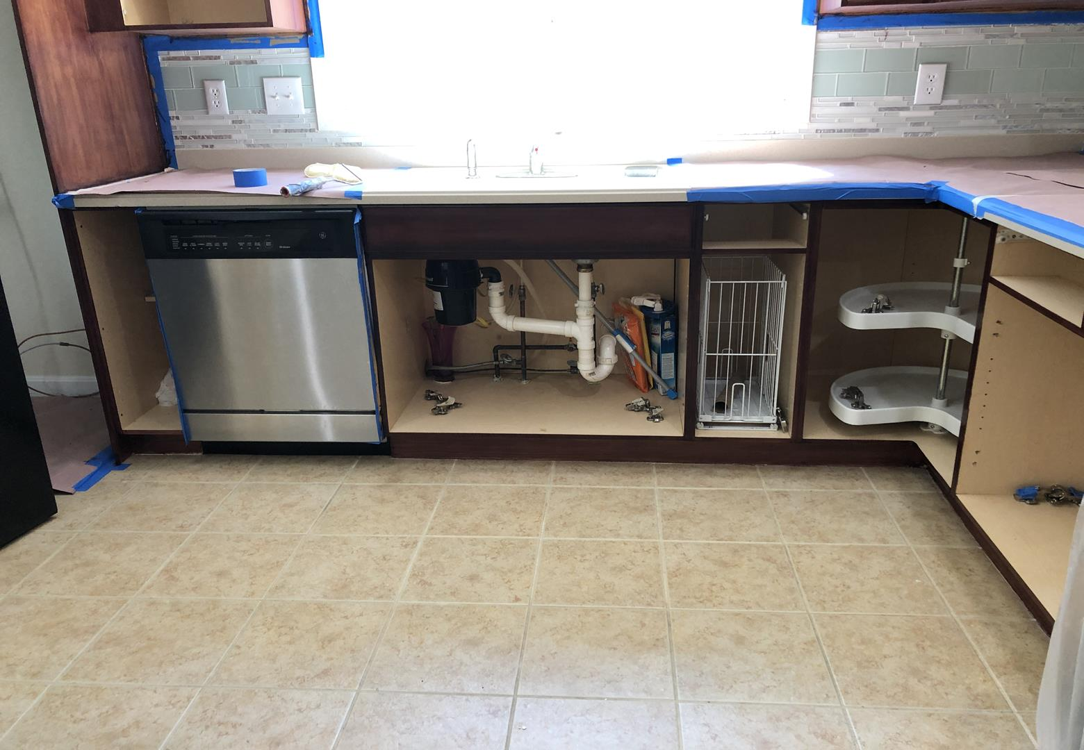
DON'T INCLUDE STAIN INSIDE THE CABINET.
33 AMERICAN BLVD ASHLAND MA 01721
CABINETS:
COLOR CHERRY DARK DOORS 34Unit
STYLE SMOOTH DRAWERS 11 Unit
COMPLETE JOB IN 2 WEEKS

We use only the highest quality materials.
” Thank you so much for trusting me . I do my best, taking care of your house as if it were mine. I take pleasure and love my job. “
Wellington B. Bovenschulte
Master Painter
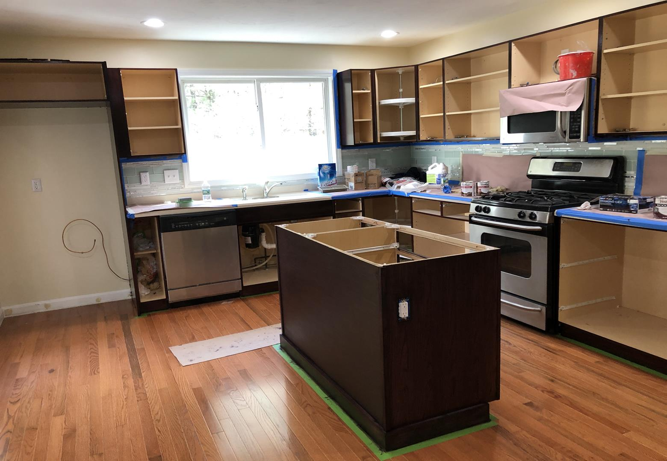
DON'T INCLUDE STAIN INSIDE THE CABINET.
33 AMERICAN BLVD ASHLAND MA 01721
CABINETS:
COLOR CHERRY DARK DOORS 34Unit
STYLE SMOOTH DRAWERS 11 Unit
COMPLETE JOB IN 2 WEEKS

We use only the highest quality materials.
” Thank you so much for trusting me . I do my best, taking care of your house as if it were mine. I take pleasure and love my job. “
Wellington B. Bovenschulte
Master Painter

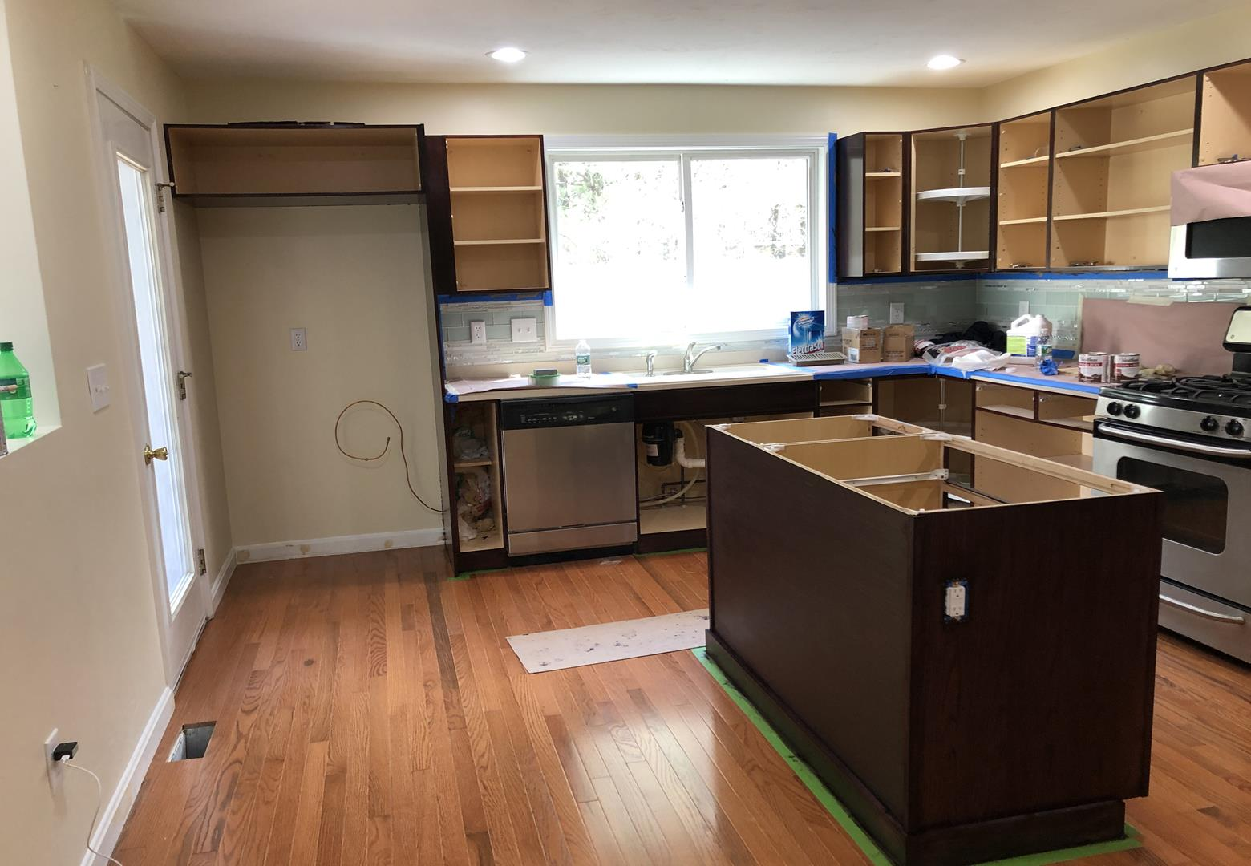
DON'T INCLUDE STAIN INSIDE THE CABINET.
33 AMERICAN BLVD ASHLAND MA 01721
CABINETS:
COLOR CHERRY DARK DOORS 34Unit
STYLE SMOOTH DRAWERS 11 Unit
COMPLETE JOB IN 2 WEEKS

We use only the highest quality materials.
” Thank you so much for trusting me . I do my best, taking care of your house as if it were mine. I take pleasure and love my job. “
Wellington B. Bovenschulte
Master Painter
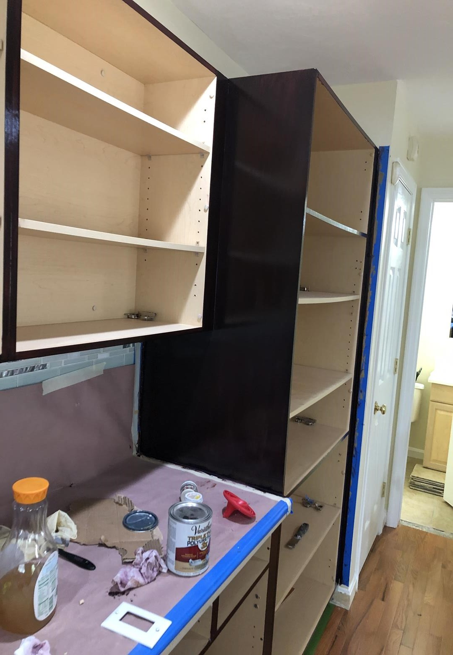
DON'T INCLUDE STAIN INSIDE THE CABINET.
33 AMERICAN BLVD ASHLAND MA 01721
CABINETS:
COLOR CHERRY DARK DOORS 34Unit
STYLE SMOOTH DRAWERS 11 Unit
COMPLETE JOB IN 2 WEEKS

We use only the highest quality materials.
” Thank you so much for trusting me . I do my best, taking care of your house as if it were mine. I take pleasure and love my job. “
Wellington B. Bovenschulte
Master Painter
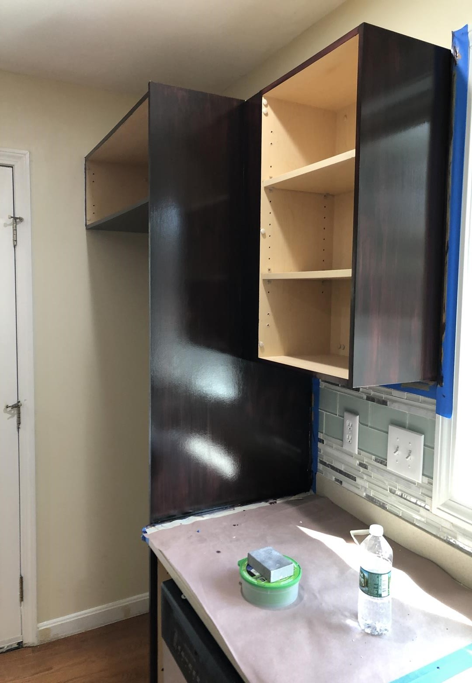
DON'T INCLUDE STAIN INSIDE THE CABINET.
33 AMERICAN BLVD ASHLAND MA 01721
CABINETS:
COLOR CHERRY DARK DOORS 34Unit
STYLE SMOOTH DRAWERS 11 Unit
COMPLETE JOB IN 2 WEEKS

We use only the highest quality materials.
” Thank you so much for trusting me . I do my best, taking care of your house as if it were mine. I take pleasure and love my job. “
Wellington B. Bovenschulte
Master Painter
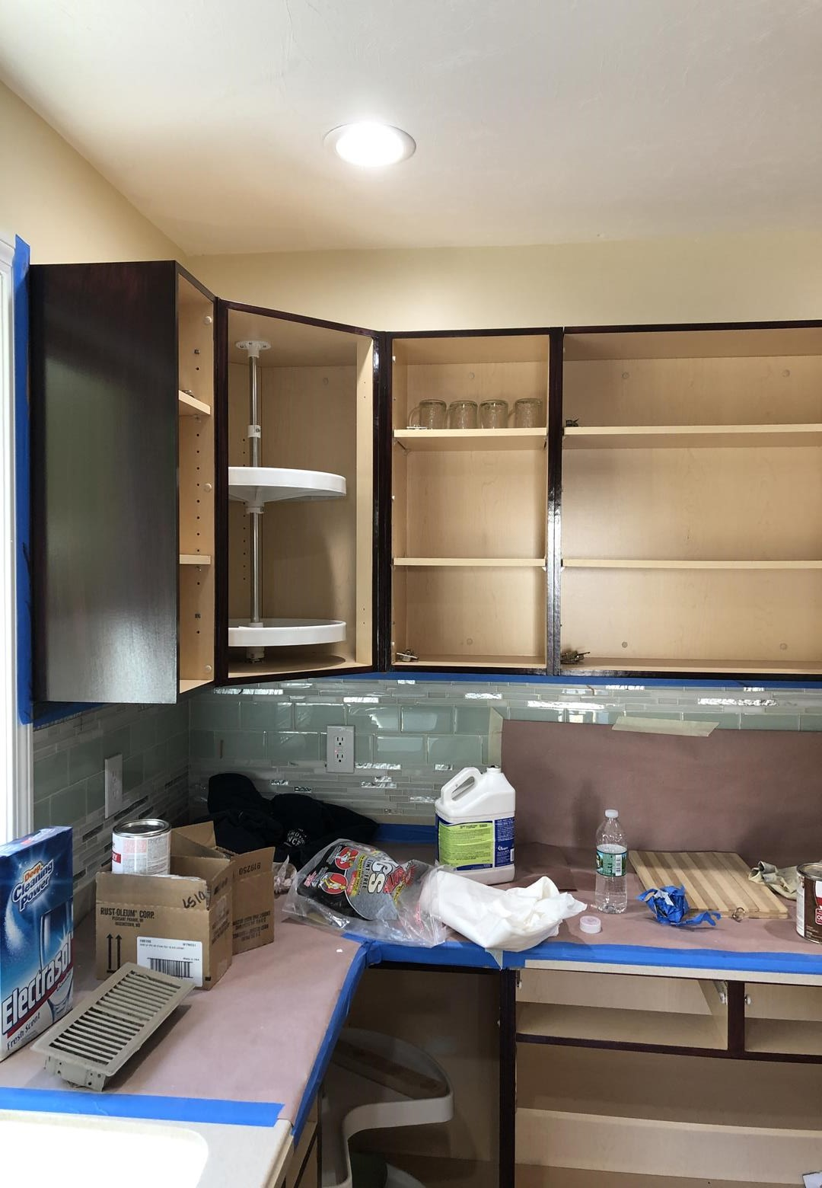
DON'T INCLUDE STAIN INSIDE THE CABINET.
33 AMERICAN BLVD ASHLAND MA 01721
CABINETS:
COLOR CHERRY DARK DOORS 34Unit
STYLE SMOOTH DRAWERS 11 Unit
COMPLETE JOB IN 2 WEEKS

We use only the highest quality materials.
” Thank you so much for trusting me . I do my best, taking care of your house as if it were mine. I take pleasure and love my job. “
Wellington B. Bovenschulte
Master Painter
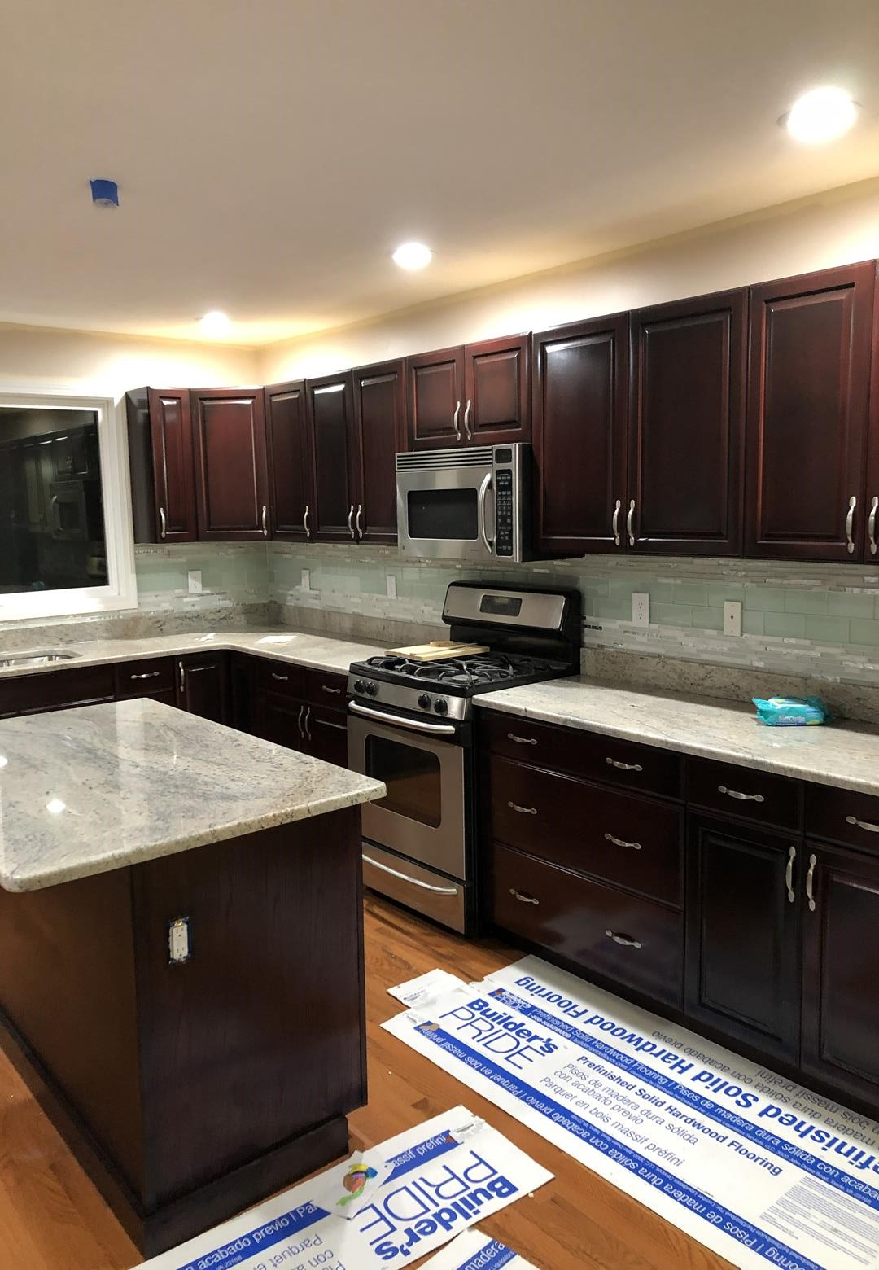
DON'T INCLUDE STAIN INSIDE THE CABINET.
33 AMERICAN BLVD ASHLAND MA 01721
CABINETS:
COLOR CHERRY DARK DOORS 34Unit
STYLE SMOOTH DRAWERS 11 Unit
COMPLETE JOB IN 2 WEEKS

We use only the highest quality materials.
” Thank you so much for trusting me . I do my best, taking care of your house as if it were mine. I take pleasure and love my job. “
Wellington B. Bovenschulte
Master Painter
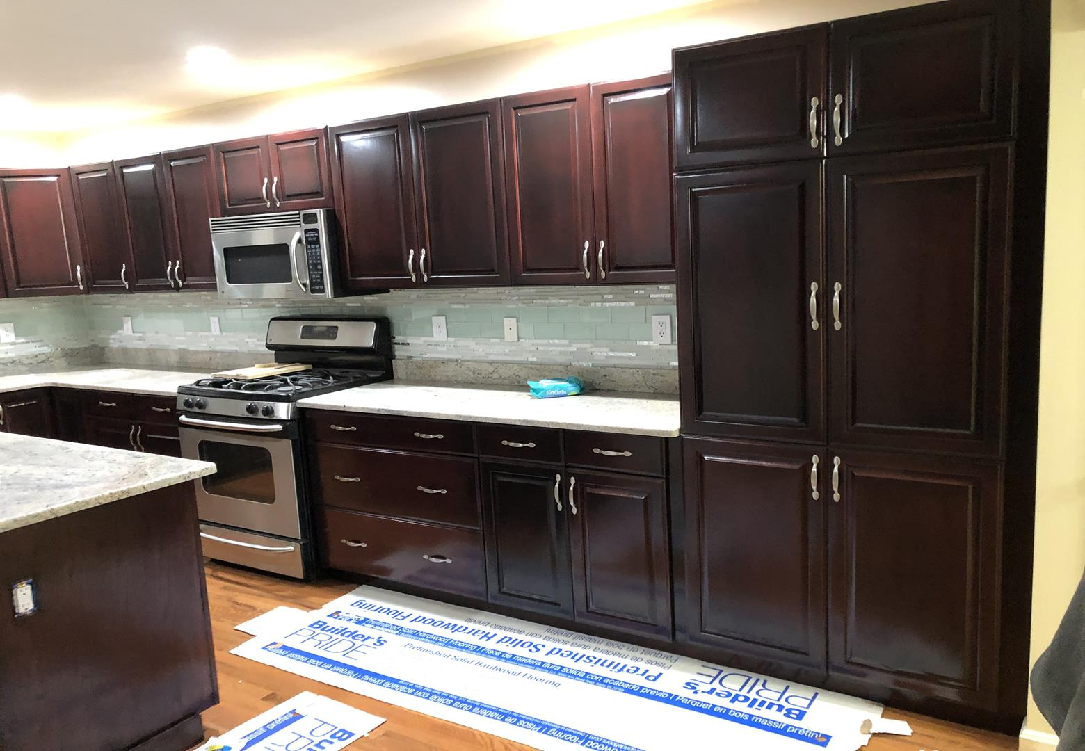
DON'T INCLUDE STAIN INSIDE THE CABINET.
33 AMERICAN BLVD ASHLAND MA 01721
CABINETS:
COLOR CHERRY DARK DOORS 34Unit
STYLE SMOOTH DRAWERS 11 Unit
COMPLETE JOB IN 2 WEEKS

We use only the highest quality materials.
” Thank you so much for trusting me . I do my best, taking care of your house as if it were mine. I take pleasure and love my job. “
Wellington B. Bovenschulte
Master Painter

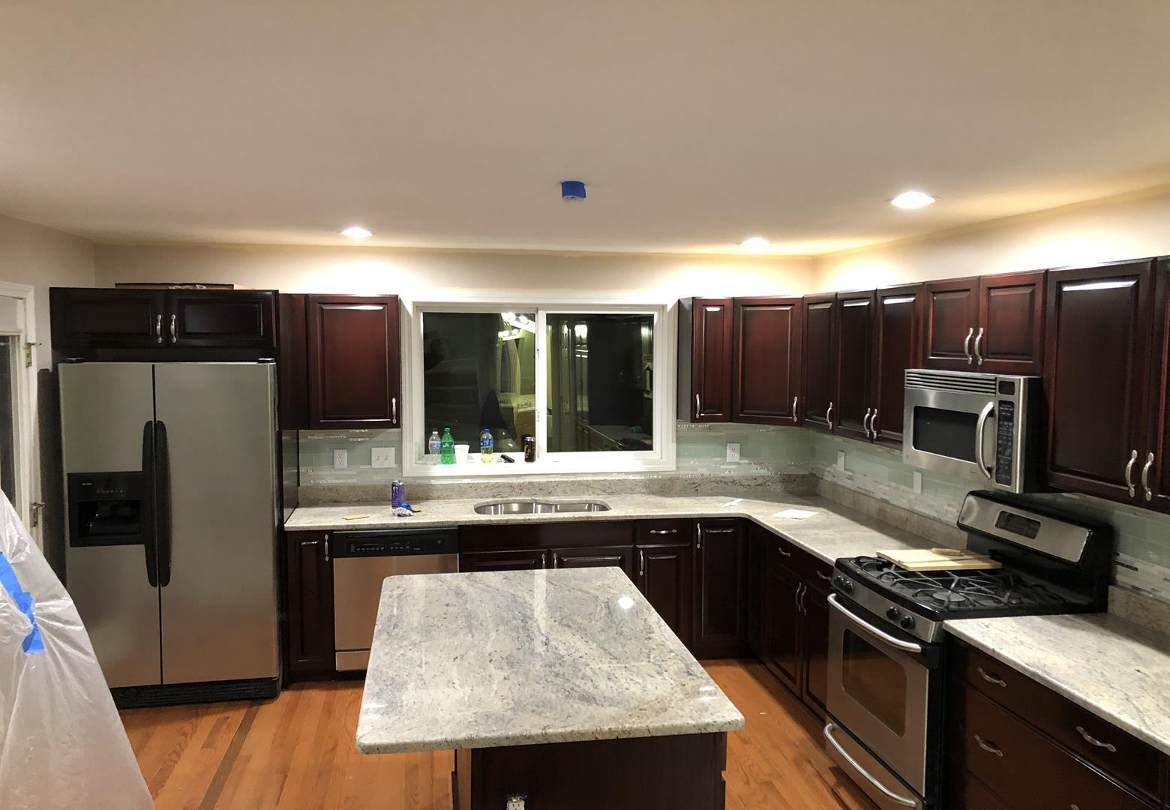
DON'T INCLUDE STAIN INSIDE THE CABINET.
33 AMERICAN BLVD ASHLAND MA 01721
CABINETS:
COLOR CHERRY DARK DOORS 34Unit
STYLE SMOOTH DRAWERS 11 Unit
COMPLETE JOB IN 2 WEEKS

We use only the highest quality materials.
” Thank you so much for trusting me . I do my best, taking care of your house as if it were mine. I take pleasure and love my job. “
Wellington B. Bovenschulte
Master Painter
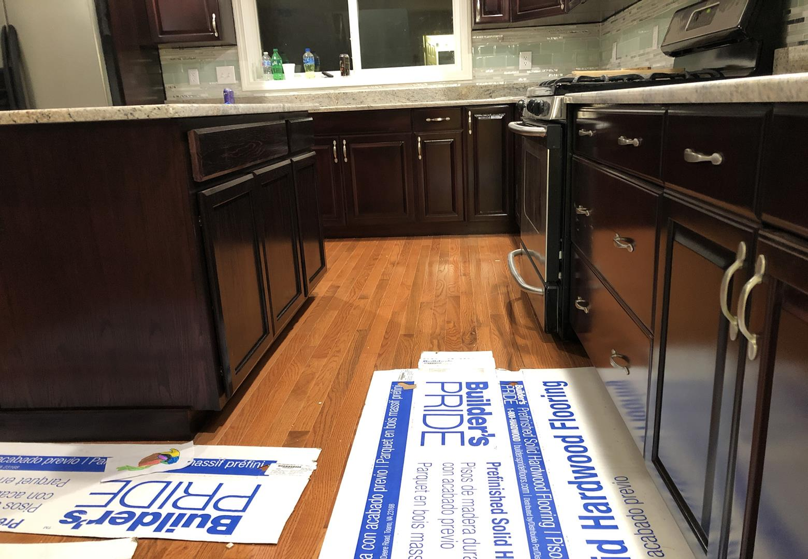
DON'T INCLUDE STAIN INSIDE THE CABINET.
33 AMERICAN BLVD ASHLAND MA 01721
CABINETS:
COLOR CHERRY DARK DOORS 34Unit
STYLE SMOOTH DRAWERS 11 Unit
COMPLETE JOB IN 2 WEEKS

We use only the highest quality materials.
” Thank you so much for trusting me . I do my best, taking care of your house as if it were mine. I take pleasure and love my job. “
Wellington B. Bovenschulte
Master Painter

